By John Hathaway, Tocqueville Asset Management L.P.
The Case For Gold II

March 1 (King World News)

The investment case for gold, in our opinion, rests squarely on the prospect for U.S. sovereign credit, and by extension, the value of the U.S. dollar. The prospect, in short, appears poor. Therefore, we find that the rationale for gold remains solid. In fact, it seems stronger than ever.

One could argue that there has been a bull market in bearish commentary regarding U.S. fiscal issues and that therefore, worst cased outcomes have already been priced in at roughly $1575/oz. (2/28/13) Three years of steadily rising equity prices could suggest that there is an argument opposite to the bearish case which will only be fully evident years from now.

What follows is a compendium of my beliefs, observations, inferences, opinions and perceptions that lead me to conclude that the gold price is headed substantially higher in terms of all paper currencies. The thesis rests on considerations which I feel are categorically ignored by mainstream commentary. In our opinion, gradual, and to most, imperceptible evolutions of economic and political realities preclude a return to “normal” cycles of economic growth. We believe that expectation is a web of fantasy produced by major financial institutions, government officials, academia, and made possible by the complicity of an uninformed public.

We view assessing the long term direction of the gold price correctly as a big part of our job as the manager of a gold strategy. It is our view that the lengthy correction from the 2011 peak is nearly over, and that a solid base for future advances has been established. Any price that attempts to go parabolic, as gold did in August of 2011, is bound to suffer from a hangover (as noted several times by John Mendelson of ISI) and we believe that gold’s hangover is in its final stages. All sentiment measures that we monitor are at rock bottom levels. The demoralization of gold investors is a sign, however painful and understandable, that further downside risk is minimal.

In 2002, we wrote in our website article “The Investment Case for Gold” that the rationale rested “on the notion that the overvaluation and excessive supply of the U.S. currency has funded a decade’s worth of uneconomic investment and unsustainable consumption.” The only revision that we would make today to our statement of ten years ago is that another decade of overvaluation and excessive supply has come and gone with no resolution of the basic problem. Economic rot has been repackaged in sovereign credit, which it could eventually corrupt.

What is the case for further upside? During the crash of 2008, we argued in our website article “Is Gold Still in a Bull Market?” (October 2008, click here to view) that the consequences of massive Fed intervention would cause alarm among investors and broaden interest in gold as an alternative to paper currencies. Then, as now, it was necessary to reckon the basis for a further advance in gold that had not already been articulated:

What will drive a further advance in gold? Let’s start with the implausible assumption that the worst of the credit crunch had been already discounted when gold scaled $1000. Let’s also assume an even greater stretch that the Paulson bailout succeeds in restarting the wheels of lending and commerce. Finally, let’s toss in an end to the decline of asset prices and the commencement of a bull market in equities. The unequivocal precondition for these felicitous events would be the transformation of the dollar and other paper currencies as we know them. The socialization of credit in the U.S. may well work the miracles as its proponents claim, but not without stiff costs. We suspect that two inescapable costs will be inflation and negative real interest rates as far as the eye can see. Both of these outcomes are friendly to gold. Neither is likely to improve the credit rating of the dollar or increase the desire of non U.S. investors to increase their holdings of U.S. Treasuries.

We believe that a future downgrade of U.S. sovereign credit is a strong possibility. It would defrock U.S. Treasuries of their safe haven status. In the late 1970’s, they were dubbed “certificates of confiscation”. We fully believe they will once again be referred to in a similar manner as a direct result of current and still to come interventions by the government to shore up financial markets.

Those who seek to find the rationale for owning gold in the growth of the Fed and other central bank balance sheets, future inflation, the prospects for a deflationary collapse, the flight to safety or other macroeconomic themes only touch on ephemeral aspects of the forces that drive the bull market in gold. The narrative for gold has evolved several times since the bull market began in 1999. At first, central bank selling and producer hedging was the focus of most commentary. The attack of 9/11/01 added a geopolitical dimension. In 2006 and 2007 a thirst for “hard assets” premised on emerging market growth co- opted the investment thesis. The crash of gold during 2008 was explained by the specter of deflation. The dollar price of gold rose from its bear market low of $250 in 1999 to more than $700 according to several different narratives as voiced by conventional wisdom.

Post the 2008 meltdown, media commentary on gold flourished. High profile investors proclaimed the merits. Quantitative easing with implications for future inflation dominated investment thinking. The sovereign debt crisis in euro land and the 2011 showdown over the debt ceiling in Congress culminated the frenzy. The bull market, unnoticed by most for the previous eight years, became front page and hostage to popular perceptions.

To be caught up in a debate dictated by the explanations of mainstream commentary is, in our opinion, a waste of time. The rationale for further advances is destined to change. What needs to be addressed, as in any investment analysis, is not what is on the tip of everybody’s tongue, but rather what is it that has not been articulated; positive or negative.

The DNA of the bull market in gold is bad money, which in turn is evidenced by negative real rates of interest. In our view, one only needs to return to the notion of an overvalued and over abundant dollar for a starting point. Is the dollar less over valued and in less oversupply than it was ten years ago? Will it become more or less so during the coming decade?

Gold at roughly $1575 most certainly reflects the negative evolution of dollar fundamentals since 2000. Gold’s advance suggests that the dollar is worth substantially less, but in terms of what? The dollar buys 80% less gold than it did ten years ago. It buys 25% less of the DXY basket of foreign exchange than ten years ago. Because however reported, inflation remains tame and most do not seem to grasp or feel the dollar’s loss of value.

In addition to reflecting history, the dollar-gold price also discounts the future. The dollar’s decline versus gold is, in our opinion, a market expression of uncertainty as to its future purchasing power. In this sense, the dollar’s crash in gold terms is similar to a previously highly valued equity that investors have soured on. The multiple has contracted. Former cheerleaders are forced to become value players. The facts have to be reconsidered. We believe the rise of gold should be considered a warning.

At the moment, capital markets are calm. Stocks have doubled over the past three years. Interest rates are at historic lows. The world economy, according to most, is on the mend. The Obama regime appears to have consolidated power in its second term. Optimists seem to have the upper hand.

According to the recently published Congressional Budget Office (CBO) ten year base line projections, the budget deficit will shrink to 2.5% of GDP in just three years from the current 7%. Stated in dollar terms, the $1.15 trillion deficit of 2012 will become only $433 billion in 2015. The economy will grow at 3.1%, 3.5%, and 5.9% in nominal terms. Tax receipts will rise and spending will be held in check. Interest on ten year treasuries will not rise above 3.5% by 2015. Interest on 90 day treasuries will not rise above 20 bps, as promised by the Fed. Inflation will remain tame and the interest component of the consolidated budget willrise from $223 billion to only $273 billion (For details, go to CBO website-Baseline Budget Projections). If this forecast turns out to be accurate, gold is no place to be.

We have our doubts and believe that the CBO ten year forecast will miss the mark by a wide margin. Looking back at prior forecasts, in 2001 the CBO baseline projection called for a ten year cumulative surplus of $5.6 trillion. Instead, there was a cumulative deficit of $9 trillion. The real question is whether the miss will be on the upside (smaller deficits) or downside (much bigger deficits). The upside case is based on economic growth. A healthy private sector and a deleveraged consumer sector would more than offset the well- advertised problems of the public sector. After all, the private sector is much larger (2/3 of GDP) than the public sector (1/3 of GDP). A move towards less dependence on foreign energy would shrink the troublesome trade deficit, and that seems to be happening. There is a renaissance in American manufacturing. Perhaps a restructuring of the public sector still lies ahead which could lead to a more efficient government with unimagined benefits for the private sector. Is the prospect conceivable? Maybe, but count us as skeptics.

The case for a miss on the downside is the prospect of sputtering global economic growth or even a recession on nobody’s horizon. That would balloon the 2013 deficit and force even more money printing. We are fairly certain that economic growth is destined to sputter and would not be surprised by a recession.

Investment demand is the swing factor that sets the gold price. As we and others have often shown, the mechanism that activates or stifles investment demand is real interest rates. Positive real rates are bad for gold, negative real rates good. The condition that applies today is negative real rates; a condition that we believe is likely to continue for years to come. The inability of capital to earn a competitive return in liquid investments that are free of credit or duration risk opens a very wide door for capital to migrate into gold. 90-Day treasuries are the competition for gold, not ten year treasuries (duration risk) or the stock market (multiple risks of other kinds) or “alternative” investments such as fine art, real estate or farmland (liquidity risk). Below, we provide a long term chart of the inverse correlation between gold and real interest rates. It should be noted that the relationship depicted is based on the CPI as if the official government measure of inflation were the gospel. It is useful only as an illustration. We believe the CPI does not accurately measure the true rate of inflation, which we believe to be higher. For more on the real rate of inflation, please refer to John Williams’ Shadowstats service.

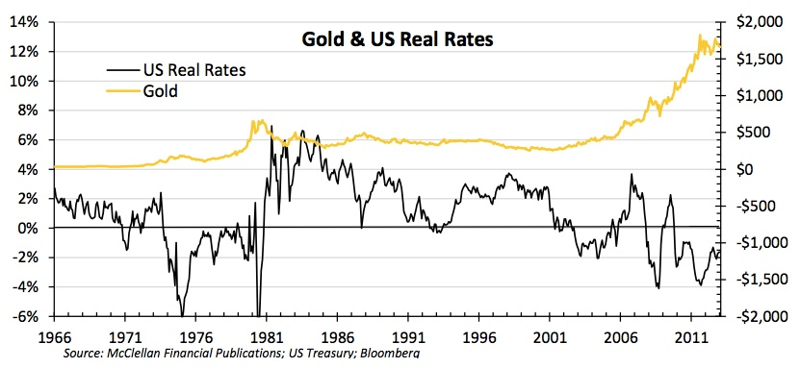

It is certainly possible that the correction in the gold price is discounting a return to competitive real interest rates, but we don’t think so. When it comes to cornering a market, the Fed is no slouch. They have taken a page right out of the book written by the Hunt brothers who cornered the silver market in 1980. Owing to a strategy of manipulating long term interest rates lower to help revive the housing industry, the Fed now owns more than 40% of all Treasuries with a maturity greater than 5 years (Peter Tchir-TF Market Advisors in Business Insider 2/10/13). Compared to what the Fed has done, the outrageous scheme of the Hunt brothers was small potatoes. Unwinding these positions will be difficult and not, we believe, without adverse consequences. For the Hunts, damage was limited to their creditors and their personal net worth. What will happen to long term interest rates when the Fed is no longer buying the lion’s share of Treasury issuance? At stake is the economy, employment, and asset valuation to mention a few possibilities for collateral damage.

Interest on gross federal debt is projected by the CBO to be $224 billion in 2013 and $272 billion in 2015; more or less proportional to the projected increase in debt outstanding of $16.5 trillion currently to $18.5 trillion in 2015. The blended interest rate across all maturities is 1.7%. Even though Treasury debt outstanding has tripled since 1998, the sum total of all interest paid by the Federal government on that debt has barely budged. A return to competitive real interest rates seems highly difficult given these facts. Each swing of 1% on $ 17 trillion is $170 billion. A blended interest rate, for the sake of argument, of 4% across the yield spectrum instead of 1.7% would add $390 billion to the projected budget deficit. We believe that a free market blended interest rate of 4% is conceivable only if measures to check the rise of government spending are credible. If the credibility of austerity/efficiency measures yet to come remain suspect, the market interest rate on federal debt in our opinion will be much higher than 4%, absent government intervention. Evidence of progress will be revealed in the remaining years of the Obama administration. Investors who choose to maintain positions in gold can be excused for their skepticism.

It seems to us that government finances and the economy are in no position to afford real interest rates that would allow 90-day Treasuries to compete with gold. Those who are trashing gold must be convinced that government spending will be revamped and that the credit outlook for the U.S. will show material improvement over the intermediate term.

We disagree with the current bearish consensus on gold. It is not the first time in the past 14 years that we find ourselves almost alone in our stance. We believe the repercussions and consequences of the current posture of the Fed balance sheet, zero interest rates, manipulated long term interest rates, unprecedented liquidity in the banking system, which seems unlikely to be withdrawn on a timely basis (thereby risking high inflation), and manipulated currency exchange rates remain unknown and unarticulated. The narrative for gold is highly likely to undergo another transformation during the next two years, most probably having to do with the negative consequences of the foregoing. While the private sector may be poised to do well, bad economic policy and bad money could constitute serious headwinds to sustainable real economic growth.

Gold can provide insurance against the very plausible possibility that the credit of the U.S. government will be no better, and quite possibly worse in four years than it is today. We are comfortable with our gold positions on that basis alone.

We also find comfort in the fact that gold seems as contrarian at this moment as it did in 1998 and in 2008. A few sentiment readings, as compiled by 13-d Research illustrate the point:

-Market Vane’s bullish gold consensus dropped to 49% in February, the lowest reading on record and only seen previously for a single day at the important gold bottom in 2008.

-the DSI (Daily Sentiment Index) dropped to 3%, a new record low since the index was started in 1987.

-GLD’s bullion holdings dropped 1.55% on 2/20, evidence of capitulative selling. -finally, speculative Comex shorts rose to the highest on record:

King World News note: The following chart is absolutely incredible as it reveals small specs shorting the gold market en masse:

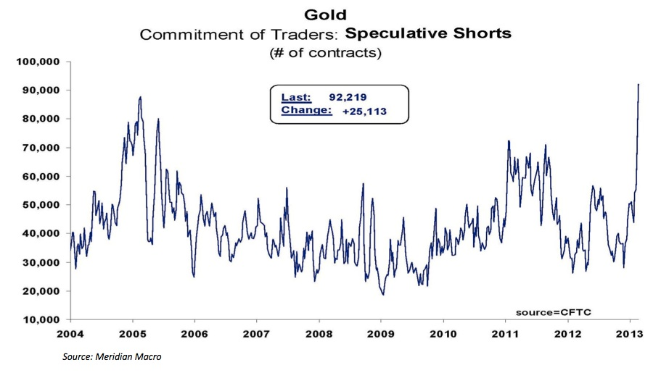

We count ourselves among the few that perceive a steady and stealthy erosion of the present and future purchasing power of what is commonly described as “money”. The degeneration of the utility of currency is almost never considered as a factor in economic forecasting. However, it destroys capital and inhibits and misdirects investment. We believe that the erosion has been camouflaged by a debasement of the slew of government and private sector yardsticks purporting to measure that purchasing power. For the most part, the yardsticks, such as the CPI, have been crafted and contorted by bureaucrats and PhD’s in a way that is unintelligible to most, and to our thinking, meaningless against the test of common sense. What is reflected in the dollar price of gold, despite the meandering rationalizations of conventional wisdom, is the ongoing and potential future loss of utility in the dollar as the cornerstone of global credit. In our view, the next stage of the bull market in gold will be marked by a widely shared awareness of the lost purchasing power of paper money. Such an outcome is, after all, the design of Fed policy which has set upon a course that could prove extremely difficult to alter. When the fog clears and, as we expect, the dollar’s loss of value becomes broadly palpable, we look for the gold price to advance to new all- time highs against all paper currencies.

John Hathaway
Portfolio Manager and Senior Managing Director
© Tocqueville Asset Management L.P.
March 1, 2013

