Bob Murphy will be teaching Mises on Money and Banking, an 8-week online course for the Mises Academy, February 1 – March 27.]
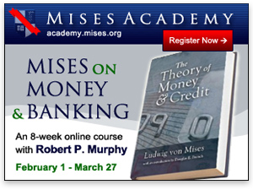
I am pleased to announce that on February 1 the Mises Academy will launch my new online class, Mises on Money and Banking. The class will cover selected portions of Mises's first major book, the classic The Theory of Money & Credit, for which I have written a study guide.
The book is too long to cover in its entirety, so we will focus on the portions necessary for students to walk away with a solid understanding of the two major accomplishments in the book:
- Mises's unification of "micro" and "macro" by applying subjective value theory to money, and
- his development of what we now call Austrian business-cycle theory.
The course will showcase not only Mises's brilliance as a novel thinker but also his excellent command of the literature and his selection of the best ideas from other schools.

The Scope of the Course
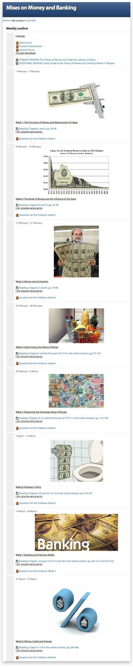
The course runs for eight weeks, from February 1 through March 21. All of the assigned reading and videos are available for free online. In the first week, we will cover the basics of the theory of money in light of the subjective theory of value pioneered by Carl Menger.
In the second week, we will spend some time walking through Mises's taxonomy of different types of money, including such crucial concepts as commodity money, money substitutes, and fiduciary media. We will see that it is well worth the effort to learn these distinctions, because they aren't arbitrary; Mises consciously adopted them to suit his theoretical enterprise.
In the middle section of the course, we will explore Mises's views on the interaction between subjective valuation and the objective exchange value (i.e., purchasing power) of money. It is here that Mises developed his now-famous "regression theorem." This theorem was the missing ingredient to yield a satisfactory explanation for the value of money that was consistent with the subjective theory of value, which economists had endorsed for a barter economy.
In the final section of the course, we will learn Mises's views on banking and monetary policy, including such crucial topics as deflation and "free banking." In the last week, we will have developed the tools necessary to understand Mises's circulation-credit theory of the trade cycle, or what we nowadays refer to as Austrian business-cycle theory.
(For a more detailed look at the syllabus, click the thumbnail to the right.)

Structure of the Course
In a typical week of the course, I will give a live video broadcast on Wednesday from 6:30–8:00 p.m. ET. I will spend the first 75 minutes lecturing on that week's material, and then I will field questions from students for the remaining time. In addition, on Saturday I will have "office hours" (the times varying from week to week to cater to different students), meaning that I will be available on a live video broadcast to answer questions from any students who tune in.
Note that the Saturday sessions are purely for the students' convenience, and are not mandatory. Also, all broadcasts will be recorded and available to enrolled students, so that people who have a scheduling conflict can still take the class if they wish.
If a student wishes, he or she can simply "audit" the class. This has been a popular option for many adults who took my previous classes, because they had a busy work schedule and would only watch my lectures but couldn't keep up with the reading.
However, students may also take the class for a grade. These students will take a multiple-choice quiz each week, in addition to a final exam. Although the Mises Institute is not accredited, we will present certificates of completion and a formal grade at the end of the class to those students who desire it.

"Is This Course Going to Be Really Hard?"
Let's be frank. Mises's writing at times can be difficult, especially his earlier work when he was writing for other economists, rather than the lay public. The amateur fan of Austrian economics who flips through The Theory of Money & Credit might recoil, thinking it is too hard and that anything important from the book would have been distilled by Rothbard in Man, Economy, and State.
If I've just described your view, I suggest doing the first week's reading (the first two chapters from Mises) with my study guide as a companion. You might be pleasantly surprised to discover that Mises's prose, though a bit formal, is still accessible to the layperson. If — using my study guide for help — you can get through the first week's readings, then I believe you have what it takes to get through the whole class. It's true, we will get into material that is more complicated than what Mises lays out in the opening chapters, but then again that's what you have me for, to explain it for you.
Now if you determine that you are capable of digesting the material, I would urge you to take the plunge and sign up for the course. Yes, Rothbard and others have explained the Austrian theory of the business cycle in other venues. However, by exploring the Misesian framework of money and banking, you will walk away with a much deeper understanding of his theory of economic fluctuations. For example, the typical objection that "we had business cycles before the Fed, so the Austrians are obviously wrong" will seem quite ludicrous after studying Mises's classic work.
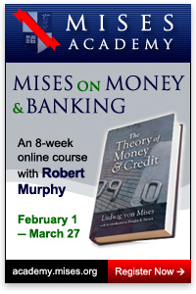
I personally am much more confident in my understanding of the Misesian position after writing the study guide, and I believe that even long-time fans of Austrian economics will learn new insights from this course.

Conclusion
Even if he had written nothing else, The Theory of Money & Credit would have secured Ludwig von Mises's place among the great 20th-century economists. I invite you to sign up for my forthcoming Mises Academy class to learn just what all the fuss is about. The material would be interesting in any environment, but with today's financial turmoil it is particularly important.
Robert Murphy is an adjunct scholar of the Mises Institute, where he teaches at the Mises Academy. He runs the blog Free Advice and is the author of The Politically Incorrect Guide to Capitalism, the Study Guide to "Man, Economy, and State with Power and Market," the "Human Action" Study Guide, The Politically Incorrect Guide to the Great Depression and the New Deal, and his newest book, Lessons for the Young Economist. Send him mail. See Robert P. Murphy's article archives.
Comment on this article.
You can subscribe to future articles by Robert P. Murphy via this RSS feed.
You can receive the Mises Dailies in your inbox. Subscribe or unsubscribe.

