Like Tweet +1 | Forward Unsubscribe

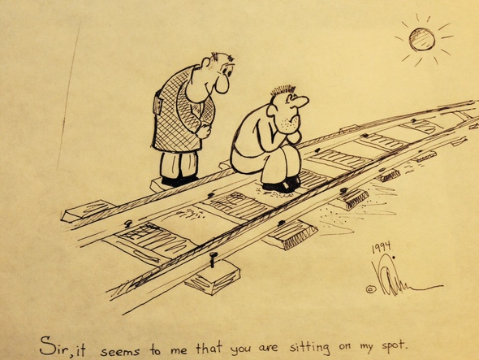

This cartoon is by my brother Alex Katsenelson

Crony Capitalism and the Oracle of Omaha

I am back from the Berkshire Hathaway annual meeting in Omaha, Nebraska, and my brain is still spinning from the dozens of meetings and stimulating conversations. In a series of articles for over the next few weeks (they'll be published on Institutional Investor Magazine's website), I’ll try to download the thoughts that were triggered by this trip, a lot of them unrelated to the main event — the Warren Buffett & Charlie Munger show — but rather by-products of the conversations I had.
After I wrote about my disappointment with Buffett’s mishandling of Coca-ColaCo.’s “excessive” compensation plan, I got an e-mail from Carol Loomis asking me if I wanted to ask Mr. Buffett a question about Cokegate. Loomis is the Berkshire Hathaway CEO’s longtime friend, editor of his annual shareholder letter and one of three reporters at the annual meeting who ask Warren and Charlie questions submitted by readers.
Here is the question I submitted:
I’ve been coming to shareholder meetings for seven years, and for the first time I’m seeing two Warren Buffetts: The first is the moral compass of corporate America — the standard of corporate ethics and integrity (the one we see in the Salomon Brothers scandal intro video year after year). And then last week a second Warren Buffett emerged, the one who commented on Coke’s excessive compensation plan: “We didn’t agree with the plan. We thought it was excessive.”
But then as a significant shareholder he abstained from voting on the plan, saying, “I could never vote against Coca-Cola.” The second Buffett behaved like just another middling American politician — the common type that all of us respect so little, the one that votes not for what he believes in but for what is going to keep him reelected. Forty thousand people did not come to Omaha to see the second Buffett, the one that chose crony capitalism; they came to see the first one, who knows the difference between right and wrong.
So I would like the first Buffett to judge the behavior of the second one._
- Vitaliy Katsenelson, Chief Investment Officer, Investment Management Associates, Inc., Denver, Colorado
Loomis ended up using someone else’s question on that topic, which asked (I am paraphrasing), “This spring, Coca-Cola proposed a large option program for its top managers. Why did Warren Buffett not say he was against the plan beforehand? Why did Berkshire Hathaway abstain rather than vote against?”
Buffett said that the proposal from a shareholder (mutual fund manager David Winters) opposing the plan made incorrect calculations and that the actual dilution from share issuance will be lower than a total of 16 percent over four years. With ease, Buffett went through a hypothetical example that showed that annual dilution would be 1 or 2 percent. He still believed it was excessive, he said, but not as excessive as Winters claimed. (Here is a link to Winters’ presentation.)
Estimating the true cost of stock option compensation is difficult because you have to make myriad assumptions about the future: where the stock price will be in four years (good luck) and how many stock options will actually be earned (deserved). You even have to guesstimate the average strike price (Coke has disclosed the strike price for the current plan, but compensation plans from the past are still active, and proxy disclosures are very vague). We don’t own Coke’s stock, thus my interest was very academic, but I went through Coke’s proxy, and by my calculation the dilution from stock options is closer to Buffett’s than to Winters’.
“We had no desire to go to war with Coca-Cola, and we did not want to endorse calculations that were wildly inaccurate,” Buffett stated, then noted, “I don’t think going to war is a very good idea in most cases.”
I understand why Buffett did not want to team up with David Winters or endorse his calculations. But Winters was not a loudmouthed activist who was proposing to break up Coke; he was just asking Coke’s shareholders to vote against a compensation plan that Buffett, before and during the annual meeting, had repeatedly called “excessive.”
All Buffett had to do was to check the “No” box on the proxy statement.
There may be some quirky nuances in the alternate universe of corporate governance to which I am not privy, but voting against a compensation plan is not considered going to war in the universe where I live. Buffett has been one of the loudest and most respected critics of exorbitant corporate compensation, but when it came time to lead by example, he did not — unless his message was, when you disagree with excessive compensation, abstain.
But you, dear reader, have heard nothing yet. In another question, Buffett was asked about his son Howard, who sits on the board of Coke and did not vote against its cushy executive compensation plan. Though the elder Buffett did not directly answer that question, his nonanswer sent chills up my spine.
He explained that independent directors are not necessarily independent. Though they don’t work for the company, they make $300,000 a year for attending six meetings. It’s a sweet gig, and they typically do very little to rock that gravy train. Aside from the financial benefit, there is a lot of prestige in being on a major corporate board. Boards don’t look for “dobermans,” Buffett said, “they look for cocker spaniels.” Then he added that when he served on many boards, he approved compensation plans and mergers he did not like.
Pause for a second to digest this. What Buffett told us (I truly applaud him for his honesty) was that corporate boards are not there to protect and serve the interests of shareholders. Their incentives — lavish compensation without any accountability for their actions or nonactions — have created an environment where board members are chosen not by how much value they’ll add to protecting the interests of shareholders but on their pedigrees and, more important, their ability to sing “Kumbaya.”
For a long time I could not understand how Hewlett-Packard Co.’s board — packed with talent — could vote to buy U.K. software maker Autonomy for more than $10 billion. The price tag was slightly insane, but, more to the point, a Google search or just some primitive, scuttlebutt research would have shown that some serious questions had been raised about Autonomy’s accounting (questions that proved to be valid and led to a significant write-off a year later).
What is slightly depressing about all this is that if even Warren Buffett voted for compensation plans and mergers he did not like in order not to upset the harmony of the corporate boardroom, what can we expect from the rest? For a long time the term “crony capitalism” held little meaning for me; but today, with great sadness, I look at corporate boards, I look at the vote to abstain by Buffett, and I realize that crony capitalism is defined by the corporate boardrooms of this country.
Suddenly, Carl Icahn, whose annual meeting doesn’t attract 40,000 people, looks like a crusader against crony capitalism. I never thought a visit to Omaha would trigger an appreciation of the role Icahn and other activist investors play in corporate America.

If you believe your friends, enemies, relatives or random strangers accumulated a seven figure portfolio and will benefit from our investment services, call Theresa at (303) 796-8333 and we’ll be happy to mail them a signed copy of The Little Book of Sideways Markets.

Vitaliy N. Katsenelson, CFA, is Chief Investment Officer at Investment Management Associates in Denver, Colo. He is the author of The Little Book of Sideways Markets (Wiley, December 2010). To receive Vitaliy’s future articles by email or read his articles click here.
Investment Management Associates Inc. is a value investing firm based in Denver, Colorado. Its main focus is on growing and preserving wealth for private investors and institutions while adhering to a disciplined value investment process, as detailed in Vitaliy’s book Active Value Investing (Wiley, 2007).

© 2014 IMA | Investment Management Associates, Inc. 5690 DTC Blvd, 140W Greenwood Village, CO 80111

Preferences Forward Unsubscribe

http://www.acting-man.com/?p=30382#more-30382

