Why is gold mining such a crappy business?
Steve Saville
Posted Oct 20, 2014
Below is an excerpt from a commentary originally posted atwww.speculative-investor.com on 12th October 2014.
That gold mining has generally been a crappy long-term investment for almost five decades is evidenced by the following chart. The chart, much of the data for which were provided by Nick Laird of www.sharelynx.com, shows the ratio of the Barrons Gold Mining Index (BGMI) and the US$ gold price from 1920 through to the present*. More specifically, it shows that, relative to gold bullion, the group of gold-mining stocks represented by the BGMI has been in a secular decline since 1968 and is now close to its lowest level since 1948. The question is: Why have gold mining stocks performed so poorly for so long relative to the metal?
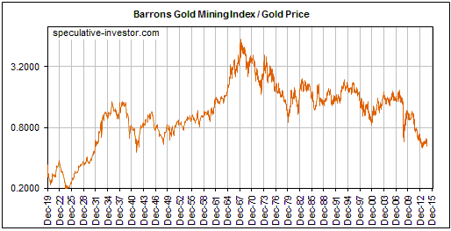
To answer the question we are going to draw on the Keynote speech recently delivered by Doug Pollitt of Pollitt & Co. at the Denver Gold Forum. A transcript of the speech can be read -- and should be read by anyone interested in gold mining investment -- HERE. This speech contains some eye-opening facts about the gold sector's operational performance and an important insight that, we think, explains why the gold-mining business has generated sub-par returns over a very long period. Hint: It isn't because the people who manage gold-mining businesses are, on average, dumber than the people who manage other commodity-production businesses.
Before getting to the root cause of the problem it's worth emphasising that the generally poor long-term performance of gold mining stocks stems from the generally poor long-term performance of gold mining businesses. In other words, although the swings in market sentiment are partly responsible for the swings in the BGMI/gold ratio shown in the above chart and although speculative sentiment towards gold mining is probably near a low ebb at this time, the lousy stock-market performance isn't primarily due to excessive pessimism on the part of share traders/investors. We are, after all, talking about a trend that has been in place for several decades, not something that just sprung up over the past two years. Instead, the lousy stock market performance is a rational response to the lousy returns generated by the underlying businesses. Currently, for example, with the gold-mining sector near its lowest level since 1948 relative to gold bullion, the stocks of most senior and mid-tier gold producers don't look cheap based on traditional measures of business health such as profitability and free-cash-flow generation.
Two pieces of information from the above-linked speech highlight the poor performance of the gold-mining industry. We are referring to the charts labeled Figure 9 and Figure 10 on page 5. Figure 9 compares the retained earnings of the gold sector with the retained earnings of the oil and base-metals sectors, and indicates that over the past 15 years there were large increases in the retained earnings of oil and base-metal companies versus almost no increase in the retained earnings of gold-mining companies. This is despite a huge increase in the gold price. Figure 10 reveals that the production per share of the gold mining industry fell by about 35% over the same 15-year period while the production per share of the oil industry rose by about 30%.
The explanation for why gold mining has been a crappy business was mostly, but not fully, addressed in the above-linked speech. The rest of the explanation was provided by Morgan Poliquin, who is one of about three gold-mining CEOs with a good grasp of economic theory (Morgan is the CEO of Almaden Minerals (AAU)). It goes like this:
- Gold is the premier counter-cyclical asset. When the financial/banking system appears to be in trouble or it is widely feared that central banks are playing fast and loose with the official money, the stock and bond markets are perceived to be less attractive and gold-related investments are perceived to be more attractive.
- Gold to the stock and bond markets is like an ant to an elephant, so the aforementioned shift in investment demand results in far more money making its way into gold-related investments than can be used efficiently.
- Geology exacerbates the difficulty of putting a flood of new money to work in an efficient manner in the gold-mining industry, in that lucrative gold deposits are more difficult to find and are usually not as scalable as, for example, copper deposits, iron-ore deposits and oil deposits. By "not as scalable" it is meant that whereas a higher commodity price will often create an opportunity to expand an existing industrial-metals mine or oil-sands operation, that's usually not the case with a gold mine.
- The new money flooding into the gold sector will be attracted to the companies showing the most growth. Due to the considerable amount of time, effort and risk involved in finding an economic gold deposit and then developing it into a mine, the quickest and easiest way to achieve the sort of growth for which the market brays is via M&A (mergers and acquisitions). However, whenever there is a surge in M&A activity, many of the purchases and business combinations will prove to be ill-conceived. Furthermore, the companies with solid cash-generating operations and high returns on investment that don't play the 'growth-at-any-cost-by-M&A' game will get swallowed by the companies that do.
- The new money flooding into the gold sector will also tend to make large deposits more desirable, even if the deposits are in risky locations and are unlikely to ever be economic as a result of their low grades or problematic metallurgy.
- Due to the issues noted above, the gold-mining sector experiences a lot more mal-investment than other commodity sectors. In the same way that the mal-investment fostered by the Fed's monetary inflation has caused the US economy to effectively stagnate over the past 15 years, the bad investment decisions fostered by the periodic floods of money towards gold mining have made the industry inefficient. Putting it another way, just as the busts that follow the central-bank-caused economic booms tend to wipe out all the gains made during the booms, the gold-mining industry experiences a boom-bust cycle of its own with similar results. The difference is that the booms in gold mining roughly coincide with the busts in the broad economy.
- Not coincidentally, the problems for the gold-mining industry began at around the same time that central banks in general and the Federal Reserve in particular became free to inflate the money supply and manipulate interest rates without any rigid restrictions. The time was the early-1970s, when the US$ was untethered from gold.
Gold producers have taken steps to become more efficient over the past 18 months and have liquidated many of the mal-investments of the preceding boom. This paves the way for dramatic strength in the shares relative to the bullion during at least the first year of the next bull market in gold-related investments, but it's a virtual certainty that the surging demand for gold during the coming economic bust will lead to yet another round of massive mal-investment in the gold-mining industry.
The bottom line is that gold mining is doomed to remain a crappy business as long as the current monetary system is in place. This means that it will periodically be the recipient of a flood of new money, prompting a great deal of unproductive investment and TEMPORARILY generating huge returns for gold-stock investors.
*The chart uses weekly data since 1960 and monthly data prior to 1960. Also, the chart uses BGMI data beginning in 1938 and the share price of Homestake Mining (HM) scaled to the BGMI prior to that.
###
Steve Saville
email: sas888_hk@yahoo.com
Hong Kong

Table of Contents
Index Summary • Domestic Equity Market • Economy and Bond Market • Gold Market
Energy and Natural Resources Market • Emerging Markets • Leaders and Laggards• Fund Performance Link

What the Strong Dollar Does to Yellow and Black Gold and Why We're Seeing Green
By Frank Holmes
CEO and Chief Investment Officer
U.S. Global Investors
The United States is doing better than it has in years. Jobs growth is up, unemployment is down, our manufacturing sector carries the rest of the world on its shoulders like a wounded soldier and the World Economic Forum named the U.S. the third-most competitive nation, our highest ranking since before the recession.
As heretical as it sounds, there’s a downside to America’s success, and that’s a stronger dollar. For the 12-month period, our currency has seen a 1.1-standard deviation move, which has put pressure on two commodities that we consider our lifeblood at U.S. Global Investors: gold and oil.
It's worth noting that we’ve been here before. In October 2011, a similar correction occurred in energy, commodities and resources stocks based on European and Chinese growth fears. But international economic stimulus measures helped raise market confidence, and many of the companies we now own within these sectors benefited. Between October 2011 and January 2012, Anadarko Petroleum rose 58 percent; Canadian Natural Resources, 20 percent; Devon Energy, 15 percent; Cimarex Energy, 15 percent; Peyto Exploration & Development, 15 percent; and Suncor Energy, 10 percent.
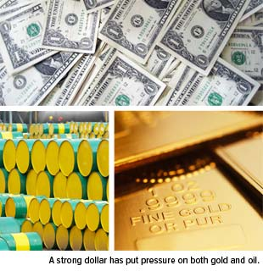
Granted, we face new challenges this year that have caused market jitters—Ebola and ISIS, just to name a couple. But we’re confident that once the dollar begins to revert to the mean, a rally in energy and resources stocks might soon follow. Brian Hicks, portfolio manager of our Global Resources Fund (PSPFX),notes that he’s been nibbling on cheap stocks ahead of a potential rally, one that, he hopes, mimics what we saw in late 2011 and early 2012.
A repeat of last year's abnormally frigid winter, though unpleasant, might help heat up some of the sectors and companies that have underperformed lately.
September Was the Cruelest Month
On the left side of the chart below, you can see 45 years’ worth of data that show fairly subdued fluctuations in gold prices in relation to the dollar. On the right side, by contrast, you can see that the strong dollar pushed bullion prices down 6 percent in September, historically gold’s strongest month. This move is unusual also because gold has had a monthly standard deviation of ±5.5 percent based on the last 10 years’ worth of data.
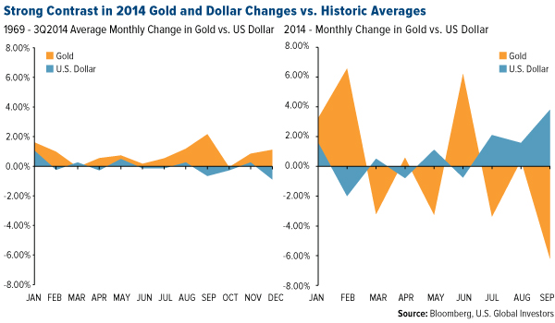
click to enlarge
Here’s another way of looking at it. On October 3, bullion fell below $1,200 to prices we haven’t seen since 2010, but it quickly rebounded to the $1,240 range as the dollar index receded from its peak the same day.
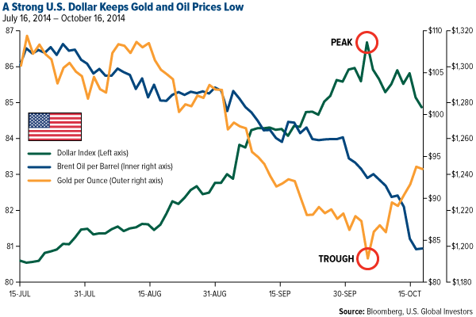
click to enlarge
There’s no need to worry just yet. This isn’t 2013, when the metal gave back 28 percent. And despite the correction, would it surprise you to learn that gold has actually outperformed several of the major stock indices this year?
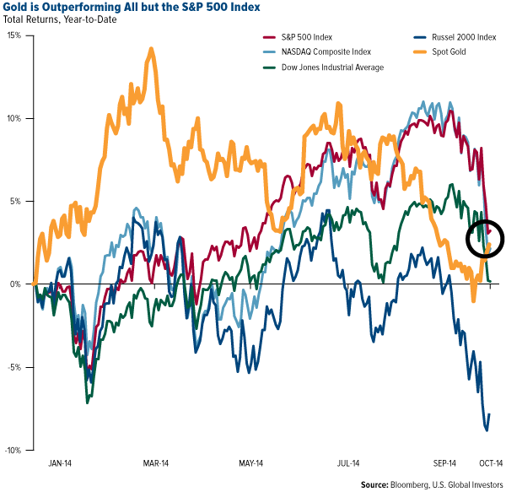
click to enlarge

As for gold stocks, there’s no denying the facts: With few exceptions, they’ve been taken to the woodshed. September was demonstrably cruel. Based on the last five years’ worth of data, the NYSE Arca Gold BUGS Index has had a monthly standard deviation of ±9.4, but last month it plunged 20 percent. We haven’t seen such a one-month dip since April 2013. This volatility exemplifies why we always advocate for no more than a 10 percent combined allocation to gold and gold stocks in investor portfolios.
Oil’s slump is a little more complicated to explain.
Since the end of World War II, black gold has been priced in U.S. greenbacks. This means that when our currency fluctuates as dramatically as it has recently, it affects every other nation’s consumption of crude. Oil, then, has become much more expensive lately for the slowing European and Asian markets. Weaker purchasing power equals less overseas oil demand equals even lower prices.
What some people are calling the American energy renaissance has also led to lower oil prices. Spurred by more efficient extraction techniques such as fracking, the U.S. has been producing over 8.5 million barrels a day, the highest domestic production level since 1986. We’re awash in the stuff, with supply outpacing demand. Whereas the rest of the world has flat-lined in terms of oil production, the U.S. has zoomed to 30-year highs.
In a way, American shale oil has become a victim of its own success.
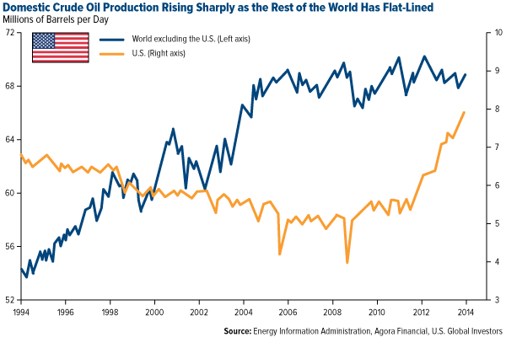
click to enlarge
At the end of next month, members of the Organization of the Petroleum Exporting Countries (OPEC) are scheduled to meet in Vienna. As Brian speculated during our most recent webcast, it would be surprising if we didn’t see another production cut. With Brent oil for November delivery at $83 a barrel, a four-year low, many oil-rich countries, including Iran, Iraq, Venezuela and Saudi Arabia, will have a hard time balancing their books. Venezuela, in fact, has been clamoring for an emergency mee ting ahead of November to make a plea for production cuts.
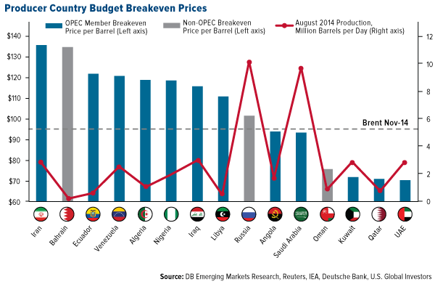
click to enlarge
Although not an OPEC member, Russia, once the world’s largest producer of crude, is being squeezed by plunging oil prices on the left, international sanctions on the right. This might prompt President Vladimir Putin to scale back the country’s presence in Ukraine and delay a multibillion-dollar revamp of its armed forces. When the upgrade was approved in 2011, GDP growth was expected to hold at 6 percent. But now as a result of the sanctions and dropping oil prices, Russia faces a dismally flat 0.5 percent.
Volatility Has Returned
The current all-in sustaining cost to produce one ounce of gold is hovering between $1,000 and $1,200. With the price of bullion where it is, many miners can barely break even. Production has been down 10 percent because it’s become costlier to excavate. As I told Kitco News’ Daniela Cambone, we will probably start seeing supply shrinkage in North and South America and Africa.
The same could happen to oil production. Extraction of shale oil here in the U.S. costs companies between $50 and $100 a barrel, with producers able to break even at around $80 to $85. If prices slide even further, drillers might be forced to trim their capital budgets or even shelve new projects.
Michael Levi of the Council on Foreign Relations told NPR’s Audie Cornish that a decrease in drilling could hurt certain commodities:
[I]f prices fall far enough for long enough, you’ll see a pullback in drilling. And shale drilling uses a lot of manufactured goods—20 percent of what people spend on a well is steel, 10 percent is cement, so less drilling means less manufacturing in those sectors.
At the same time, Levi places oil prices in a long-term context, reminding listeners that we’ve become accustomed to unusually high prices for the last three years.
"People were starting to believe that this was permanent, and they were wrong,” he said. “So the big news is that volatility is back.”
On this note, be sure to visit our interactive and perennially popular Periodic Table of Commodities, which you can modify to view gold and oil’s performance going back ten years.
A Penny Saved Is a Billion Dollars To Spend and Invest
With fresh volatility in oil production comes the fear that the most price-sensitive states will be hurt the most. Exceptionally vulnerable states include Oklahoma, Wyoming and North Dakota. Texas, the nation’s leading oil producer—one of the world’s top producers, in fact—is diversified well enough to not feel the pain as much.
What’s bad for oil producers, though, turns out to be good for American consumers, who are already benefiting from lower gasoline prices. According to AAA’s Daily Fuel Gauge Report, the national average for a gallon of gas is $3.16, down more than 6 percent from $3.35 a year ago.
As a result, American consumers are looking at huge savings—$40 billion this year alone. According to Deutsche Bank’s Joe LaVogna, every penny that’s saved at the pump equates to a billion dollars in household energy consumption that can be put back into the economy in other ways.
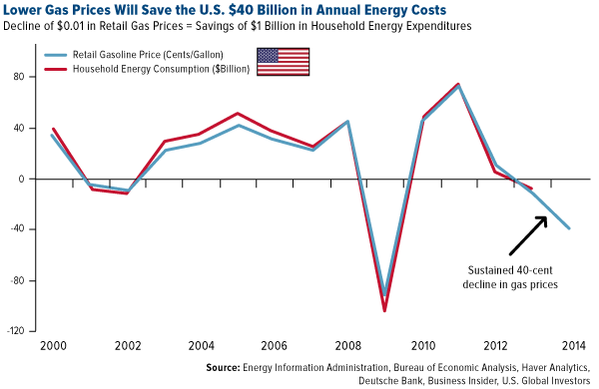
click to enlarge
I like to think of this as an unexpected and very welcome tax break. Automobile sales are already up from 2009. Lower gas prices might encourage some families to spring for that Suburban instead of a Prius.
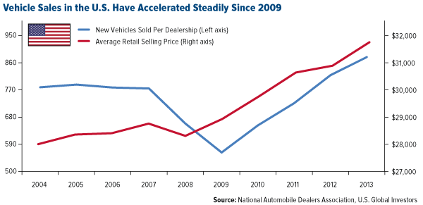
click to enlarge
Klondex Turning Heads and Profits
As I said earlier, gold stocks have been hurting lately. One mining company that’s managed to not only survive in this uncertain climate but actually thrive is Klondex Mines, our largest holding in both our Gold and Precious Metals Fund (USERX) andWorld Precious Minerals Fund (UNWPX), with additional exposure in our Global Resources Fund (PSPFX). Headquartered in Vancouver, Klondex has complete ownership and control of the Fire Creek Project and Midas Mine, both in Nevada.
The chart below, based on our own research, shows Klondex’s relative strength to its peers and why we find the company so attractive in the long term. The y-axis indicates profit margin, the x-axis, enterprise value. The size of the spheres represents the amount of revenue generated by each one of these companies in the second quarter of 2014, Klondex’s first quarter of full commercial production.
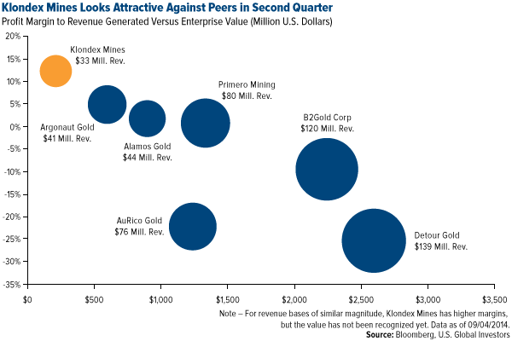
click to enlarge
What the chart conveys is that, in relation to its peers, Klondex has a significantly higher profit margin than companies with a market cap two to three times its size.
“This is going to be very positive for Klondex shareholders as we go into the year-end,” portfolio manager Ralph Aldis said during our webcast. “The third quarter should be another great quarter, and that’s when people will say, ‘Hey, that second quarter report wasn’t a fluke.’ They’re going to start buying the stock and get it moving.”
Indeed, Klondex has managed to stay above the Market Vectors Junior Gold Miners ETF for the 12-month period, delivering a positive return of 7 percent versus the ETF’s -7.5 percent.
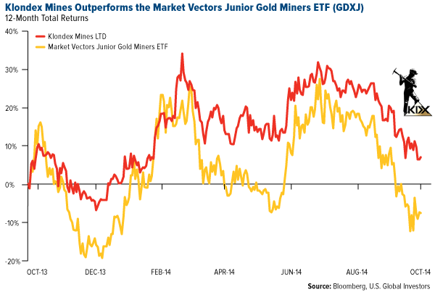
click to enlarge
On numerous occasions I’ve written about our research on the typical lifecycle of a mine, most recently in my whitepaper “Managing Expectations: Anticipate Before You Participate in the Market.” Below you can see the relationship between a mine’s lifecycle and the company’s share price.
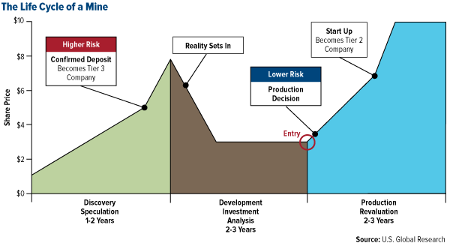
click to enlarge
As experts in mining stocks, it’s imperative for us to know which production stage the mine is in to manage our exposure to the company.
In the case of Klondex, its price action mimics the movements in share price based on the chart above, confirming our research.
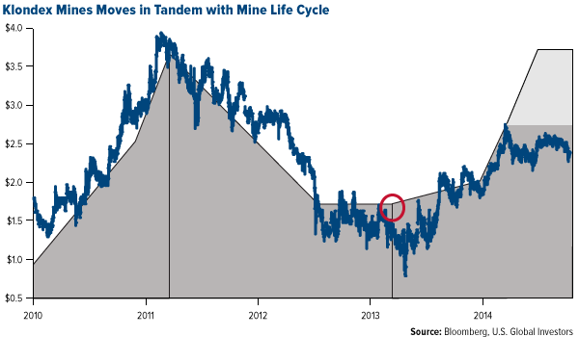
click to enlarge
It also supports the benefits of active management.
“When you buy an indexed fund, you’re basically just buying the market capitalization of those companies,” Ralph said. “You’re not getting the benefit of active management where we go out, meet the company’s management team and know its history. We’re familiar with the lifecycle of the mine in question, the money, the burn rate and the minerals the company is involved in.”
I couldn’t have said it better myself.
Speaking of Active Management…
Last week, I expressed my concerns about how the European Union is handling (or not handling) its fiscal and monetary mess. Because the EU is such an important region for the global economy, investors have become impatient with the bickering that’s stalled any clear solution to its slowdown.
This week I’ve been in Italy meeting with other global business leaders, while U.S. Global’s Director of Research John Derrick has been visiting and assessing Greek and Turkish companies such as Tsakos Energy Navigation, Jumbo, Turk Telecom and Turkcell.
Watch for our firsthand accounts of and insights on the European situation next week.

--

Gold and Silver Mining Shares and the Economic Mess Ahead
by Kenneth J. Gerbino - KenGerbino
Published : January 17th, 2014
2862 words - Reading time : 7 - 11 minutes
( 6 votes, 5/5 )

 |  | Article |  | Comments |  | Rating
Keywords : Banking Crisis | Bullion | Bullion Bank | Bureau Of Labor Statistics | Central Bank |Federal Reserve | Global | Gold | Gold Holdings | Gold Market | Gold Ownership | Gold Production |Gold Supply | Government | Great Depression | Italy | London Bullion Market Association | Metals X |Mining Stocks | Monetary System | Money Supply | Paper Money | Precious Metals | Purchasing Power| Recession | Unemployment |
Currently the mining shares are still selling at near record discounted values with the gold price in the $1220 range. At this point, even a sideways gold price could support a major rally in the gold mining shares.
North American gold shares are 43% undervalued based on the current gold price vs. the value of proven and probable reserves. Since 2001, any discount below 30% has signaled a major rally in the mining shares. Higher gold prices will then be another important driver to force values higher. Mining companies that have strong growth patterns and lower cost production profiles will have these items also as positive drivers of their share price.
Sea Change in the Mining Industry
As investment funds flooded the industry in the 2004-2008 period, many companies made a strategic choice and became growth conscious in terms of ounces produced and not profit conscious. Therefore there was a big push towards large tonnage deposits that had lower grade (richness per tonne) gold. These massive capital intensive projects sometimes requiring $2-5 billion in starting capital became the main focus of the larger companies. As many of my articles in the past have stated, the most important item to look at in a mining deal besides the management is the grade of the ore.
Low grade deposits create an environment where if anything goes wrong the project can be in trouble. High grade deposits make even bad management look good because the rock is so rich in gold (and profitability) that cost overruns in the engineering of the mine plan and processing plants are absorbed by so much more gold being recovered per tonne. Some of these mega projects have been put on hold in various parts of the world and many are basically on stand-by until the gold price recovers.
Today it now takes 9-12 years from discovery to production of a typical large mining project. This is much longer than years ago when I can remember a 6-7 year ramp up. What this means is that a significant sea change has occurred in the precious metal industry. During a period of time when the global money supply has exploded (when compared to historical averages) and banks are more overleveraged than in any previous decade, the availability of real money (gold and silver) is going to be curtailed dramatically in the future by a slowdown in mine supply. At the same time the forces at play that make investors and savers want to own precious metals continue to march onwards unabated.
Banking Problems
Imagine someone starting a bank and collecting $1 million in capital to open the business and then going out and leveraging that money by 40 times, placing $40 million in investments. If 3% of those investments failed, the bank would lose everything. Deutsche Bank, Credit Suisse and Societe General are three of the largest banks in the world. They are leveraged almost 40 to 1. Many of the investments being carried on their books are bond issues from insolvent EU countries that are possible default candidates. The 3rd largest bank in Italy and the world’s oldest bank, Banco Monte Paschi is again insolvent after the Italian taxpayers have spent $5.6 billion to keep it afloat.
The European banks have a funding gap of $1.7 trillion. This means they are that far behind “prudent” levels of leverage and even more vulnerable to loan losses. This leverage points toward a massive new bailout of printed money coming in the future.
Because of the international scope of the banking industry, many U.S. banks are very exposed to any monetary or economic hiccup in the EU. This means the Federal Reserve will not hesitate to break out the paper and ink if needed to help shore up the EU system since a problem overseas could also mean a problem here as well. The banking industry borrows money and invests that money but the money they are borrowing is money that another institution has leveraged themselves to lend. This is a round robin of dangerous leveraged money lending which can backfire when an economic slowdown, higher interest rates or a credit/confidence crisis develops as in 2008. This is one of the main reasons to own precious metals and precious metal assets in the ground via mining stocks.
In a recent interview, the European Central Bank’s new banking Chairman Mario Draghi (from Italy) was asked about Italy’s gold holdings, which are substantial. He gave an outstanding reply. With no back off he told it like it is, that gold is the best monetary asset a Central Bank could have and an important part of central banking. The Chinese, Indians and Arabs all understand this as well.
Central banks that have been flooding the world with paper and ink and calling it money have just completed their tenth consecutive quarter of net purchases of gold. They have accumulated over 180 tonnes of gold so far (latest available figures) in 2013.
Inflation
John Williams is a well-respected Dartmouth economist who runs a sophisticated economic website called Shadowstats.com. This website calculates the inflation rate in the United States based solely on the Bureau of Labor Statistics’ (the purveyor of the Consumer Price Index) old 1980 format before it was changed to either defy reality or hoodwink the country into thinking that inflation is really not a problem. Since 1993 – twenty years ago – the real consumer price index calculated the old way has almost tripled. Officially the CPI has “only” gone up on average 2.5% annually or compounded 64%.
Milk costing $2.00 going up to $2.05 next year is not the end of the world. But when this is compounded year after year it creates a lot of lost purchasing power for everyone. The media rarely report that people’s take home pay has not kept up with the rise in the cost of living because of the creation of paper money robbing them of purchasing power. They do report of the income inequality and blame it on capitalism or low tax rates but never the real culprit – paper money. These reports create incentive for politicians to do something to help people. This always involves creating or borrowing even more paper money. This slow motion increase of the CPI allows the establishment monetary players (the Fed and the Congress) to continue to print money and run huge deficits. They have now stepped up the printing and eventually one of the great inflations will show up in the United States.
Economic Problems for the Wage Earner
The loss of purchasing power for the average wage earner creates a political problem and that problem is solved by doing whatever the politicians can concoct to placate voters. The solutions to the lower standard of living for the wage earner is too somehow give him more of something else. There are now 47 million Americans on food stamps. It is irrelevant whether this issue is good or bad for the country. If there are people starving or families going hungry at a higher rate than anytime since the Great Depression it means more printed money and more debt. The food stamp issue relates to gold ownership. It is an economic indicator (see chart below) that people are much worse off than 10-20 years ago. Politicians both on the right and left will try and fix this by more deficits and printed paper.
Because of the loss of purchasing power of the lower and middle income earners more and more people are going to require food stamps. This will require even more government assistance and become another reason to print money or raise taxes that will slow the economy down and create more unemployment and even more food stamp recipients.
Unemployment continues to plague the U.S. Much of this is a direct result of two things: 1) Small business owners (who employ 65% of the work force) not hiring. If you own a small business and the economy slows down and your costs and taxes keep going up you have to cut back on your payroll. 2) The U.S. is overemployed to begin with. In the good old days from 1950 to 1975, the economy did well with only 31% of Americans working. Unemployment averaged less than 4% most of those years.
Now with a peak of 45% of the population wanting a job, there is just no room. Hence the government solution of printing even more money to try in vain to get this unemployment rate down. If the government would stop trying to over-regulate the economy and over taxing businesses, the economy and employment would improve dramatically. When you read about the thousands of bills (new potential laws) that are circulating in Washington you are reading about more control of people, businesses and the economy by lawmakers that are collectively unfit to govern.
Most businesses would hire more people if tax rates were reduced. It is an economic fact denied by the NY Times and Washington that when you lower taxes you increasegovernment revenue because more business takes place as more people employed contribute to the tax base. Lower taxes means small businesses hire more people. If you give millions of people a real job a multiplying effect takes place. These people pay taxes but they also spend their income and other businesses make more revenues and pay taxes on those profits. This is a positive spiral. Raising taxes causes a negative spiral. We are now in a negative spiral and that will be matched by three bad policies, higher taxes, more debt and more printed money. The price of gold assets will not ignore the obvious for too much longer.
The U.S. Economy
The U.S. economy is chugging along. With all the money creation it would be hard to see a recession coming any time soon. The stock market is strong with the Dow around the 16,400 level. This is actually a positive economic indicator as well as the copper price above $3.00. But the market is richly valued and deserves careful watching as a top may be in the works. As long as the “official” inflation rate stays below 3% all may be well for awhile. But the usual suspects always eventually show up and change things. The usual suspects show up in the following order:
- Inflation starts to increase and persists higher and higher month after month and quarter after quarter.
- Interest rates then follow the inflation rate.
- As interest rate rise higher and higher, businesses curtail capital spending and expansion plans that are usually financed with loans get shelved.
- Employment hiring slows down dramatically and then stops. Lay-offs increase.
- The slow-down in the economy is now in full swing coupled with higher inflation rates and since productivity is also lowered one has a classic situation of plenty of money floating around chasing less goods, contributing to even more inflation.
- As inflation expands so does the interest rate level and a vicious cycle is now in play. It is 1973-75 and 1979-81 all over again.
- A major recession ensues and the stock market retreats.
Normally investing in precious metals and mining stocks is a good idea when inflation is a persistent and perceived problem by the crowd on Wall Street. This is not the case presently but I expect the near term future to see the above scenario start occurring. But there is an even more important factor today at play in the owning gold rationale.
House of Cards
The banking and monetary system is a house of cards. The overextension and massive leverage of the intertwined global banking system was not prevalent in the ’73-75 or ’79-81 high inflation periods. Therefore this coming storm will have an even more upsetting result. It will not be a disaster. It will not be the end of the world economy nor will it be another Great Depression. It will be a high inflation period that could last a decade and a recession that could linger for 2-3 years. Coca cola, Big Macs and your favorite toothpaste and television shows will all be available – at a higher price of course. The world will move along. The system will not break down but asset classes will be volatile. The poor will get poorer and the rich will actually give plenty back as the credit and leverage problems backfire for many investments. Gold asset ownership will be the great lifeboat.
Monetary Leverage
Because of the banking system being corrupted by leverage, the money will be suspect because it is a leveraged paper asset with zero backing. A banking crisis can wipe out people’s bank accounts despite what the government may promise. Gold cannot be wiped out. Bank accounts can.
The current situation in the United States is as follows (and just as bad in most countries). There is only $1.2 trillion of currency in circulation but the U.S. money supply is almost $11 trillion. Where’s the beef? The answer is that no one knows what the future will bring but owning precious metal assets including the mining shares is good insurance and is a solid place to patiently wait for the inflation that is coming or the panic out of paper assets into something more tangible.
Asia
The Shanghai Gold Exchange is now in full gear and in just the first six months of 2013 physically delivered more gold than all the U.S Commodity markets combined. The amount equaled almost 40% of the entire world’s mine supply!
This is a sign of growing Asian demand that is expected to continue.
Bullion Dealers Hustling For Gold
Another major underlying fundamental to the gold supply and demand equation is something called the Gold Forward Offered Rate.
This is not understood by many but it is an essential part of the trillion dollar gold industry. In simple terms it means the following: If someone wants to borrow $1 million from a bullion bank, the bank lending the person money will charge interest on the loan as is customary. But in this loan scenario if the borrower would put up gold as collateral for the loan the bullion bank will actually pay the person some small interest rate (sort of like a rebate) on his/her gold. This interest rate is called the Gold Forward Offered Rate or GOFO. This means the bullion banks need current gold to satisfy obligations they have to deliver to the physical market. The last two times this happened GOFO rate was positive (2000 and 2008) a major rally occurred in the gold price and the mining shares. So look for this when you are online. It is a reliable indicator of a gold rally.
Global gold production is about 2400 tonnes annually. The London Bullion Market Association Precious Metals Clearing Company reports that every day, 9,020 tonnes of gold is traded. That’s about a trillion dollars every three days. The gold market is a robust and vibrant global market and most of the players are all circling around the same thought process regarding money. “Paper and ink under the control of governments or a gold bar?”
Portfolio Watch
Mining shares are extremely undervalued. What is commonplace on Wall Street when extremes are pervasive is a counter-trend materializes. The counter trend is usually a powerful reversal.
This reversal is primarily because of two reasons: 1) there are few if any sellers left and most of the shares are now in strong hands that realize that their downside is limited but their upside is well above average. This makes these investors continue to add to their position as well when the reverse trend starts; 2) Value and momentum investors are a large part of Wall Street. Value players are constantly searching for situations that show lots of value at a discount and eventually will find industries that may not have been on their radar screens in the past but are now flashing a green light. Mining shares are certainly in this category. Momentum players understand that the longer momentum cycles return the most rewards. Extremely discounted sectors on Wall Street usually last a long time since the natural return to normal values from such a steep discount would logically happen over an extended period of time.
There is also a third aspect to the above as well. Since we live in a world of economic uncertainty and a world where debt outweighs the money supply by a wide margin, there will always be a period in the future when gold and the mining stocks become once again front and center as an important part of an investment portfolio.
Market Vane is an important Wall Street sentiment research group. Regarding the gold mining shares the per cent of bulls to bears is at an extreme. The level is at 45% bullish. For gold, this is at the lowest end of bullishness. The last time the bullish consensus was this low was mid-2001, the beginning of the major seven year bull market in mining stocks.
There are enough indicators to allow one to feel confident that the mining stocks are going to move significantly higher in the future.
Kenneth J. Gerbino
www.kengerbino.com

--
The Hidden Reason Gold Stocks are Weaker than Gold and a New Discovery in Economic Theory
by Kenneth J. Gerbino
July 2011
In 2008, a horrible financial and economic contraction occurred that destroyed asset values, bankrupted financial institutions, had devastating effects on real estate and sent the world banking system into a tailspin.
This was a liquidity crisis. Since then, I have been thinking through the illogical and difficult concept of; how could there be a liquidity crisis when so much money had been printed beforehand? With money and credit available in abundance how could a liquidity problem even be possible? One would think that the more money the more liquidity. What was wrong with this picture? After a lot of thought, I have found the answer.
In the twenty years leading up to the 2008 U.S. crisis, the U.S. money supply (M1) increased by 87% and the M2 money supply by 171%. By any past standards these were huge increases in money supply. In Europe the monetary expansion was even more, with M1 increasing by 145% in only 10 years leading up to 2008. The great western world industrial countries were awash in cash, money, credit and liquidity. So how could a liquidity crisis materialize and asset values plummet almost everywhere?
The answer to this puzzle is actually a new economic theory; a discovery that I am naming The Gerbino Principle of Liquidity.
I have figured out the reason why more money can actually lead to less liquidity — not more — in a modern fiat paper money economy! I have named this new economic discovery, some may say, in an egotistical manner for two reasons; 1) I want to make sure that the source of this new economic principle is known — after all someone has to claim authorship, and 2) If anyone wants to refute it they will know who to go to.
This new theory has overwhelming importance to anyone who owns investments at this time, especially stocks, because the panic of 2008 is going to repeat again and possibly soon for reasons I will discuss later.
A liquidity crisis is not the credit cycle or a credit crisis, a business slowdown, a boom and bust economic cycle, a recession, or the business cycle. I will explain the differences of these events later in this text.
This Economic Principle or Law is something very different and never before explained by the philosopher/economists of the past or present.
Below is the Gerbino Principle and the explanation and logic behind this new economic discovery.
The Gerbino Principle of Liquidity
- Liquidity is eventually destroyed, not created by increases of fiat money.
- A financial liquidity crisis will always follow a prolonged period of fiat money creation.
- The more “paper” money printed or created by fiat the more severe the liquidity crisis will be.
- Future “offsets” * to the created fiat money supply could also create a liquidity crisis.
* Offset is a term used by central banks when they sell treasury securities to dealers (specific banks). As the dealers are required to pay for the securities they are sending money to the central bank. When these funds arrive at the central bank they have been taken out of the U.S. money supply. This money is now deducted from money in circulation. This is an offset. They have offset a past increase in the money supply. It is hard to believe that modern man would allow bureaucrats to not only create money out of thin air but to then have the authority to destroy it.
A liquidity crisis is when there is not enough money to satisfy the orderly liquidation of financial or real assets without creating a massive destruction of those asset values.
In simple terms: The Gerbino Principle is: The more fiat money the less financial liquidity.
A liquidity crisis is caused by too much money being created in an economy, not too little money. This is explained below.
A liquidity crisis is not a credit crisis. A credit crisis is a problem of solvency not liquidity. A credit crisis is when lenders are not lending to weak businesses, institutions or governments because of risk aversion. A credit crisis could start a liquidity crisis as assets are sold to meet short term insolvency problems and the selling begets more selling. But in the absence of fiat money a liquidity crisis would be impossible.
A liquidity crisis is not a business slow down or recession. This is where an over expansion has taken place by businesses and they now have to cut back and downsize.
The boom and bust economic cycle is also caused by an artificial expansion of money and/or excessive credit expansion. Fiat money causes this event also, but this is not a liquidity crisis. This is part of the business cycle which is caused by investment and overexpansion of plant and equipment by businesses usually induced by fiat money being pumped into an economic system but this is not a liquidity crisis.
The liquidity crisis relates to all of the above economic events but is unique in its short term and long term effects on real and financial asset values.
In 2006 and 2007 when the real estate markets in the U.S. and Europe started to top out there was no recession and no general business slowdown. But a liquidity crisis was born and became acute in 2008.
The Gerbino Principle Explained
With a paper or fiat money system, the more money that is injected into an economic system the higher the eventual price of consumer goods (inflation) and during this time the higher the prices of real estate and stock values – both values also responding to the new circulating money supply. More debt is also created (taken on by people, institutions and governments). If the money supply goes up by 5% consumer goods will go up by 5%, also increasing the prices of other assets like real estate and stock prices usually by 5%. Sometimes these real and financial assets increase even more as the increased money and credit create abnormal speculation.
It is counter-intuitive that more money would create less liquidity and this is why this concept has remained hidden from economic thinking in the past and in the modern era.
How the Principle Works
The new money drives up the prices of financial and real assets at somewhat the same rate of increase as consumer goods but since these financial assets have so much more market value to begin with, the per cent rate is not the key, it is the increase in the monetary value that is the key. Let me explain.
In the United States the values of the four main financial and real asset classes are as follows:
All US Stocks | $13.4 trillion
All Government and Commercial Debt | $36.0 trillion
Commercial Real Estate | $ 6.5 trillion
Residential Real Estate | $20.0 trillion
Total | $75.9 trillion
This huge monetary value of asset classes is supported by the circulation of only $1.9 trillion of the current U.S. money supply, M1 (cash plus checkable deposits). The ratio of these asset values to real liquidity (cash plus checking accounts) is basically 40 to 1. So if confidence is lost in the economy, financial structure or banking system and too many people who own these assets want to “lighten up” and “get liquid” there is literally not enough money to satisfy this desire.
You cannot fit $76 trillion of assets into a $1.9 trillion bottle
In a panic mode, this leverage of asset values to actual money available creates a crisis of liquidity. This in turn acts to create a downward spiral of prices from the liquidations (selling) and brings on more panic as balance sheets deteriorate and margin calls become the order of the day on Wall Street.
The increase of fiat money has distorted the ratio of money in circulation to asset values. This distortion becomes the Achilles Heel of asset values when confidence is lessened or severely impacted by economic or political reasons.
If there are more sellers than buyers of any asset class, even as little as 1-2% more sellers who are determined to “get out”, then as long as this small but determined group persists to sell an asset the further prices will erode. Eroding prices also begets more sellers and this continues until the sellers who want to cash out are satisfied or the asset prices become so low that new buyers come into the market and absorb the selling pressure with buying pressure, stabilizing the asset price.
As more money is created to handle a liquidity crisis (bailing out the politically connected as in 2008-2011), it sows the seeds for the next crisis as the new liquidity eventually pushes up prices of financial and real assets to a level that again cannot be sustained when for some future reason general business or economic confidence is lessened and another panic ensues. These panics can start from many causes:
- Loss of confidence in economic expansion and a fear of recession.
- Political mismanagement of economies.
- Inflation rates that are higher than expected and increasing, causing the liquidation of stocks and bonds.
- Large bankruptcies from overleveraged financial institutions as in 2008.
- Excessive speculation in asset classes like residential real estate in the decade leading up to 2006.
- International events like an oil embargo or major war.
When Times Were Better
In 1960, the United States had a more stable monetary system with much less currency debasement. The prior 10 years saw a relatively modest increase by today’s standards of 26%.
The value of stocks, government and commercial debt and residential real estate was only $1.7 trillion in 1960, and the money supply (M1) was $144 billion. This was only a 11.8 to 1 ratio of liquidity to these assets compared to a 40 to 1 ratio today.
Note: I have left out of this 1960 example, commercial real estate as it is the smallest component of the four major categories discussed earlier, as this value was impossible to verify in the 1960 period.
Since 1960 a 1,250% increase in money supply (1960 - 2011) has created an almost 4,000% increase in asset values. It proves the point that creating more money has allowed for a somewhat manageable ratio of liquidity to asset values of approx. 1 to 12 that persisted in 1960 to an untenable ratio of 1 to 39 today (note again that 1960 commercial real estate values are left out of this example).
The Late 50’s and early 60’s were pretty good times in America. Families were prospering, savings rates were up, new cars were affordable every 3-4 years, middle class wage earners could actually send their kids to college. A household with two working parents was the exception. Money and wages bought you a lot of goods and services.
One of the key distortions of fiat money is that it robs the purchasing power of the lower and middle income earners. Since 1960, teachers (a typical middle income earner) salaries have increased 9.7 times, but home values (even today) are still up 21 times. One can almost find any good or service and it will also be up 20-30 times.
Who is to Blame?
It’s a simple list; Liberals and Conservatives, Republicans and Democrats. They have all been duped by the banking elites and Keynesian economists.
Do Not be Scared of the Future
It is important to remember that money does circulate and sometimes in much greater amounts than the overall value of the money supply. In other words there could be $10 trillion of financial transactions in one week with only $1 trillion in money available. These liquidity crises are actually rare but will become more prevalent as more fiat money is created because the increase of the asset values far outpace the underlying per cent increase of the money supply.
Investor A, panicking out of IBM, for instance, and dumping the stock at any price, will end up with cash in his/her account. But that money will most likely go into a money market fund or be invested in U.S. Treasuries or a corporate bond. It will not sit there. Someone else who sells the Treasuries or the corporate bond to Investor A will now have that cash and now in turn can go and buy some other assets, maybe even IBM if he/she feels the price is right.
If Investor A’s cash from selling IBM is placed in a money market account, these funds in turn will be invested or lent to various institutions by the money market managers to earn an interest rate on the capital in the fund. If an Investor buys US Treasuries directly from the U.S. Treasury it will be spent by Uncle Sam and put into the system by government expenditure.
It is because of the money supply circulating in an economic system that some equilibrium of asset prices can usually be maintained. Selling by Joe is met by buying by Tom. Historically this has worked to restore prices to an economic equilibrium but with a cash to asset value ratio bloated by fiat money the equilibrium becomes distorted dramatically and invites a major sell off when confidence in the value of asset prices becomes widespread or a panic starts. Then a liquidity crisis develops.
At this time I would like to add that an equilibrium point in the value of an asset or asset class is reached when buyers and sellers are satisfied and most likely the return on the asset (rent, interest, dividends) is reasonably compared to the world one lives in. In other words, a condo valued at $200,000 that can’t be rented for even a 1% return is probably overpriced. Subjective and logical reasoning based on everyday life experiences and choices by buyers and sellers will eventually arrive at an equilibrium value in a normal economic environment. But in a liquidity crisis these values can be distorted dramatically.
Fiat Money A Bad Solution For Investors
With a cash to asset value ratio bloated by fiat money the equilibrium becomes dramatically distorted and invites a major sell off when confidence in the value of asset prices becomes widespread or a panic starts. Then a liquidity crisis develops. The start of the liquidity crisis can be caused by many factors but the underlying reason it persists is caused by fiat money.
The more money that is created the more ballooned are the values of various investment asset classes. A relatively small per cent increase in money supply can increase the value of these mentioned financial and real assets well beyond the increased per cent of the money supply.
A 5% increase to a money supply of $1.9 trillion is $95 billion more in circulation. As that $95 billion circulates within the economy it will eventually raise consumer prices by 5%, but it will also raise the value of real and financial assets. This 5% increase applied to the above $76 trillion of asset values (including commercial real estate) mentioned earlier can become $3.8 trillion (5% of $76 trillion) of increased asset values.
The arbitrary and artificial increase in the money supply creates a never ending problem of asset values expanding and then collapsing. Too much money creates too little liquidity when there is a loss of confidence in financial assets.
Today these asset classes, except real estate, are now more susceptible to a panic or asset sell off or another liquidity crisis. Real estate has been so battered because of the illiquidity of the sector to begin with coupled with the liquidity crisis of 2008 and beyond, that it may be close to an equilibrium level.
The fiat money system that creates liquidity crises also destroys purchasing power of the lower and middle class. No where is this more pronounced than the last 50 years. In 1960 typical middle income wage earners were school teachers. Their salaries in 1960 were $5,175. The average home in 1960 was $12,700. Since then school teacher salaries have gone up approx. 10 times. But the average home price, even after the sell offs of the last few years, as of last month have increased 21 times. Fiat money has destroyed the purchasing power of the average American.
This Principle of Liquidity also is another reason why gold is going up, as it is the ultimate liquid financial or monetary asset. If one wants liquidity with no strings attached, gold is it. The asset class that will be left standing in any crisis will be precious metals - gold and silver.
The Mini Liquidity Crunch in the Precious Metal Mining Stocks
I believe the gold and silver mining stocks which are presently very undervalued against the high prices of gold and silver are currently experiencing a mini liquidity crunch (a distant cousin of a crisis) within the realm of gold and silver mining investors.
These investors have only so much inclination and money at their disposal to buy these mining stocks. But the supply of new mining deals, IPO’s, new financings and private placements have stretched and somewhat overwhelmed the buying power of this relatively small group of international players (individual investors and institutions with an appetite for mining stocks).
An exhaustion of capital allocated to this sector by these players has occurred and has also been diluted further because of the newly created family of associated asset classes like uranium, base metal and rare earth companies. It is simply a matter of a limited amount of money and too many companies. Until more players (and capital) come forth on this stage, this sector could languish at what appears to be excellent and undervalued stock prices. Only the best growth and value mining stories will do well until new players arrive with more capital to invest.
This Principle may also explain why U.S. Treasuries (1-5 year paper) is relatively very strong while it is paying so little interest. It could be because buyers of these bills and bonds can rely on being able to cash them in at a fixed value at maturity as opposed to not knowing what the price of IBM or a duplex apartment will be worth in another full scale crisis or sell off.
The Next Crisis
What will cause the next liquidity crisis is unknown, but the U.S. and Europe are being set up for one to occur because of the continued reliance of fiat money to bail out debtors, the banking system, and government deficits.
German, French and British banks have $1 trillion of exposure to Portugal, Ireland, Greece and Spain, the so-called PIGS. A large per cent of these loans are suspect and due to this a race to liquidity in Europe could start at any time.
After the 2008 crisis another stock market rally occurred, 2009-2011. This was because massive amounts of fiat money were injected into the U.S. economy by the Fed. From January 2008 to May 2011, the U.S. money supply has seen the greatest short-term increase in history, 41%.
Because of this, financial assets again will rise and eventually real estate will also rise probably very slowly (based more on supply and demand as opposed to the rampant speculation of the last pre-2008 decade).
Final Thoughts
The lesson to be learned is that the more money created the more severe the next liquidity crisis will be and that the more money created the less liquidity there will be for financial and real assets to withstand any sort of liquidation panic as the extra money cannot come close to the asset monetary value created by the circulation of that extra fiat money. This is the Gerbino Principle of Liquidity.
This phenomenon has been in plain sight for decades and our good friend Sir Arthur Conan Doyle said it best....
“There is nothing more elusive than an obvious fact.” — Sherlock Holmes.
These liquidity crises are disruptive and dangerous and are caused solely by fiat money which has caused major distortions in modern economies. End fiat money creation and you will end future liquidity crises that disrupt and cause havoc to modern economies.
Kenneth J. Gerbino

Gold Mining Stock Account
An Account to Balance Your Inflation/Deflation Future
Minimum Account Size: $250,000. Annual Fee 2.0%
A Growth Industry and a Hedge for Wealth Preservation
Your account will be managed at the Private Wealth Management division at the UBS branch in Beverly Hills, California. The gold mining stock account offers you the following benefits:
- Opportunities from a basic industry – mining
- Growth from new mine openings and developing new deposits
- Value in the ground from billions of dollars of recoverable minerals
- Hedge against inflation or economic uncertainty
- Insurance against too much world debt and money creation
- A balance to your other financial assets
- Increasing demand from newly industrializing China and India
- Portfolio Insurance with the most trusted of all global assets — gold
Your individual account will have a well-diversified and extensively researched portfolio of precious metal mining stocks. The account will be invested in large, medium and some small mining companies but with very large deposits measured in billions of dollars. We have no interest in risky small exploration stocks, small mining deposits or small operating companies.
The Gold Mining Stock Account uses two proprietary in-house computer programs to arrive at valuations for mining companies. One program is designed for major and mid-tier producers and the other is for developmental companies. Qualified developmental companies are mining companies with a major project usually with $2-10 billion worth of mineral resources.
We believe our developmental mining company valuation program is one the most sophisticated program of it’s kind in the world. It encompasses over 340 separate line items of information on a mining company as well as each individual project that the company is developing. This allows us to do our own in-house geological and engineering assumptions usually between 9 and 18 months before Wall Street guidance.
We believe this program and 37 years of experience investing in this sector allows us a significant advantage to identify quality projects at good values. The Account invests in companies with significant deposits of gold, silver, platinum, copper, zinc, lead and other metals, but mostly precious metals.
Strict rules and regulations from the S.E.C and the Canadian authorities prohibit various corporate statements regarding categories of resources and reserves and the economic viability of projects. Our experience in this sector, with the hard data guidance of our computer model and our extensive contacts with professional engineers and geologists allow us to run our own valuations and scenarios that can show a major deviation from the public market place valuations of a company or it’s projects. Sometimes the valuation by the market is too rich and we avoid these stocks. Many times the opposite is true and we take advantage of these situations.
The Account does not invest in any grass-roots exploration companies. This category is a crapshoot and is responsible for the bad reputation of the gold and precious metal mining sector. We only invest in companies that have properties with significant amounts of drill inferred resources. Usually our minimum cut-off is our own estimate of a minimum of 2 million ounces of gold or other precious metals or $4 billion worth of potential base metals.
To protect assets from political, economic and monetary uncertainty and instability -- including inflation or deflation and the repercussions of excessive government debt or currency depreciation -- we offer our Gold Mining Stock Account. Even with the rising levels of paper money, government debt and market speculation, it is still highly unlikely that an "unthinkable" economic accident could happen in the short to medium term, but just in case, history has shown that no matter what the economic situation, the long-term purchasing power of gold remains intact, which makes it a potentially important insurance or "hedge" for a portion of your net worth.
With the accelerating modernization of China, India and other developing countries, global demand for gold has significantly outpaced world mine output for many years, and we feel this established long-term trend will transform gold, silver and base metal mining into an attractive growth industry. China is now the largest consumer in the world of copper, zinc, lead, aluminum and soon nickel. A possible multi-decade demand increase in resources is developing that has never been experienced before.
Gold Equals Opportunity
Jewelry demand for gold alone continues to exceed mine production year after year. As progress and industrialization spreads to more and more areas of the world, gold jewelry, even in small and seemingly inexpensive pieces, adds up to millions of extra ounces of gold demand each year. For the majority of the last decade, gold jewelry demand alone has outpaced all world gold mine production.
Gold is also a time-honored global monetary asset. Government policies all over the world are many times devised for political gain, not economic health. Hence, in a world where in over 100 countries the local currency as a store of value is a speculation at best, gold is important. Various governments of the world continue to print money every day, to the tune of billions of dollars per week. By owning gold mining stocks, one in essence owns gold in the ground, an ideal investment in this climate. Globally the $570 trillion derivative market and the effects of a $12 trillion U.S. national debt are simply unknown, but a little caution never hurt when it comes to preservation of capital. Long term, gold has always proved itself to be a good place for a portion of one's assets.
Deflationary and Inflationary Hedge
During the greatest deflation in our recent history (1929-36) gold mining stocks went up in value. Homestake Mining shares went from $40 in 1926 to $544 in 1935. Gold as a store of value (inflation hedge) also works well. For example from 1977 to 1980, when inflation averaged 9% per year, many gold mining stocks went up 3-5 times in value. Gold mining stocks offer investors an opportunity to own companies that literally are mining "cash."
The Undervalued Resource
In 1973 the price of gold was $100/ounce and the Dow Jones was 1000 -- a ratio of 1 to 10. Gold was undervalued. In 1980 the price of gold was $800/ounce and the Dow Jones was 800 -- a ratio of 1 to 1. Gold was overvalued. At this writing gold is approximately $1400 per ounce and the Dow Jones is approximately 11,000 -- a ratio of 1 to 8. Gold appears undervalued again. This simple ratio compares the basic centuries-old yardstick of real asset value (gold) to a reliable index of corporate value (Dow Jones). Currently, the ratio shows gold to be still undervalued.
A Summary of Benefits of Your Gold Mining Stock Account Portfolio
It is an excellent time to open your Gold Mining Stock Account and prepare yourself for what we believe will be a 5-10 year major bull market for gold investments. Below is a summary of the chief benefits to be gained from this type of account:
Gold Mining Stocks Offer Growth Potential
Gold mining companies can increase profits substantially with no increase in the price of gold. Mining companies, by putting more mines into production, achieve higher revenues and profits when the new mines go on line. Expansion can also take place when mining companies renovate and upgrade existing mines and increase production.
Gold Mining Stocks Represent Real Value in the Ground
From a value standpoint, gold reserves in the ground are like having money in the bank. Also, most mining companies have properties containing a large gold resource which has been drilled and tested but not yet formally added to reserves. This represents hidden value not reflected on their balance sheets. Mining companies also own and lease vast tracts of potential mining land where gold has already been discovered, but where no advanced developmental work has been performed. As gold prices go higher or even remain level at prices above $850 an ounce, many of these properties could become mines. These also are "hidden assets."
Allow Our Industry Experts, Engineers, Geologists and Consultants to Work for You
Kenneth J. Gerbino & Company follows and studies the Canadian and North and South American as well as the African , Chinese and Australian mining industries. We review and research hundreds of mining companies per year. Our exclusive and extensive database is updated by continuous survey of expert industry and company contacts. In addition to our in-house expertise, we have an extensive network of mining people, including engineers, geologists and consultants, to refer to when researching a company.
We feel that the price of gold will rise on balance throughout the next 5-10 years as global jewelry and investment demand continues to far outpace world mine supply. Asian demand will also continue to accelerate, driven by population increases and strong economic growth.
The Gold Mining Stock Account will offer you exposure to gold, silver and some base metal companies that we feel have exceptional growth and value opportunities. This growth is based on the world demand for these resources and also because of the excessive amount of debt and currency increases (printing of money) that has prevailed globally, and in our opinion, to very uncomfortable levels.

