http://seekingalpha.com/article/3115306-barrick-gold-a-contrarian-point-of-view?auth_param=c838:1ak4bnp:31cedf838a2aa821ddba383badaa3b85

Barrick Gold: A Contrarian Point Of View
Apr. 29, 2015 9:23 AM ET | 11 comments | About: Barrick Gold Corporation (ABX)
Disclosure: The author has no positions in any stocks mentioned, but may initiate a long position in ABX over the next 72 hours. (More...)

Summary
- There are bears a plenty that are saying "sell" Barrick because of the debt it has on the balance sheet, but they fail to understand the company's true financial position.
- Barrick does have a lot of debt due to blundered acquisitions and capex overruns, but the debt is longer term and it has the ability to pay this down.
- Barrick trades at half the market cap of companies that have similar net debt levels and operating cash flow.
- The operating cash flow that is generated from its core mines, as well as asset sales and reduced expenses, will lower this debt burden.
- It's time to buy Barrick.
I have been bullish on Barrick Gold (NYSE:ABX) for the last 6 months or so. That's not an enviable side of the trade to be on as the price of gold has been languishing near multi-year lows and there are bears a plenty that are saying "sell" Barrick.
The company has many detractors given the failure of Pascua-Lama and the total bust of its Equinox acquisition. These two events resulted in Barrick's balance sheet being stretched to the limit as debt has soared. Many critics always harp on these debt woes. But "the street" is wrong on Barrick, as usually is the case when the herd piles on to one side of the trade. Debt is only bad if you have no ability to repay it, and for some reason many believe that Barrick doesn't have this ability. That's the fallacy of the bear case.
While there are some bullish articles on the company here on Seeking Alpha, I find the majority that have been written are either neutral or just outright bearish. Here are some of the more negative ones from the last 6 months or so:
After Losing Half Of Its Value, The Largest Gold Producer Is Still A Sell
Is Barrick Gold A Candidate For Bankruptcy?
Update: The Case Against Barrick Gold
The Case Against Barrick Gold - Part 3
The Case Against Barrick Gold - Part 2
The Case Against Barrick Gold
Gold Market Dynamics And Problems In Zambia Make Barrick Gold A Risky Investment
Avoid Barrick Gold At This Time
Barrick Gold: Pascua-Lama Status Is Disturbing
Barrick Gold May Have Difficult Times Ahead
Barrick Gold: Ultimate Value Or Dud?
A Few Reasons Why Barrick Gold Is Not A Good Investment
The main concern that all of these articles bring up is the debt load that Barrick has amassed. Other issues are discussed as well and used as part of the bearish thesis. But most of these articles really don't give an accurate picture of the current situation Barrick is in and how it's able to deal with these issues.
As for the "analyst" community at the investment banks, while not a lot of them have sell ratings on the stock, many are in the neutral camp. But a neutral rating from an analyst might as well be a sell in my book, as it's rare for these firms to be negative on the whole. They don't typically issue outright "sell" ratings when things go bad.
Look at the drastic difference in ratings today on Barrick compared to just 3 years ago.

February 2012:
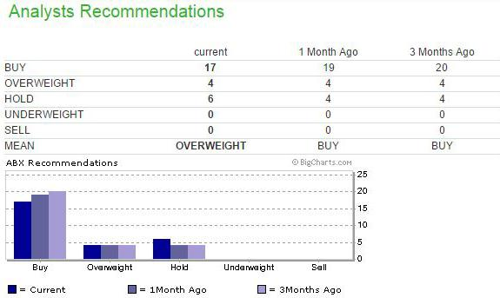
(Source: MarketWatch.com)

Today:
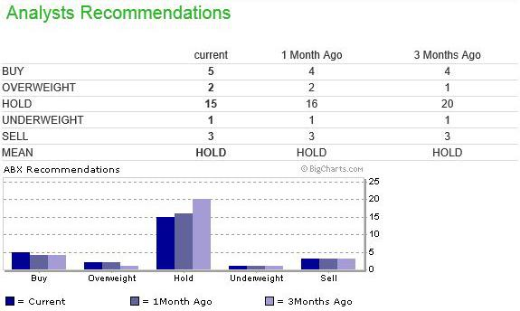
(Source: MarketWatch.com)
And here is a little taste of what is being said by these analysts. While you are reading this, keep in mind these investment banks had buy ratings on Barrick a few years ago. Those turned out to be wrong, just like these sell ratings will be:
Deutche Bank downgrade in November 2014 to sell, citing:
Despite an operationally solid 3Q14, we (again) are increasingly concerned on Barrick's ability to deleverage its balance sheet given headwinds facing the gold price, dimming prospects for its copper business and lack of strategic action on partnerships.
RBC downgrade in January 2015, citing:
ABX's debt-to-total-capital ratio is 45%, so its financial leverage is higher than average, and points to market concerns about how ABX will fund future capital and repay debt.
ABX needs to generate excess cash to reduce its ~$13B in long-term debt through the sale of non-core assets or from free cash flow, as well as create operating joint ventures for its copper and gold mines, or negotiate strategic financing agreements.
Canaccord Genuity with a Sell rating in February 2015, citing:
Barrick is trying very hard to recreate the magic of its youth ("Back to the Future" analogy used). Unfortunately the DeLorean may not fly as planned with some of the parts being sold off for scrap and the car somewhat heavier, burdened by a massive debt load. The fuel source is also suspect with the flux capacitors forced to run on very minimal free cash flow (at spot) and given the larger-than-expected sustaining capital.....Overall, we applaud management's new vigor and alignment, unfortunately the magic of youth is unlikely to return. ABX is losing the weight it needs but it remains mature with a rapidly declining production profile that will need to be addressed. The value destruction from asset fire sales needs to stop. We believe ABX should use its current strong NAV multiple for M&A."
Macquarie Capital Markets downgrade to underperform in January 2015,citing:
Miners are known for their ability to dig holes; big miners dig big ones. Barrick, the biggest gold miner on the planet, however has dug itself into a huge financial hole that is going to be difficult to get out of any time soon unless metal prices improve.
The investment banks are focused mostly on the debt as well. This negativity towards Barrick isn't just because the price of gold has declined, rather it's because of the company's balance sheet.
The stock is off of its lows from late 2014, but it's still down significantly from where it was at 3-4 years ago. And sure enough, everybody is piling on to the bear side and saying "sell, sell, sell." Where were these calls 4 years ago? Following the herd will get you nowhere and it sure won't make you any money.
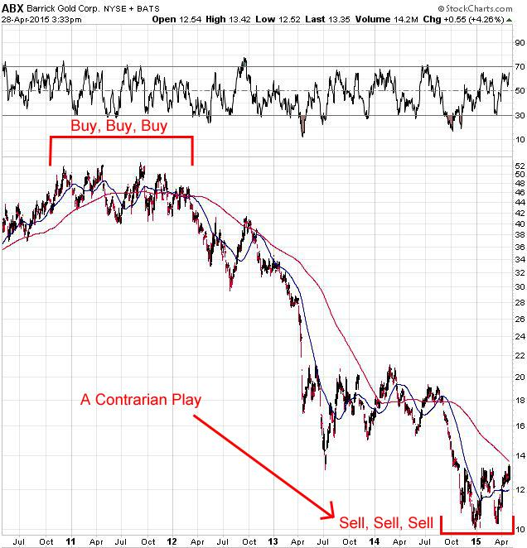
(Source: StockCharts.com)

Upon Closer Inspection...
Below is a look at the balance sheet of Barrick going all the way back to 2010, just before troubles started. There is no need to go into great detail here, focus on the four main areas that I have highlighted. Cash is still strong at $2.7 billion, but PP&E value has declined due to write-downs, and long-term debt has doubled. This has caused the Net Tangible Asset Value of the company to decline significantly over the last 3 years.
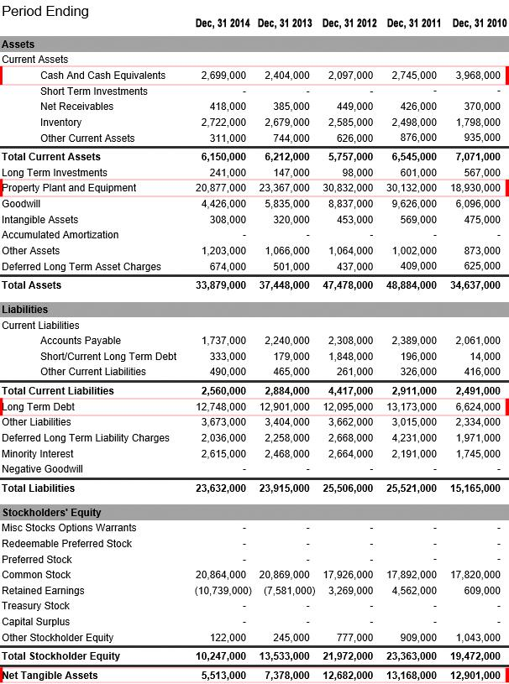
(Source: Yahoo Finance)
Since the concern is the debt on the balance sheet, let's break it down. The majority of this debt is longer term in nature; Barrick only has modest repayments over the next 6 years. There is $2.8 billion in debt due between now and the end of 2019, which the company can almost cover given the cash on hand.
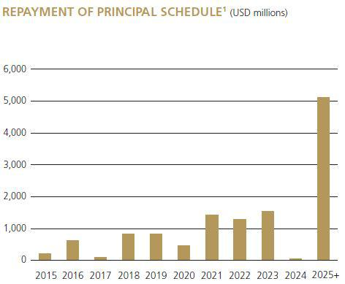
(Source: Barrick Gold)
However, there is still about $10 billion more of debt due in the future, plus you have all of the interest on this debt. Barrick's average interest rate is probably about 5%, which means the interest payments alone right now are about $650 million per year on this $13 billion of debt.
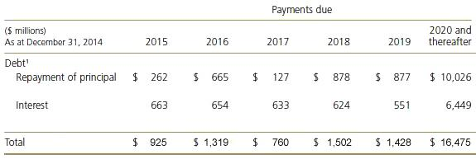
(Source: Barrick Gold)
So if we include interest, the company is on the hook for $5.9 billion in debt repayments through 2019, plus another $16.5 billion from 2020 and thereafter. Given that Barrick only has $2.7 billion in cash, its situation doesn't look that great. The problem is anybody analyzing Barrick's debt balance and making an assumption that the company is facing serious issues is flat out wrong. As I mentioned earlier, debt is only bad if you have no ability to repay it.
Barrick also has a $4 billion credit facility, but that's just replacing current debt with new debt, it's not really solving the problem. However, it does give it more time if needed.
The fact is the bears and analysts don't understand the company. They don't understand the assets that Barrick owns, because if they did they wouldn't be so concerned about this debt.

A Comparison Test
There are many companies that have similar debt levels to Barrick, yet they have strong buy ratings on their stocks and much bigger market caps. American Airlines (NASDAQ:AAL), Hilton (NYSE:HLT), and T-Mobile (NYSE:TMUS), just to name a few.
If we just compare the balance sheets of those companies, Barrick is the strongest by far as Net Tangible Asset value is much higher compared to the other three.
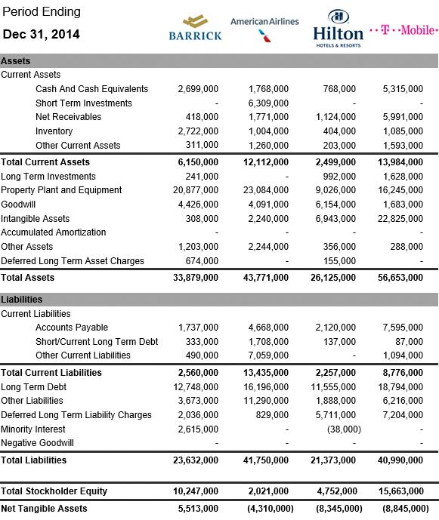
(Source: Yahoo Finance)
But even though Barrick has a higher Tangible Asset value, and the same net debt as the other three, the company is trading at basically half the market cap as the rest of the group.
 | Barrick Gold | American Airlines | Hilton Hotels | T-Mobile
Market Cap | $14.9 B | $35.8 B | $29.7 B | $26.9 B
Net Debt | $10.1 B | $9.8 B | $9.9 B | $11.9 B
As you can see, Barrick also has been generating similar operating cash flow as well. So you have to ask why is Barrick's market cap so low?
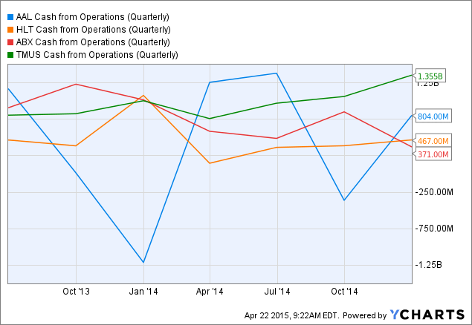
AAL Cash from Operations (Quarterly) data by YCharts
Barrick is plenty capable of generating the same amount of operating cash flow as the companies above. In the end does it really matter if a company is selling gold or hotel rooms or airline tickets or cell phone service? It's all about the numbers. Can a company, whatever it sells, generate cash flow? Or maybe I should ask does it have the ability to generate enough cash flow to pay off its debt? For Barrick, the answer to that question for is "Yes."

How Barrick Can/Will Pay Down This Debt
Now that I have explained what the situation is with Barrick, it's time to lay out how the company can/will reduce its debt burden. There is a three pronged approach here:
- Cash flow from operations
- Asset sales
- Reduced expenses

1. Cash Flow From Operations
I have been following gold stocks for years and years. Thousands and thousands of hours of research have gone into my search to find the top companies in the sector. I can unequivocally say that Barrick has the best gold assets in the world. You will not come across another company that has a better group of mines and projects, it's as simple as that.
If you just look at the reserves for the largest gold producers, not only does Barrick have the most gold in the ground, but it also has the highest grade. Barrick has almost double the reserves of Goldcorp (NYSE:GG), and almost 50% higher grade as well. Yet Goldcorp has the bigger market cap. I don't want to take anything away from Goldcorp, it does have a very nice stable of assets that most gold companies would die to have. It just doesn't come close to Barrick's portfolio. Newmont (NYSE:NEM) has almost the same amount of reserves as Barrick, but again, look at the difference in grade.
 | Gold Reserves | Reserve Grade
Barrick Gold | 93.1 million | 1.37 g/t
Newmont Mining | 88 million | 1.04 g/t
AngloGold | 57 million | 1.32 g/t
Goldcorp | 50 million | 0.95 g/t
Kinross | 34 million | 0.72 g/t
This high reserve grade gives Barrick a huge edge when it comes to cash costs, as its all-in sustaining costs is the lowest out of all the major gold producers. In fact, Barrick has one of the lowest AISC in the industry. That's a pretty powerful combination when not only are you the largest gold producer in the world, but you also have one of the lowest cost structures in the sector. 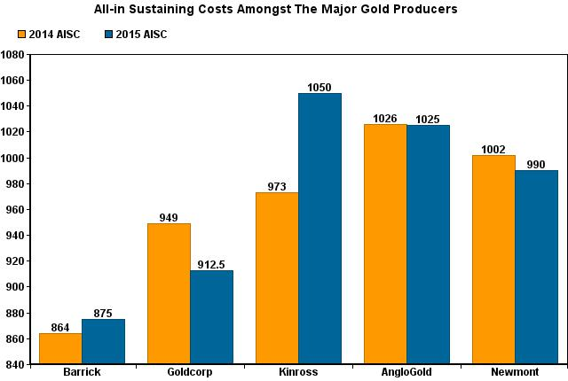
(Source: Author)
You have many companies just struggling to make money at $1,200, Barrick has margins of $325 per ounce at that gold price. If you factor in the 6.4 million ounces of gold production that the company is guiding for 2015, that's $2.1 billion of pre-tax operating cash flow just from the gold side of the business. Barrick also produces about 500 million pounds of copper per year, which will probably generate about $200 million of operating cash flow for 2015 at current copper prices.
It's these assets that the company owns that will allow it to reduce the debt load. This is what the street is missing, this is what they don't understand. All the bears are doing is looking at the debt and completely ignoring Barrick's glorious asset base.
The company has many standout assets in its portfolio, but it has a handful that it refers to as its "core" group of mines. Those being Cortez, Goldstrike, Lagunas Norte, Pueblo Viejo, and Veladero. These 5 mines make up 60% of the company's production, and they are very low cost operations with tons of reserves. This group also generates a substantial portion of Barrick's total operating cash flow.
 | 2014 Production (oz) | 2014 AISC | Reserves (oz)
Cortez | 902,000 | $706 | 9.8 million
Goldstrike | 902,000 | $854 | 9.6 million
Lagunas Norte | 665,000 | $588 | 2.8 million
Pueblo Viejo | 582,000 | $543 | 9.3 million
Veladero | 722,000 | $815 | 4.7 million
Total | 3,773,000 | $716 | 36.2 million
Turquoise Ridge is being referred to as a core mine in the making by the company. It contains 4.5 million ounces in reserves (75% basis) at a very high grade of 16.9 g/t. The company is advancing a project to develop an additional shaft which will almost double production to 500,000 ounces per year on a 100% basis, at all-in sustaining costs of about $625-$675 per ounce. The total capex is only $300-$325 million (100% basis). Construction could begin later this year, with initial production in 2019. So in a few years you can probably add this mine to the "core" list above.
 | 2014 Production (oz) | 2014 AISC
Turquoise Ridge (75%) | 195,000 | $628
Barrick has several other mines in operation that can generate a good amount of cash flow at current gold prices as well. But their overall costs are much higher on average. I will discuss these more below under "Asset Sales."
But it's not just the current core operations that are important, it's also the massive projects that are waiting in the wings that would be part of this core group of mines as well.
Pascua-Lama is located on the border of Chile and Argentina, high up in the Andes mountains, and is approximately 10 kilometers from Barrick's Veladero mine. It's probably one of the most challenging gold projects ever built, or at least attempted to be built. Pascua-Lama has been a disaster though, as Barrick spent $6 billion on the mine yet it's sitting idle. The problem is capex costs kept soaring. They started out at $2.8-$3.0 billion in 2009, and by 2013 they had exploded to $8.0-$8.5 billion.
Barrick decided to halt construction as it just couldn't take the chance of spending another $2.0-$2.5 billion to complete the project given all of the cost overruns and the uncertainty related to legal and regulatory requirements in Chile.
But Barrick isn't throwing in the towel on Pascua-Lama, this is an asset after all that has $6 billion of capital spending on it already. Just look at all that infrastructure below.
(click to enlarge)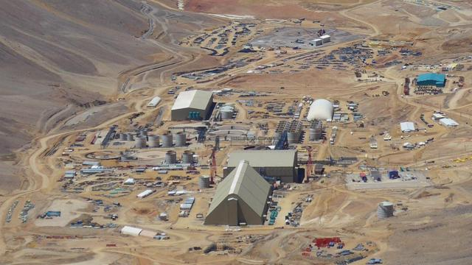
(Source: Barrick Gold)
In the company's Q4 2014 earnings release, it stated the following:
Over the last six months, we attracted 12 new leaders to Barrick who personify the company's original values and bring vital skills and experience that support our business objectives, such as strengthening the balance sheet, fixing Pascua-Lama, improving efficiency and productivity and building partnerships in China and beyond.
The project will definitely be completed at some point in the future. This is a massive mine and it contains one of the world's largest gold and silver resources, with more than 15 million ounces of proven and probable gold reserves, and 675 million ounces of silver contained within the gold reserves. Annual production in the first five years is expected to average 800,000 to 850,000 ounces of gold and 35 million ounces of silver at a cash costs of under $200 per ounce of gold. The expected mine life is 25 years.
When Pascua-Lama comes online, it will be another "core" operation for Barrick. In fact, it will probably be the top producing asset in its portfolio. And it might not have to spend that $2.5 billion to bring it online either, as it is exploring having a partner come in on the project.
Barrick also has the newly discovered Goldrush deposit in Nevada that is right next to its Cortez Hills mine. It is one of the largest and highest grade gold discoveries of the last decade and it already contains 15.6 million ounces of gold resources. Barrick is advancing the project and a pre-feasibility study should be complete by the end of 2015. This could easily become a 500,000-1,000,000 ounce per year mine, and another core operation for the company.
You also have the Donlin Gold project, the Lower Zone project at Cortez Hills, and the Spring Valley project. Barrick is also looking at mining the refractory ore body below the current oxide ore body at Lagunas Norte, which will greatly extend the mine life of that core asset.
There are basically 5-6 mega projects that could generate a significant amount of cash flow. Nobody is saying all of these will be built, but Barrick can continue to evaluate these assets and pick which ones offer the best return at the moment. Either way Barrick is definitely going to have at least one new core mine in production in the next several years.
The bottom line is all of these assets I just discussed are extremely high quality capable of generating tremendous amounts of operating cash flow.

2. Asset Sales
Barrick announced in February of this year that it's committed to debt reduction of at least $3 billion by the end of 2015, mostly via asset sales. It has disclosed that the Cowal mine in Australia and the Porgera joint venture in Papua New Guinea are both up for sale at the moment. Many companies are interested in purchasing these, and detailed due diligence is now taking place on both assets. This includes potential buyers making site visits.
Cowal has solid production, a low AISC, and a good amount of reserves and resources left. Barrick should be able to sell this asset for a decent amount of cash. The reason this mine is on the block, even though it generates a lot of cash flow, is because Barrick wants to focus on the America's. Porgera produces about 500,000 ounces of gold per year, but has a higher all-in sustaining costs.
Any of the other mines listed below could also be sold because they are considered non-core assets by Barrick.
 | 2014 Production (oz) | 2014 AISC
Porgera (95%) | 493,000 | $996
Kalgoorlie (50%) | 326,000 | $1,037
Acacia (63.9%) | 470,000 | $1,105
Cowal | 268,000 | $787
Hemlo | 206,000 | $1,059
Round Mountain (50%) | 164,000 | $1,170
Bald Mountain | 161,000 | $1,070
Golden Sunlight | 86,000 | $1,181
Ruby Hill | 33,000 | $713
Acacia Mining (OTC:ABGLF), which used to be called African Barrick Gold, is 63.9% owned by Barrick. Acacia is a public company and trades on the London Exchange. The stock has tripled off of the lows of 2013, which means Barrick's equity stake has increased in value tremendously. Right now Acacia has a market cap of $1.83 billion, that's $1.17 billion for Barrick's share. In 2014, Barrick sold 10% of its stake in the company, generating $186 million in cash. So this is definitely an option as far as monetizing this asset some more or in full.
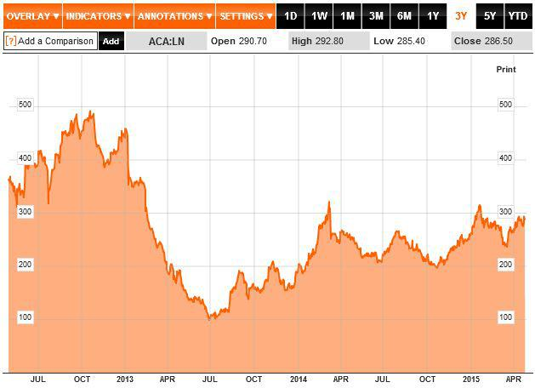
(Source: Bloomberg)
Barrick also just announced in its Q1 results press release that it has begun the process for the sale of a stake in the Zaldívar copper mine in Chile. Zaldívar is expected to produce 230-250 million pounds of copper at C3 cash costs of $2.00-$2.30 per pound in 2015. The mine can generate a lot of free cash flow at current copper prices, and it has been a consistently strong performer. With 5.5 billion pounds of copper in reserves, it's no wonder that potential buyers have expressed a strong interest.
According to Reuters:
Barrick is being advised on options for Zaldivar by the boutique firm of mining rainmaker Michael Klein, in a deal potentially worth around $2 billion, three sources familiar with the matter said.
Barrick did not say how much of Zaldivar it was planning to sell but said there has been "strong interest" in the asset.
If Barrick can sell part of Zaldivar for $2 billion, and sell Cowal and Porgera for somewhere around $1.1-$1.2 billion (which is what they are estimated to go for), then it will hit its goal of reducing debt by at least $3 billion for 2015.
This takes the company's net debt down to $7.1 billion, and you still have Acacia which could be sold off for at least $1.2 billion, as well as a few of the other non-core mines that could be monetized.
You might be looking at $5 billion in asset sales when this is all said and done. Even if Barrick gets rid of these operations to pay down the debt, it still has its core group of mines that generate the majority of the operating cash flow. Plus, it has all of those massive projects waiting in the wings that will eventually increase production again. In the end, you are effectively replacing high cost mines with low cost mines. And banking a lot of cash by selling off these non-core assets in the process, which in turn will be used to pay down the debt.
Again, if the bears understood the assets that Barrick owned, they wouldn't be bears anymore.

3. Reduced Expenses
Barrick has implemented a lean, decentralized operating model to generate more free cash flow. The company's G&A had ballooned higher over the years, now it has put that in reverse. It has reduced the size of its head office in Toronto by close to half, from 260 positions in 2014 to 140 positions in 2015. All management layers between Toronto and the mines have been eliminated as they were deemed unnecessary and created constraints. The company says:
What remains are shared service centers in the field that provide support directly to our mines and projects. These costs will no longer be reported as G&A. They will be charged directly to the mines and projects that use the services, and will be reflected in operating costs, as they should be.
Barrick expects to realize $30 million in savings for 2015 from this reduction in head office personnel, and that figure will increase to $70 million in annualized savings by 2016.
It has also implemented a strict new capital allocation program where it expects its mines and any projects to deliver a 10-15 percent return on invested capital. Anything that can't meet that hurdle will be deferred, cancelled or sold. Barrick is effectively making its operations/projects compete for this capital, and there is no limit on how much a mine can obtain. In other words, this is a survival of the fittest and money will flow to mines that have the highest returns.
The company has already identified $200 million in capital expenditure reductions for 2015 because they didn't meet that 10%-15% ROI, and Barrick expects to see further reductions in capex as it proceeds with these evaluations. This means that capex for 2015 will be $250-$300 million lower from last years levels.
Barrick has also launched the "Value Realization Project", which is basically a top to bottom analysis of operations that it owns. The purpose is to find ways to maximize free cash flow by looking at the economic potential of every mine and identify specific projects that could help lower costs and/or increase production.
These reviews are well underway for 10 operations, including its five core mines. The company has already identified a number of ways to increase cash flow in the future at Pueblo Viejo. Barrick is also performing these reviews on its non-core assets that are for sale to ensure it understands the full value of every mine before it sells it.
All of these programs that Barrick has implemented are significantly reducing annual expenses. You are talking at least a couple hundred million per year that the company will be saving. Half of the interest that Barrick is paying on this debt could effectively be cancelled out by these expense reductions.

Buy, Buy, Buy
In late 2012, Hewlett-Packard (NYSE:HPQ) was plunging and hit $12 a share as investors were concerned over its balance sheet. The company spent about $20 billion on acquisitions that were deemed failures and its debt soared. Sound familiar?
I was reading similar stories about HP that I'm reading today on Barrick. But I was buying Hewlett at $12 because I saw the operating cash flow that the company was generating and the financial flexibility that it had because of that cash flow. The concerns over the balance sheet were overblown as Hewlett clearly could pay down its debt. A year later the stock was at $28, two years later it was at $40. And during this whole time what has happened? The company has paid off $10 billion of debt and also spent several billion buying back stock.
I see the same thing for Barrick. It too has the operating cash flow to reduce its debt burden. It has this luxury because it owns the best gold assets on the planet. This operating cash flow gives it more financial flexibility, as it can monetize these cash generating assets as well.
The thing to also keep in mind is all of this debt is longer term in nature, Barrick doesn't have any substantial payments due during the next three years. Even if you include interest, the company can cover all of it with cash on hand during that time.
But Barrick is being proactive, it is going to start paying down the debt this year. And if it can generate $3-$5 billion from sales of non-core operations, imagine how much its core operations are worth. That's what the bears continually fail to understand.
A $3 billion debt reduction will also result in a decrease in interest payments of $150 million annually. When you add to that the expected decline in annual G&A expenses ($30 million in 2015 and $70 million thereafter), that's $220 million from 2016 onward in savings each year. Capex is also roughly $300 million lower for 2015 as well. When Barrick talks about taking steps to maximize free cash flow, this is what it is referring to.
Last year, Barrick had negative $136 million in free cash flow. Thanks to all of these cost saving measures, there should be a pretty substantial turnaround by the end of 2015 in this department. Free cash flow and billion dollar asset sales, that's what the future holds for Barrick.
The company is 100% focused on getting back on track cutting its debt. It went way overboard a few years ago by spending so much on projects and acquisitions. It's the massive capex spending and asset purchases that got it in trouble. It knows this, and it isn't out there repeating the same mistakes. There are no signs of 2010-2012 in terms of huge capex overruns and overpaying for companies. Everything has been scaled back and cut down. It has a laser like focus and I wouldn't be betting against the company now. Especially not with the assets it owns.
It's time to buy Barrick Gold.

In Summary
There aren't too many bulls right now on Barrick Gold, as investors and analysts show continued concerns about the company's balance sheet. While the company does have a lot of debt, what these bears fail to understand is that Barrick has the ability to pay this down. It doesn't need higher gold prices either.
The company has the best portfolio of gold assets in the world. At current gold prices, it generates over $2 billion in pre-tax operating cash flow. Its core mines make up a substantial portion of that.
Even though Barrick doesn't have much debt due over the next 3 years, it is being proactive and plans to reduce its debt by at least $3 billion this year. The company has several non-core assets currently up for sale, which could generate this amount if sold.
By cutting the net debt down to $7.1 billion, it will also see a big reduction in annual interest payments to the tune of $150 million. It is also reducing G&A as well as other expenses, which should save the company at least another couple hundred million annually.
All of these steps taken should result in Barrick generating free cash flow in 2015. This can be done without getting rid of any core mines that the company owns. That speaks volumes for the quality of the assets that Barrick has in its portfolio. The detractors of the company fail to understand this.
It's time to buy Barrick Gold.
Read more on alternative investing »
Share this article with a colleague

