Why is gold mining such a crappy business?
Steve Saville
Posted Oct 20, 2014
Below is an excerpt from a commentary originally posted at www.speculative-investor.com on 12th October 2014.
That gold mining has generally been a crappy long-term investment for almost five decades is evidenced by the following chart. The chart, much of the data for which were provided by Nick Laird of www.sharelynx.com, shows the ratio of the Barrons Gold Mining Index (BGMI) and the US$ gold price from 1920 through to the present*. More specifically, it shows that, relative to gold bullion, the group of gold-mining stocks represented by the BGMI has been in a secular decline since 1968 and is now close to its lowest level since 1948. The question is: Why have gold mining stocks performed so poorly for so long relative to the metal?
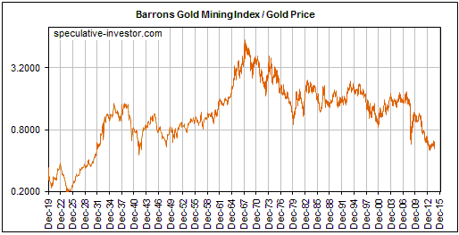
Now at .30 on Aug. 10, 2015
To answer the question we are going to draw on the Keynote speech recently delivered by Doug Pollitt of Pollitt & Co. at the Denver Gold Forum. A transcript of the speech can be read -- and should be read by anyone interested in gold mining investment -- HERE. This speech contains some eye-opening facts about the gold sector's operational performance and an important insight that, we think, explains why the gold-mining business has generated sub-par returns over a very long period. Hint: It isn't because the people who manage gold-mining businesses are, on average, dumber than the people who manage other commodity-production businesses.
Before getting to the root cause of the problem it's worth emphasizing that the generally poor long-term performance of gold mining stocks stems from the generally poor long-term performance of gold mining businesses. In other words, although the swings in market sentiment are partly responsible for the swings in the BGMI/gold ratio shown in the above chart and although speculative sentiment towards gold mining is probably near a low ebb at this time, the lousy stock-market performance isn't primarily due to excessive pessimism on the part of share traders/investors. We are, after all, talking about a trend that has been in place for several decades, not something that just sprung up over the past two years. Instead, the lousy stock market performance is a rational response to the lousy returns generated by the underlying businesses. Currently, for example, with the gold-mining sector near its lowest level since 1948 relative to gold bullion, the stocks of most senior and mid-tier gold producers don't look cheap based on traditional measures of business health such as profitability and free-cash-flow generation.
Two pieces of information from the above-linked speech highlight the poor performance of the gold-mining industry. We are referring to the charts labeled Figure 9 and Figure 10 on page 5. Figure 9 compares the retained earnings of the gold sector with the retained earnings of the oil and base-metals sectors, and indicates that over the past 15 years there were large increases in the retained earnings of oil and base-metal companies versus almost no increase in the retained earnings of gold-mining companies. This is despite a huge increase in the gold price. Figure 10 reveals that the production per share of the gold mining industry fell by about 35% over the same 15-year period while the production per share of the oil industry rose by about 30%.
The explanation for why gold mining has been a crappy business was mostly, but not fully, addressed in the above-linked speech. The rest of the explanation was provided by Morgan Poliquin, who is one of about three gold-mining CEOs with a good grasp of economic theory (Morgan is the CEO of Almaden Minerals (AAU)). It goes like this:
- Gold is the premier counter-cyclical asset. When the financial/banking system appears to be in trouble or it is widely feared that central banks are playing fast and loose with the official money, the stock and bond markets are perceived to be less attractive and gold-related investments are perceived to be more attractive.
- Gold to the stock and bond markets is like an ant to an elephant, so the aforementioned shift in investment demand results in far more money making its way into gold-related investments than can be used efficiently.
- Geology exacerbates the difficulty of putting a flood of new money to work in an efficient manner in the gold-mining industry, in that lucrative gold deposits are more difficult to find and are usually not as scalable as, for example, copper deposits, iron-ore deposits and oil deposits. By "not as scalable" it is meant that whereas a higher commodity price will often create an opportunity to expand an existing industrial-metals mine or oil-sands operation, that's usually not the case with a gold mine.
- The new money flooding into the gold sector will be attracted to the companies showing the most growth. Due to the considerable amount of time, effort and risk involved in finding an economic gold deposit and then developing it into a mine, the quickest and easiest way to achieve the sort of growth for which the market brays is via M&A (mergers and acquisitions). However, whenever there is a surge in M&A activity, many of the purchases and business combinations will prove to be ill-conceived. Furthermore, the companies with solid cash-generating operations and high returns on investment that don't play the 'growth-at-any-cost-by-M&A' game will get swallowed by the companies that do.
- The new money flooding into the gold sector will also tend to make large deposits more desirable, even if the deposits are in risky locations and are unlikely to ever be economic as a result of their low grades or problematic metallurgy.
- Due to the issues noted above, the gold-mining sector experiences a lot more mal-investment than other commodity sectors. In the same way that the mal-investment fostered by the Fed's monetary inflation has caused the US economy to effectively stagnate over the past 15 years, the bad investment decisions fostered by the periodic floods of money towards gold mining have made the industry inefficient. Putting it another way, just as the busts that follow the central-bank-caused economic booms tend to wipe out all the gains made during the booms, the gold-mining industry experiences a boom-bust cycle of its own with similar results. The difference is that the booms in gold mining roughly coincide with the busts in the broad economy.
- Not coincidentally, the problems for the gold-mining industry began at around the same time that central banks in general and the Federal Reserve in particular became free to inflate the money supply and manipulate interest rates without any rigid restrictions. The time was the early-1970s, when the US$ was untethered from gold.
Gold producers have taken steps to become more efficient over the past 24 months and have liquidated many of the mal-investments of the preceding boom. This paves the way for dramatic strength in the shares relative to the bullion during at least the first year of the next bull market in gold-related investments, but it's a virtual certainty that the surging demand for gold during the coming economic bust will lead to yet another round of massive mal-investment in the gold-mining industry.
The bottom line is that gold mining is doomed to remain a crappy business as long as the current monetary system is in place. This means that it will periodically be the recipient of a flood of new money, prompting a great deal of unproductive investment and TEMPORARILY generating huge returns for gold-stock investors.
*The chart uses weekly data since 1960 and monthly data prior to 1960. Also, the chart uses BGMI data beginning in 1938 and the share price of Homestake Mining (HM) scaled to the BGMI prior to that.
###
Steve Saville
email: sas888_hk@yahoo.com
Hong Kong

‘Crappy’ Gold Mining
April 11, 2015Guest PostsGold Mining
By Steve Saville

The crappy gold mining business revisited
Last October I wrote a piece that explained why gold mining had been such a crappy business since around 1970 and why it was destined to remain so as long as the current monetary system was in place. The explanation revolved around a boom-bust cycle and the associated mal-investment linked to the monetary machinations of central banks.
The crux of the matter is that when the financial/banking system appears to be in trouble or it is widely feared that central banks are playing fast and loose with the official money, the stock and bond markets are perceived to be less attractive and gold-related investments are perceived to be more attractive. However, gold to the stock and bond markets is like an ant to an elephant, so the aforementioned shift in investment demand results in far more money making its way towards the gold-mining industry than can be used efficiently. Geology exacerbates the difficulty of putting the money to work efficiently, in that gold mines typically aren’t as scalable as, for example, base-metal mines or oil-sands operations.
In the same way that the mal-investment fostered by the Fed’s monetary inflation has caused the US economy to effectively stagnate over the past 15 years, the bad investment decisions fostered by the periodic floods of money towards gold mining have made the industry inefficient. That is, just as the busts that follow the central-bank-caused economic booms tend to wipe out all the gains made during the booms, the gold-mining industry experiences a boom-bust cycle of its own with even worse results. The difference is that the booms in gold mining roughly coincide with the busts in the broad economy.
In a nutshell, the relatively poor performance of the gold-mining industry over the past several decades is an illustration of what the Fed and other central banks have done, and are continuing to do, to entire economies.
Obviously, gold itself is not made less valuable by the monetary-inflation-caused inefficiencies and widespread wastage that periodically beset the gold-mining industry. That’s why gold bullion has been making higher highs and higher lows relative to the average gold-mining stock since the late-1960s, and why the following weekly chart shows that the BGMI/gold ratio (the Barrons Gold Mining Index relative to gold bullion) is now at its lowest level since the 1920s.
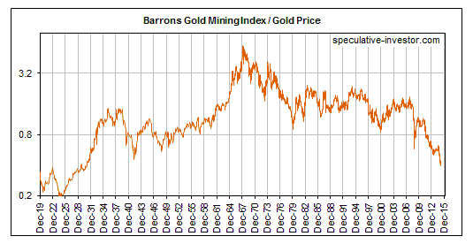
When the next bust gets underway in the broad economy, the surging demand for gold will temporarily generate huge real gains for gold-stock investors. At the same time it will lead to yet another round of massive mal-investment in the gold-mining industry that ensures the eventual elimination of these gains.
--

Dan Popescu Gold & Silver Analyst / Member of the Goldbroker.com Editorial Team
Mr. Popescu is an independent investment analyst and studies the gold and silver market and their future role in the international monetary system. He has followed regularly since 1970 the gold, silver and foreign exchange markets. He has a bachelor degree in physics (1993) from Concordia University in Montreal, Canada and has completed the Canadian investment management certificate (1999) of the CSI. He is a member and was the president in 2004 of the CSTA and also was president in 2005 of the Montreal CFA Society. He is a member of the CFA Institute, the MTA, NYSSA, UKSIP, the CSTA and the Gold Standard Institute International.

My articles

Gold vs Barron’s Gold Mining Index (BGMI)
Published May 21, 2014
One cannot understand gold without understanding its supply side. Although gold production accounts only for 1.64% of existing above-ground gold, it still represents 64% of the gold market supply. Can we predict the price of gold by observing the gold mining index? As a reference for this article, I have chosen the Barron’s Gold Mining Index (BGMI), since it has been published since 1940 and thusly provides a long basis for analysis.
Firstly, one has to know that shares of a mining company are not the same thing as physical gold. The share prices are derived from the price of gold, but also from other factors. Those are companies managed by fallible people facing multiple corporate risks. Several things have to go right within those structures in order for individual shareholders to profit from the price of gold. Gold is liquid money without any counterparty risk, whereas mining companies’ shares are an investment. Gold protects capital whereas shares can increase it considerably, but with the risk of losing it. There is 40% volatility in the gold mining shares, whereas the correlation between gold mining shares and physical gold is around 0.642.
If we look at chart #1, we can see that the BGMI index signaled the start of the rise in the gold price in 1960 nearly ten years before it started. However, one has to know that at that time, the gold price was fixed, whereas the prices of mining shares were floating. Investors had rightly predicted that such a situation could not last and that the gold price had to be readjusted higher or liberated. We also see that the increase in the prices of mining shares, compared to the one in gold, has diminished after the closing of the « gold window » by the United States. In 2000, this gold mining index hasn’t signaled the start of a new bull market, but it coincided with the start of gold’s bull market. We can see that, once the shock of liberating the price of gold has subsided, the price of the mining index in ounces of gold has stabilised. It is now at its lowest level since 1943. Update: August 2015, the BGMI to gold index closed at .31!
The market being an aggregate of differentiated opinions, the theory goes that it can predict the future of the economy. This implies a diversity of opinions and an absence of collusion. Conditions for « crowd wisdom » are diversity, aggregation and stimulus. If only one of those elements is missing, there is no crowd wisdom, but rather collective madness. Crowds are wise under these conditions, but they become mad when diversity disappears. In such a case, crowds act like herds. Diversity always disappears in the midst of uncertainty. Since 1980, and even more so since 1990, financial markets have been dominated by almost 80% of institutional investors using more and more computer systems to execute their trades, whereas before 1980, individual investors dominated the market. Since most institutional investors use the same quantitative approaches or very similar ones, there is no more diversity (needed for wisdom of the crowds), and financial markets have become herds that follow the trend. Thus, it has become difficult and even dangerous to trust market signals. This time, the signal of a new gold bull market will not come from the gold mining indices. It will be the opposite, in fact. Gold will be giving the signal of a new bull market, money will then flow in the mining companies, and they will outperform.

Chart #1: BGMI Share Price vs Gold Spot Price – BGMI Share Price in Ounces of Gold 1940-2014
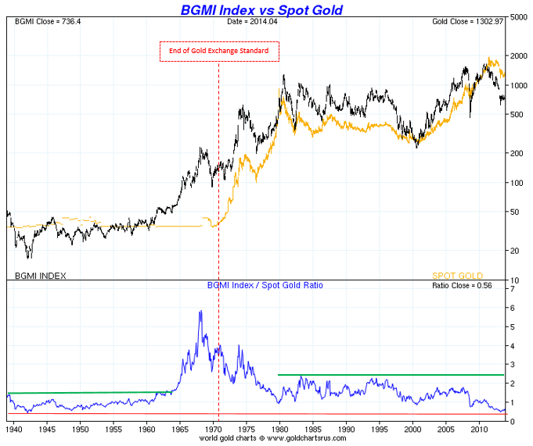

Chart #2: BGMI Share Price vs Gold Spot Price – BGMI Share Price in Ounces of Gold 1970-2014
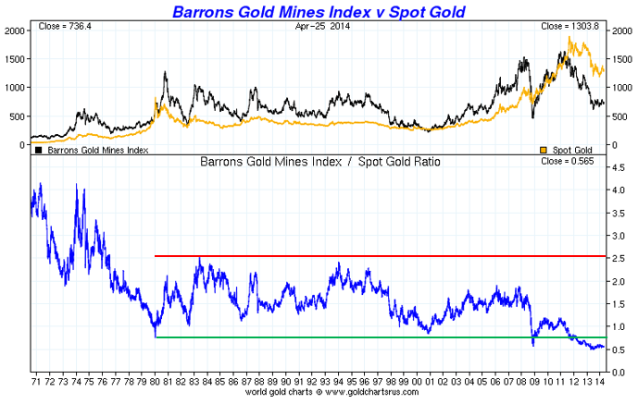
Aug. 11, 2015, index at .31!

I have always considered gold not as an investment, but rather as hard liquid money. Real tangible money with, above all, no counterparty risk. If there is something I agree with Warren Buffett on, it is that I don’t invest in liquid money, but in businesses, companies or industries. I find refuge in liquid money, above all in gold, when risks are too high and I don’t see any interesting investment opportunity. This does not exclude the possibility of speculating on currencies or commodities (gold, silver, oil, dollar, euro etc.) on the very short term. If I want to invest in gold or silver, I buy shares or businesses linked to gold or silver, such as mining companies, precious metals storage companies, precious metals brokers, jewellers, etc. It needs to be said that there has been times where liquid money has been king. It is said that, in a financial bubble, ‘gold is trash’, while in a financial crisis, ‘gold is king’. There are rare periods in which risks warrant finding refuge in the safest liquid money, or gold, that is. I believe we are in one of those periods. If we look at the long-term performance of the gold mining shares index since 1970, we see that it is closer to the general stocks indices like the Dow Jones Industrial than to the price of gold. In chart #3, we can also observe, since 2008, a divergence between the gold price and the mining companies versus the DJI. I believe that the start of a bear market on the DJI shares will act as a trigger of a new bull market in gold and in gold mining companies. In a recent article, I analysed the Dow Jones Industrial Index vs Gold, which demonstrates the negative correlation between the gold price and the DJI. This gold bull market should correspond to a major fall of the US dollar along with a monetary system crisis.

Chart #3: Dow Jones Industrial Index vs Gold Price vs BGMI Index (growth in percentage)
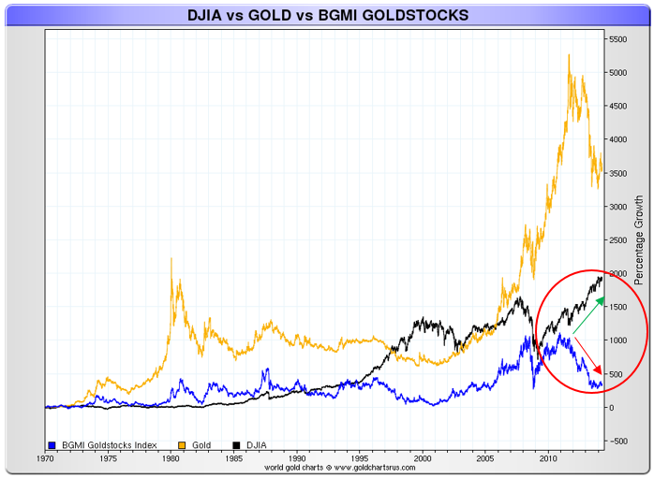

Chart #4: Dow Jones Industrial Index vs Gold Price vs BGMI Index (growth in percentage)
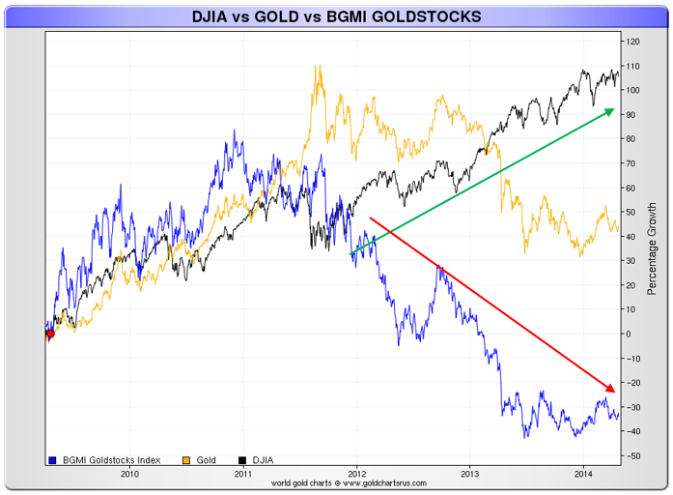

In chart #5, we can see that the volatility of returns on mining companies is much higher than that of the gold bar since 1970. This indicates that, in a bull market, mining shares will outperform gold, though with much more risk involved. It is becoming more and more costly to find gold and extract it. In the last decade, we have seen production costs increase very rapidly, which has greatly limited the mining companies’ performance, even in a gold bull market.

Chart #5: Gold Price vs BGMI (variations in percentage)
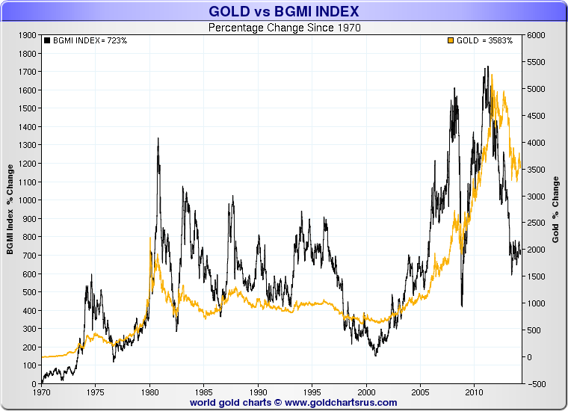

Ever since I was a little kid, I have always been told to have from 5% to 10% of my savings in gold and hope never having to use it. Gold, as ex-Fed chairman Alan Greenspan so aptly says, is « in extremis » money (gold is the money of last resort), whereas gold mining companies shares are an investment, which entails risks and a certain correlation with the Dow Jones Industrial Index.

« I’m more worried by the return of my money than the return on my money. » Will Rogers.

