http://www.minyanville.com/business-news/editors-pick/articles/11/3/2015/id/56227?refresh=1
Minyanville > Business News > Editor's Pick

Hubris Cubed: The Valeant Story
By Peter Atwater Nov 03, 2015 1:27 pm

The Valeant story is a classic case of overconfidence.
Bottom of Form
Valeant (VRX) has fallen and it won't get back up.
I offer that conclusion not as a short-seller hoping to profit from the company's demise or as a research firm trying to make a name for itself with a brash call.
As a socionomist and researcher in confidence-driven decision making, I am simply interested in what behaviors say about confidence levels.
As I look at Valeant, there is a rich mosaic, lush with overconfident behavior which suggests that things are likely to get much worse before they get better.
Before detailing many of the extreme overconfident behaviors on display, it is important to have a relative sense for the collective confidence in and around Valeant.
As a researcher, I believe that stock prices can serve as a useful proxy for confidence. At major lows in price, uncertainty abounds.
At the peak of price, there is extraordinary trust in a company's management, products, profitability, and future.
The higher price goes, the more we believe.
As this chart from Michael Sedacca of Rareview Macro shows, the recent top in Valeant's stock price wasn't just a major peak in confidence.
It was a peak that rivals the tops in the Nasdaq, China and gold bubbles.
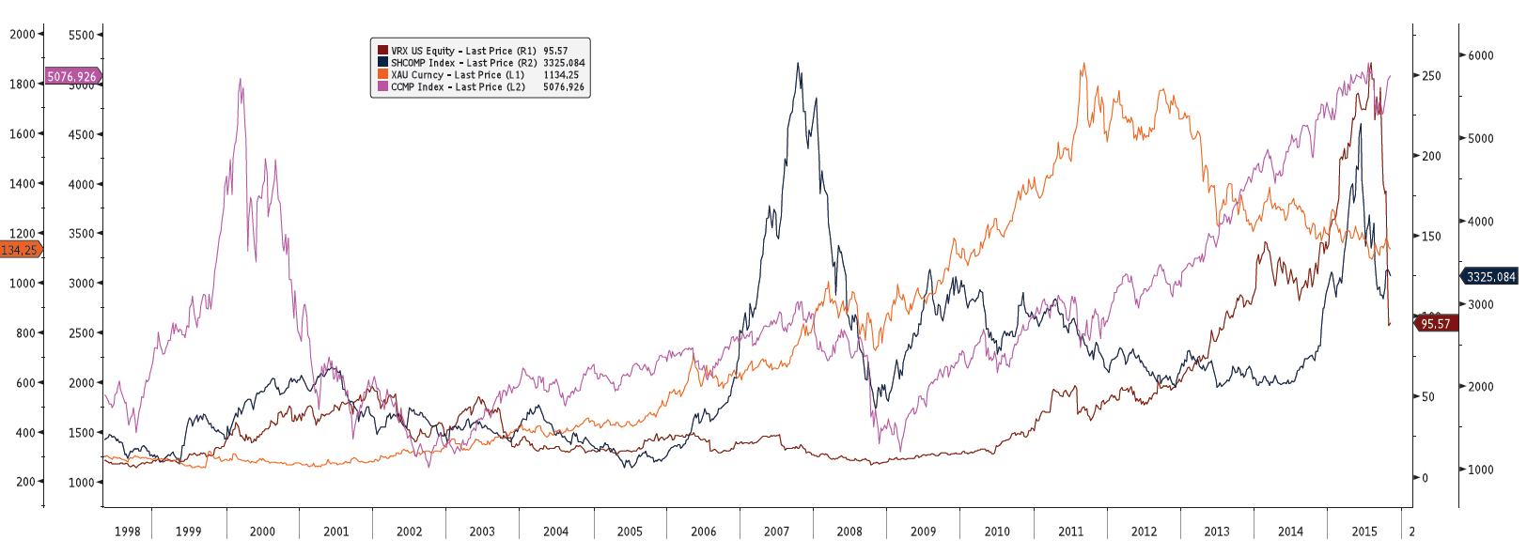
This chart suggests that at the recent top, not only was there extraordinary confidence, but everyone -- the entire entourage of debt and equity investors, rating agencies, regulators, suppliers, customers, the whole food chain - was in.
Sentiment was one for the record books.
In my book Moods and Markets, I listed several traits that are always present at extreme peaks in confidence.
While we are still in the very early innings in uncovering the signs of overconfidence at Valeant's peak, we are already seeing significant examples of many of them.
1) Big Truth
As I wrote in Moods and Markets, underlying every bubble is a "statement that is both compelling and at the same time, if false, would draw the entire investment premise into doubt. It's something like 'the internet will change the world forever,' or 'China will dominate the global economy.'"
For Valeant, the Big Truth was that the company could acquire an unlimited number of drug companies and dramatically increase prices while cutting R&D and tax expenses.
At Valeant's peak, no one doubted Its Big Truth. In fact, the short-selling doubters had been brutalized by the surging stock price.
It is very likely that they too had capitulated.
2) Abdication of Risk Management
While I haven't yet seen an example of the abdication of risk management from within Valeant, the oversized positions of two of the company's leading shareholders certainly qualify. At the peak, almost 30% of Sequoia was invested in Valeant; and media reports suggest that Valeant represents somewhere between 15 and 20% of Pershing Square's investment portfolio.
But these firms were hardly alone in their aggressive positions. Yesterday, the Wall Street Journal noted this:
At its peak, Valeant accounted for 6.1% of Canada's S&P/TSX Composite Index, as battered energy- and mining-sector stocks shrank on the country's flagship benchmark.
As Valeant's influence grew, portfolio managers came under increased pressure to take risks to ensure their fund's performance was aligned with the S&P/TSX index. The company's enhanced weighting attracted a broad cross section of Canadian funds, which align their investments with the index to ensure their performance doesn't fall behind.
By not investing in such a heavily-weighted stock, they risked underperforming the index and their peers.
"Most managers wouldn't bet against the stock because if they were wrong their compensation would get hit," said Peter Hodson, a retired money manager at Sprott Asset Management and CI Financial Corp., who runs an independent research firm called 5i Research.
Some funds conceded to clients that Valeant's prominence on the index compelled them to bet on the company, despite the hazards of betting on a skyrocketing stock. (bolded for emphasis)
As we see routinely at market peaks, fund managers throw risk management aside because of perceived opportunity and the dire consequences of underperformance.
Again, THE top creates a social vortex in which everyone wants/needs to be in.
3) Organizational Complexity
It has been fun to see the historical analogies that have popped up in media stories and pundit commentaries on Valeant.
On Friday, Josh Brown cited a presentation by Berkshire's Charlie Munger earlier this year tying Valeant to ITT -- a company which went on a mad acquisition spree during the early 1960's only to collapse under its massive collective weight shortly thereafter.
While Bill Ackman downplayed the analogy because of Valeant's monoline industry focus, I think the ITT connection more than fits.
In fact, in Moods and Markets, I specifically identified ITT as "a great example of the oversized complexity" that naturally accompanies extreme peaks in confidence.
Looking at the all of the companies Valeant has rolled up in the past five years -- not to mention the company's relationships with specialty pharmacies and use of variable interest entities (VIEs) -- "oversized complexity" certainly fits.
And we are still in the early stages of discovery. As confidence falls further, and scrutiny naturally intensifies, I expect we will find many, many examples of just how complicated Valeant became.
But I think it is also important to appreciate the extraordinary speed at which Valeant grew. The Valeant of today is essentially a five year old enterprise. From 2010 to 2015, Valeant acquired more than 100 companies and amassed more than $30 billion in debt.
That investors enabled the layering and re-layering of increasing complexity and leverage with one deal right after another itself speaks to the extreme confidence sustaining the company's growth trajectory.
4) Excessive Architecture
Like the example of risk management abdication above, the best example of excessive architecture also ties to Valeant's shareholders -- in this case, Pershing Square's CEO Bill Ackman.
Last fall, the New York Times reported that Mr. Ackman and "a couple of very good friends" spent $90 million to purchase "The Winter Garden" -- a 13,500-square-foot duplex "with an eagle's-eye view of Central Park" atop One57, a new 90-story hotel and condominium building "described by one critic as 'a luxury object for people who see the city as their private snow globe.'
Mr. Ackman referred to it as "the Mona Lisa of apartments."
What was so extraordinary about the real estate purchase, though, was Mr. Ackman's intent. He didn't plan to live there. He bought the condo to flip it for "fun."
But Mr. Ackman's over-the-top real estate adventures didn't stop there.
This summer, it was reported that he was working with "starchitect" Rafael Vinoly to renovate a former Ford car-repair facility on Manhattan's West Side into new office space for Pershing Square complete with a swimming pool and tennis court on the roof and "internal automobile ramps leading to the upper floors of the building so Pershing Square employees can drive right to their office's doorstep."
5) Liberal Accounting
On Sunday, Gretchen Morgenson of the New York Times took Valeant to task for the company's "creative" financial reporting:
In news releases, Valeant executives are careful to include their results under accounting rules. But these communications tend to focus more on the company's primary hand-tailored figure - what it calls "cash E.P.S." When providing forecasts, for example, the company supplies only pro forma numbers.
Valeant strips out a laundry list of expenses from its revenue, including those related to stock-based compensation, legal settlements and costs associated with restructuring and acquisitions.
Most significant, perhaps, for Valeant are costs related to acquisitions. Generally accepted accounting principles require companies to recognize over time the diminishing value of intangible assets they acquire when buying another company - or amortization. Valeant excludes those costs.
I suspect that this is just the beginning of the accounting scrutiny Valeant receives.
In Moods and Markets, I write, "At its core, GAAP accounting is a regulation and is subject to the same mood-based influences seen elsewhere, such as in banking and nuclear energy. When we are confident, we deregulate...Even more, as both assets and liabilities reflect corporate management's mood, in periods of rising mood there is a natural exponential effect in which asset values are inflated and liabilities reduced by the increased optimistic application by management of increasingly lax accounting rules."
As an acquisition-driven company, Valeant benefited enormously from the liberalization of the accounting rules for mergers and acquisitions that took place at the very peak of confidence in 2001. If history holds, what we will soon discover is that the company liberally applied not just this very liberal rule but all of it accounting principles too as confidence soared.
But that is just half of the story. As Ms. Morgenson states, at the peak, investors were more than eager to not just accept the company's non-GAAP earnings measures, but to apply an oversized multiple to them, too.
At THE top, liberal accounting rules are liberally applied by management then liberally interpreted by investors and then liberally valued by the market. The stock price accordion is pulled out as wide as it can be.
Nothing exceeds like excess; and at extreme peaks in confidence, what people think and how they act is truly extraordinary. Even more remarkable, though, the nature of those behaviors is incredibly consistent.
At THE top, we do the same things over and over.
Based on what I see, Valeant has many of the behavioral characteristics which suggest that what we just witnessed wasn't just a top, but THE top. Everyone who could be in was in. Even more, their actions reflected their extreme overconfidence in the company.
Tomorrow, I will discuss the implications of the bursting of the Valeant bubble. They're far reaching and woefully underappreciated by investors today.
Confidence is like a Lego Tower: It takes a long time to build, but can be destroyed in an instant. And when the tower is built to the sky, the pieces fall far and wide.
Peter Atwater's groundbreaking book "Moods and Markets" is now available on Amazon and Barnes & Noble.
"Peter Atwater brilliantly provides a framework for understanding both the socioeconomic hubris that led to the great credit bubble of the past decade and the dark social-psychological hangover that has resulted from its collapse. In so doing, he offers an invaluable guide to what promises to be a very difficult and turbulent period ahead as we experience what he calls the 'me, here, and now' behavioral tendencies of the post-crash world." -Sherle R. Schwenninger, Director, Economic Growth Program, New America Foundation
Twitter: @Peter_Atwater
Read more: http://www.minyanville.com/business-news/editors-pick/articles/11/3/2015/id/56227#ixzz3qXihRTZL

--

Here’s how activist investor William Ackman got it wrong
By Thomas Lee – June 23, 2015 – San Francisco Chronicle
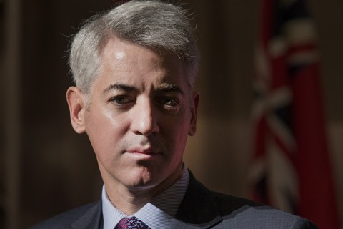
William Ackman is CEO of Pershing Square Capital, a hedge fund that invests in select companies. He was wrong about Target and J.C. Penney. Photographer: Norm Betts/Bloomberg via Getty Images
The first question directed at William Ackman was both fairly simple and also impossibly complicated: What exactly is your business?
“Harvesting souls,” Ackman said, as the crowd at Stanford Law School chuckled.
Ackman, along with Carl Icahn and Daniel Loeb, is probably one of the country’s best known activist investors — professional agitators who buy large stakes in companies they deem poorly run and then push the CEO and board of directors to do things they think will boost the stock price: merge with a competitor, spin off a business, cut costs, buy back shares.
Not surprisingly, activist investors are highly controversial — hence Ackman’s joke. Some see them as knights in shining armor, holding boards and executives accountable for lousy performance. Critics, though, see activists as short-term opportunists who just want to make a quick buck and couldn’t care less about other shareholders.
Icahn, a notorious corporate raider who recently went after Silicon Valley stalwarts Apple, Netflix and eBay, fits this category.
“The best protection (against activist investors) is running a successful enterprise,” Ackman said.

Increased activity
And it seems activist investors are rattling cages more often these days.
In 2014, 344 companies were subjected to activist demands, compared with 136 four years ago, according to Activist Insight.
“Every company is working hard to improve their business” because of the prospect of activists launching campaigns, Ackman said at the annual Directors College talks at Stanford this week. “It’s incredibly healthy for the capital markets.”
So what kind of activist is he? A complicated one, as it turns out.
Ackman says he’s launched campaigns because he believes in the long-term prospects of his targets.
I don’t doubt his sincerity. But sincerity can sometimes morph into arrogance and self-righteousness.
And those traits have tripped up Ackman in the past, despite his intelligence and success.
Let’s start with Target. In 2007, Ackman, through his hedge fund Pershing Square Capital, started buying shares in the nation’s second-largest retailer, eventually becoming its third-largest shareholder.
Ackman argued that Target shares were undervalued, and he had a plan to fix that. He demanded the company sell its credit card business and spin off its stores into a publicly traded real estate investment trust. He fought a bitter and costly proxy battle with Target’s board and ultimately lost.
I don’t have a problem with Ackman picking a fight with the Target board, because the company’s directors had grown complacent.
But Ackman identified the wrong problems and therefore the wrong solutions. Target’s biggest problem was that fewer people were visiting stores because of the growth of online shopping and mobile devices. Hard to see how creating a REIT would help Target remain relevant with a rapidly changing consumer base.
As it turns out, Target didn’t need Ackman to boost its stock price. Ackman sold his remaining Target shares during the first quarter of 2011, when the stock traded around $50 per share. Since then, Target has upped its digital game and opened smaller stores, and its stock has soared to more than $80.

Penney missteps
Ackman had similar results with J.C. Penney (perhaps he should just stay way from retail stocks). In 2011, he spent $900 million to acquire a stake in the struggling chain and joined the board.
Through Ackman’s agitation, Penney hired former Apple executive Ron Johnson as its CEO. The result was an unmitigated disaster.
Johnson decided to abruptly end Penney’s discounting (the reason people shopped at the chain in the first place) and create high-style stores within a store. The moves alienated the retailer’s core customers and sales plummeted.
Ackman fundamentally misread Penney’s situation. He thought the company needed a visionary like Johnson, who developed Apple Stores, to quickly reimagine the business. But in truth, Penney needed a CEO who could first stabilize store operations and figure out how to boost online sales.
Ackman’s tactics are also highly questionable, despite his insistence that activists like himself “are simply offering proposals.”

Herbalife demands
That’s laughable, considering his dealings with Herbalife. Ackman has openly accused the supplement maker of fraud even as he bet $1 billion the stock will go down. Encouraging the federal government to investigate Herbalife sounds a little more aggressive than offering suggestions to better the business.
The real question is not the record of individual activists like Ackman and Icahn but why companies are so vulnerable to them in the first place.
The rising popularity of activist campaigns means that boards should better communicate with investors, said Dan Gallagher, a Republican-appointed member of the Securities and Exchange Commission, who also spoke at the Stanford event.
Gallagher does not seem to favor new laws to regulate activists, and he noted that boards “are simply mismanaged, have grown stale, become too chummy with management, possess irrelevant skills.”
“If corporations are republics, then boards need to engage with investors with the same vigor as politicians,” he said. That way, “they can get out in front of these shareholder activists.”
Gallagher seems open to proposals to blunt the power of activists by strengthening the hand of long-term shareholders.
The common knock on activists is that they are short-timers, forcing companies to make big decisions and then bailing out of the stock.
One idea being floated among corporate governance circles is to give more voting power to shareholders who promise not to sell the stock for a certain length of time.
The idea is “radical but intriguing,” Gallagher said.
That way, guys like Ackman who claim to be interested in the long-term health of a company can put their money where their mouths are.
And Ackman has plenty of both.
Thomas Lee is a San Francisco Chronicle columnist. E-mail: tlee@sfchronicle.com Twitter: @ByTomLee

http://www.businessinsider.com/ackman-email-to-valeant-2015-11

