http://www.businessinsider.com/bill-ackman-valeant-slide-deck-2015-10

their language
Some stories seem to have fallen apart lately.
Valeant has gone from darling to deviant. The losses in the stock accelerated when light was shone on some questionable business relationships that hadn’t been disclosed by the company.

The Theranos tale has been tarnished too. An excellent column by James Stewart in the New York Times provides a summary of the rise of the Elizabeth Holmes mystique, another example of “the ageless power of a great story.” But now much of it has been called into question.

In response (according to Stewart), a spokesman for the Cleveland Clinic backpedaled from its embrace of the blood-testing firm, saying that information about Theranos on the Clinic’s website was “their language, not ours.”
That is a fitting description for the most common weakness in company and investment manager due diligence.
For example, if you cross out everything on a typical stock research report that could have been written by the subject company itself, you might be surprised at how little is left. In many cases, big chunks of text are copied exactly or paraphrased from company documents or presentations to make report preparation easier. The baseline narrative is set by the company.
The same thing is true for much of the due diligence on investment managers. I have seen reports from major organizations that have virtually nothing in them that didn’t come from a manager’s pitchbook. Philosophy, people, process, performance, etc. – all reported for the reader as if independently discovered, but really just a conveyance of the manager’s story.
If you can’t find the mess in an organization, if you can’t poke holes in the story, you haven’t gone deep enough. It’s always there. Your job is to find it and then value it in the context of everything else.
Their language and their stories can’t be accepted as is, or the governing process is not “due diligence,” but “analyst capture.”

If you are interested in due diligence topics, sign up for my email list. You’ll get practical tips once a month, plus notifications of workshops that provide training in due diligence.
October 31, 2015
1 note

The stock that ate Wall Street
- by Joshua Brown

OCTOBER 30, 2015, 12:35 PM EST
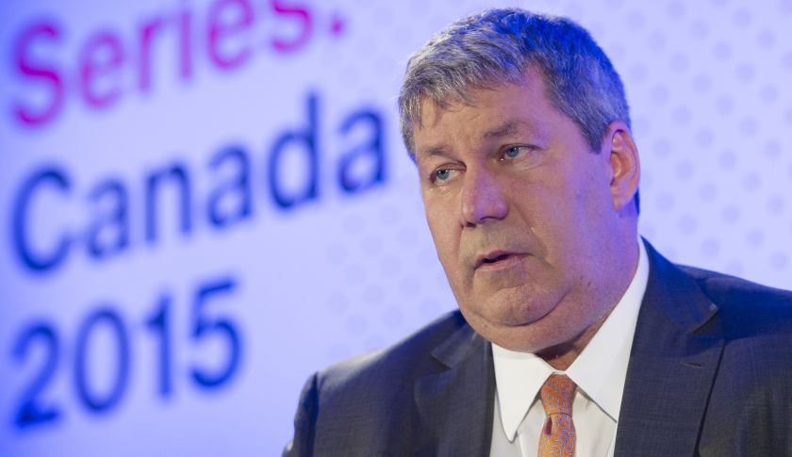

Berkshire Hathaway’s Charlie Munger recently compared Valeant to ITT, one of the worst conglomerates ever assembled by Wall Street’s deal-making machine.
This spring, Charlie Munger held court at the annual shareholder meeting for the Daily Journal Corporation, a small newspaper company where he serves as chairman of the board. Someone asked him about Valeant, at that time one of the highest-flying stocks in the market. Munger didn’t mince words: “Valeant is like ITT and Harold Geneen come back to life, only the guy is worse this time.”

Munger was alluding to one of the worst conglomerates ever assembled by Wall Street’s deal-making machine. And “the guy” in this case is McKinsey veteran J. Michael Pearson, who had built Valeant into a $90 billion pharmaceutical conglomerate virtually overnight. Pearson is no scientific wunderkind, nor did Valeant have any breakthrough drug hit the shelves during his tenure. Instead, the company’s rapid success could be chalked up to aggressive dealmaking of the sort we haven’t seen since the late 1990s heyday of Tyco and Dennis Kozlowski.

Over the past few weeks, Valeant VRX -17.04% has been embroiled in the early stages of a scandal that now threatens to level the company and its largest shareholders should it spiral out of control. Short-sellers are alleging that the company has several pharmacies it controls that enable it to subvert prescription rules and “stuff the channel” with sales that never actually materialize. The company held a conference call last week to refute these claims, but the stock continues to crater as every new detail leads to additional questions.
As of this writing, Valeant has lost almost $50 billion in market cap since its stock price peaked this summer. Hedge fund manager and Valeant supporter Bill Ackman is said to be sitting on over $1.5 billion in losses from his firm’s position in the stock.

In a gruesome bit of irony, the Warren Buffett-endorsed Sequoia Fund is one of Valeant’s largest shareholders, with almost 35% of the fund’s assets tied up in the stock. Led by investment advisory firm Ruane, Cunniff & Goldfarb, which was founded by a disciple of Benjamin Graham, the Sequoia Fund issued an explanation to its investors as two of its board directors resigned.

Munger’s Valeant-ITT comparison shouldn’t be taken lightly. Over a period of nine years, Harold Geneen used his company International Telephone & Telegraph Corp to make more than 350 acquisitions in over 80 countries around the world. Sales exploded from $765 million in 1961 to over $17 billion in 1970, before the wheels started to come off. The empire was eventually revealed to be little more than a giant accounting trick that covered up the losses from one acquisition with the paper profits of the next one.

By the early 1970s, the wheels began to come off. Geneen and his monster became implicated in a million-dollar bribery scandal with the Nixon administration and charges that the firm attempted to undermine elections in Chile to further its business interests. You can see just how unflattering Munger’s analogy is when you look at the decades it took to unwind the ITT nightmare once the wheeling and dealing came to an end. The ITT scandal was one of several story lines that kept a lid on stock market enthusiasm and helped contribute to the secular bear market that paralyzed stocks until the early 1980s.
The Valeant saga has yet to fully play out, but investors are right to be skittish. The company cannot conceivably continue on its acquisition spree with its stock price in free-fall; what potential target would accept it as currency? In the meantime, Valeant is now encumbered with over $30 billion in long-term debt, equal to roughly five times the amount of shareholders’ equity.

The other leg to the Valeant story—its ability to continue raising the prices of the drugs it acquires—is also now on shaky ground. Presidential candidates on both sides are vocally expressing their disdain for the practice, and the issue has crossed into the mainstream. In the current politicized environment, it is inconceivable that Valeant and other drug companies will enjoy the same latitude to hike prices as it has over the last four years.

Whether or not investors are directly exposed to the maelstrom surrounding Valeant, we all have something at stake. Should it turn out that the company is guilty of more than just free-wheeling accounting, the impact on all U.S. stocks will be negative. Episodes surrounding the likes of Tyco, Enron, and Worldcom after the turn of the millennium fed into broader distrust of the stock market and helped prolong the bear market that had originally started with the dot-com bust. The same could be said about the many banking and trading scandals that were unearthed after the fall of Lehman.
Valeant’s epic share price decline may not affect your portfolio directly, but a reversal in overall market sentiment absolutely will. Let’s hope Charlie Munger’s assertion about “the guy being worse this time” turns out to be incorrect.
--

Pharmacist at center of Valeant scandal accuses drugmaker of 'massive fraud'
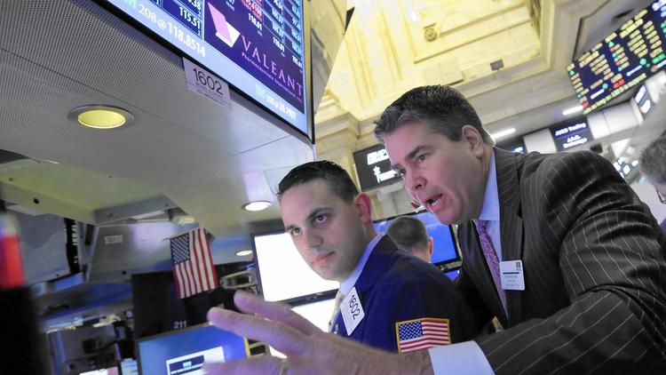
Valeant Pharmaceuticals, once a highflying Wall Street darling, in recent weeks had its stock price almost halved.
(Richard Drew / AP)
Melody Petersen and Stuart PfeiferContact Reporters
Before the group of East Coast investors arrived late last year, Camarillo pharmacist Russell Reitz had been promoting his modest prescription-filling business as "your local pharmacy."
That abruptly changed when he agreed to sell his pharmacy, in a quiet suburban office park, to the group for $350,000. As he continued as manager, Reitz began finding his store's name and his national pharmacy license number on an avalanche of prescriptions nationwide.
Then a torrent of insurers' money started flowing to his small shop, R&O Pharmacy — on pace to equal $230 million a year, according to invoices.
Reitz now finds himself at the center of the national scandal enveloping Valeant Pharmaceuticals International, the once highflying Wall Street darling that in recent weeks had its stock price almost cut in half. The Canadian company said Oct. 14 that federal investigators were probing its operations, including how it prices and distributes drugs.
In the last two months, Reitz has filed papers in two Los Angeles courthouses laying out details of what he and his lawyer call "a massive fraud."
See the most-read stories this hour >>
"I saw personal risk to my future, so I had to take action," the 64-year-old pharmacist said in an interview last week at his office.
Reitz had agreed to sell his pharmacy to a company created by Philidor Rx Services, a mail-order pharmacy with close ties to Valeant.
Valeant became one of the hottest healthcare stocks in recent years by buying other firms' medicines and then swiftly hiking their prices by as much as 500%.
Specialty pharmacies such as Philidor are part of a little-known strategy by Valeant and other pharmaceutical companies to sell high-priced drugs that insurers otherwise wouldn't pay for.
Many of Valeant's expensive brand-name medicines — including Jublia for toenail fungus and Solodyn for acne — are similar to generic medicines available for far less. When patients fill those prescriptions at the pharmacy, insurers often require the druggist to switch to the generic — causing Valeant to lose the sale.
To get around that blockade, Valeant has been distributing coupons on the Internet and to doctor's offices across the country that allow patients to lower or even avoid a co-pay — if they ordered the drugs through Philidor.
Until Reitz's court filings, including a lawsuit he filed Oct. 6 in U.S. District Court in Los Angeles, few people knew about Valeant's close ties to Philidor, even though the mail-order pharmacy was increasingly crucial to its bottom line.
Last week, under pressure from angry investors, Valeant revealed more about Philidor, saying it had an expanding "network of pharmacies" across the nation.
Another pharmacy in the Philidor network is West Wilshire Pharmacy in Los Angeles. Wilshire did not return a call seeking comment.
The concern among investors is that the giant drugmaker's fast-rising sales growth is dependent on these mail-order pharmacies, which could be operating illegally.
We did do a lot of business, but it wasn't being done right.- Russell Reitz, Camarillo pharmacist
"We did do a lot of business, but it wasn't being done right," Reitz said in the interview.
Wearing a burgundy T-shirt and jeans, Reitz seemed forlorn as he sat at a wooden desk, a crisp white pharmacy coat hanging from the back of his chair. He said he did not understand Philidor's intentions when he agreed to sell the company his business.
Valeant said that Reitz's lawsuit "is without merit."
"We operate our business based on the highest standards of ethics, and we are committed to transparency," J. Michael Pearson, its chief executive, said in a conference call with stock analysts last week.
In court papers, Reitz detailed how he had discovered that Philidor was using his national pharmacy identification number on prescriptions being filled at other pharmacies — and even on some that were filled and billed before he signed the agreement to sell R&O on Dec. 1.
He also found that, without his knowledge, a Philidor executive who had never visited the Camarillo pharmacy was answering questions about the pharmacy's billing practices during an audit by an insurer.
As Reitz pressed executives at Philidor's headquarters in Hatboro, Pa., for answers about the questionable practices, his emails became increasingly desperate.
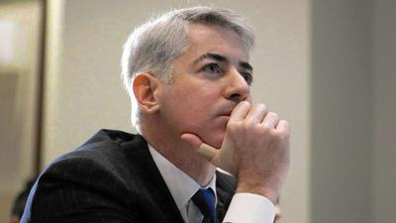
Investor Ackman defends Valeant in 4-hour conference call
"Time is of the essence," Reitz wrote to Andy Davenport, Philidor's chief executive, on July 20. "You must provide me with substantive responses immediately, as my license and professional reputation are at stake."
What Reitz hadn't known at the time he signed the sale agreement was that Philidor — and Valeant — were facing a hurdle in getting prescriptions filled in California, the largest market for medicines among the states.
State Atty. Gen. Kamala Harris' staff had denied Philidor's request for a California pharmacy license, charging that the company had falsified information in its application.
"Do you think I would sell to someone that was denied a permit?" Reitz said. "You've got to be kidding me."
Reitz said he believes that Philidor had targeted his pharmacy because it needed access to his licenses, which he has in California and 33 other states, as well as to the contracts he had negotiated with insurers.
On July 21, Davenport and three other Philidor executives arrived unannounced in Camarillo, talking to Reitz for just 15 minutes before rushing off. Reitz said the executives answered none of his key questions.
Get our weekly business news briefing >>
The next day Reitz's lawyer sent a letter to Philidor.
"Your continued silence indicates to us that Mr. Reitz' suspicions are well-founded," he wrote. "You appear to be engaging in a widespread fraud."
By then Reitz had stopped sending Philidor the millions of dollars in checks that he was receiving from insurers for prescription shipments. His lawyer explained that Reitz had to protect himself from "massive potential" liability.
On Sept. 4, the drug giant Valeant sent a letter to Reitz — demanding $69 million that it said the small-town pharmacist owed.
Until then, the pharmaceutical company had not corresponded with Reitz. Philidor executives had told him only that they "had a relationship" with Valeant to dispense its branded products, Reitz said.
A few days later, Reitz sued Valeant, asking the court to rule that he had no duty to the drug company and owed it no money.
Valeant's shares plunged 38% on Oct. 21 when Andrew Left, a short-seller at Citron Research in Beverly Hills, released a report accusing the drug company of using the pharmacies in an Enron-like scheme of inflating profits.
Get the essential California headlines delivered free >>
Early last week, Valeant executives insisted that Philidor operated as an independent company. But they also revealed that in December, Valeant had paid $100 million to Philidor for an option to buy it.
Valeant executives said that prescriptions filled by Philidor and its network of pharmacies amounted to 6% of the company's net revenue this year.
Yet on Thursday, Valeant's stock fell again when the nation's three largest drug-benefits managers — CVS Health Corp., Express Scripts Holding Co. and UnitedHealth Group Inc.'s OptumRx — said they were removing Philidor from their pharmacy networks.
On Friday, Pearson, Valeant's chief executive, tried to distance his company from Philidor. He announced that Valeant was severing all ties to the mail-order pharmacy. Philidor was shutting down operations, he said.
"We understand that patients, doctors and business partners have been disturbed by the reports of improper behavior at Philidor," Pearson said, "just as we have been."
Valeant's stock closed Friday at $93.81, down $17.69, or an additional 16%.
Reitz declined to say whether he had spoken to law enforcement or regulatory officials.
"A lot more is going to be coming out," he said.
melody.petersen@latimes.com
--

Charlie Munger Isn't Done Bashing Valeant

Noah Buhayar NBuhayar

Charles Stein
November 1, 2015 — 6:39 PM EST
Share on FacebookShare on Twitter

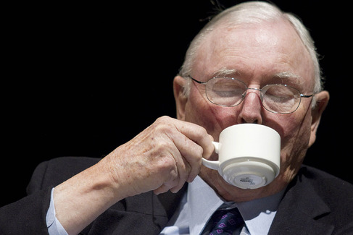
Charles Munger, vice chairman of Berkshire Hathaway.

Photographer: Jonathan Alcorn/Bloomberg
Don't Miss Out — Follow Bloomberg On
FacebookTwitterInstagramYouTube

Recommended
Russian Jet Likely Broke Up Midair Over Egypt, Officials Say
Saudi Consumers Are Still Spending Like the Oil Slump Never Happened
Bonds Send Same Ominous Signs No Matter Where in World You Look
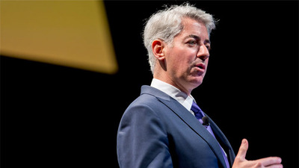 Ackman Defends Valeant, Wall Street Unloads Stocks
- In weekend interview, he calls the drugmaker `deeply immoral'
- Still, Munger says Valeant isn't house of cards like Enron
Share on FacebookShare on Twitter
Charles Munger saw it coming, and now he’s shaking his head.
Months before Valeant Pharmaceuticals International Inc. tumbled under attack from short sellers, Munger told investors in Los Angeles the company reminded him of the excesses of the 1960s conglomerate craze. “I’m holding my nose,” Warren Buffett’s longtime business partner said.
Turns out, those remarks were just the start of his concerns.
In an interview Saturday, Munger tore anew into the besieged drug company, calling its practice of acquiring rights to treatments and boosting prices legal but “deeply immoral” and “similar to the worst abuses in for-profit education.” In his role as chairman of Good Samaritan Hospital in Los Angeles, Munger said, "I could see the price gouging.” And speaking as a storied value investor, he said, its strategy isn’t sustainable: “It’s deeply wrong.”
Once a high-flying stock -- and a darling of star money managers like Bill Ackman -- Valeant has slid more than 60 percent since its peak in August. A short-seller accused it of using a mail-order pharmacy, Philidor RX Services LLC, to inflate sales and engage in accounting tactics reminiscent of Enron Corp., the power trader that collapsed in 2001. Lawmakers are examining how Valeant set higher prices for medications.
The company denied the short-seller’s allegations in a conference call on Oct. 26 and said Friday it would sever ties with Philidor. It also has said that price increases for treatments are often whittled down in negotiations with insurers.

‘Holding My Nose’
“We operate our business based on the highest standard of ethics, and we are confident in our compliance with applicable accounting rules, regulations and laws,” Laval, Quebec-based Valeant said in an e-mailed statement Sunday. “Our commitment is to the patients who use our drugs, the doctors who prescribe them, our partners who make them available across the country, and to our shareholders.”
Munger’s stance has extra significance, because some of the drugmaker’s largest shareholders follow the style of investing that he and Buffett, 85, popularized. Ackman frequently expresses his admiration for their firm, Berkshire Hathaway Inc. And Valeant’s largest investor, Ruane Cunniff & Goldfarb, which runs the Sequoia Fund, shares a decades-long history with Buffett.
Munger, 91, brought up Valeant in March, before an audience of about 200 people assembled to hear him at the annual meeting of Daily Journal Corp., where he is chairman. He was discussing a passage in Buffett’s recent letter.
Companies like ITT Corp., Munger said, made money back in the 1960s in an “evil way” by buying businesses with low-quality earnings then playing accounting games to push valuations higher. Investment managers looked the other way. And worse, he added, it was happening again.
“Valeant, the pharmaceutical company, is ITT come back to life,” Munger said at the gathering. “It wasn’t moral the first time. And the second time, it’s not better. And people are enthusiastic about it. I’m holding my nose.”

Unlike Enron
ITT acquired more than 350 companies during its years as a conglomerate, wrapping together Sheraton hotels, Avis Rent-a-Car, the maker of Wonder Bread and other businesses. It broke up in 1990s. One of its descendants, an industrial company, later took back the name.
As Valeant’s stock plummeted over the past two weeks, some big shareholders came to its defense, propelling the debate into a business-media spectacle. Ackman held a four-hour presentation on Friday, comparing the company to Berkshire as he sought to persuade investors that Valeant should be trading higher. His pitch fell flat, and the stock closed lower.
Ackman said during the presentation that he spoke with Munger about his March remarks. The Berkshire vice chairman’s objections focused on leverage, tax rates and acquisitions, and Munger explained that he says what comes to his mind, according to Ackman.
Munger elaborated on Saturday: Valeant relied on “gamesmanship” to run up its value. Its strategy, using acquisitions and price increases, is different from ITT, but it still created a “phony growth record,” he said. Unlike Enron, Valeant’s stock isn’t a house of cards because it has some some valuable properties, including its portfolio of treatments, he said. He isn’t holding or shorting the shares.

Old Ties
Valeant said Sunday that it sets prices that reflect the value of its drugs, and that it offers assistance programs to “remove the financial obstacles that may keep patients from obtaining the medications they need.”
A spokesman for Ackman declined to comment further on Munger’s latest remarks, referring to the Friday presentation. Sequoia’s managers, Robert Goldfarb and David Poppe, didn’t respond to messages seeking comment. They also have defended their investment.
Buffett’s ties with the fund stretch back decades. In 1969, he shut down his investment partnership to focus on Berkshire and suggested that clients put their money with William Ruane, a friend from Columbia University.
Ruane co-founded the Sequoia Fund in 1970 along with Richard Cunniff. Over the next decades, the pair used many of the same investing strategies that Buffett and Munger employed, looking for undervalued stocks that would climb over the long-haul. While both Ruane and Cunniff are now deceased, Berkshire is the second-largest holding at the $8.1 billion fund.
The biggest is Valeant. On June 30, the holding accounted for 29 percent of assets, largely because it had gained so much since Ruane Cunniff bought the stock.

Dismissing Comparison
Munger’s critique has been a topic of conversation at the fund manager. At a May investor meeting for Ruane Cunniff, someone asked what Goldfarb and his colleagues thought about the dig from Buffett’s right-hand man, according to a transcript of the event.
Ruane Cunniff dismissed the comparison to ITT, saying that Valeant is more concentrated in a single industry and less likely to dilute shareholders by issuing stock to fund deals. The share plunge in recent weeks has pushed Sequoia’s current managers to publicly defend their pick to investors.
“Valeant is an aggressively managed business that may push boundaries, but operates within the law,” they wrote in a letter last week. The recent value of $110 a share “does not strike us as a rational price for a company with a diverse collection of product lines and strong earnings growth.”
Having so much of the fund in one company troubled two of its independent directors -- Vinod Ahooja and Sharon Osberg -- who resigned last week, the Wall Street Journal reported Thursday, citing an unidentified source. The fund’s chairman, Roger Lowenstein, confirmed the departures, without giving a reason for why they stepped down.

Praising Goldfarb
Munger said Saturday that he had lots of admiration for Goldfarb, adding that “he’s been very right” on Valeant because the Sequoia Fund invested so early in the drugmaker.
It’s easy to see why investors have been so taken with the stock, Munger said. "It looks kind of Buffett-like,” because Chief Executive Officer Mike Pearson “cut out all the glitz” of running a drug company, he said. However, Valeant’s tumbling share price shows why morals should still be a part of the calculation for making an investment, Munger said.
“They’re deeply intertwined,” he said. "I don’t think that investing should be divorced from reality."
--

Charlie Munger Isn't Done Bashing Valeant

Noah Buhayar NBuhayar

Charles Stein
November 1, 2015 — 6:39 PM EST
Share on FacebookShare on Twitter

Charles Munger, vice chairman of Berkshire Hathaway.

Photographer: Jonathan Alcorn/Bloomberg
Don't Miss Out — Follow Bloomberg On
FacebookTwitterInstagramYouTube

Recommended
Russian Jet Likely Broke Up Midair Over Egypt, Officials Say
Saudi Consumers Are Still Spending Like the Oil Slump Never Happened
Bonds Send Same Ominous Signs No Matter Where in World You Look
Ackman Defends Valeant, Wall Street Unloads Stocks
- In weekend interview, he calls the drugmaker `deeply immoral'
- Still, Munger says Valeant isn't house of cards like Enron
Share on FacebookShare on Twitter
Charles Munger saw it coming, and now he’s shaking his head.
Months before Valeant Pharmaceuticals International Inc. tumbled under attack from short sellers, Munger told investors in Los Angeles the company reminded him of the excesses of the 1960s conglomerate craze. “I’m holding my nose,” Warren Buffett’s longtime business partner said.
Turns out, those remarks were just the start of his concerns.
In an interview Saturday, Munger tore anew into the besieged drug company, calling its practice of acquiring rights to treatments and boosting prices legal but “deeply immoral” and “similar to the worst abuses in for-profit education.” In his role as chairman of Good Samaritan Hospital in Los Angeles, Munger said, "I could see the price gouging.” And speaking as a storied value investor, he said, its strategy isn’t sustainable: “It’s deeply wrong.”
Once a high-flying stock -- and a darling of star money managers like Bill Ackman -- Valeant has slid more than 60 percent since its peak in August. A short-seller accused it of using a mail-order pharmacy, Philidor RX Services LLC, to inflate sales and engage in accounting tactics reminiscent of Enron Corp., the power trader that collapsed in 2001. Lawmakers are examining how Valeant set higher prices for medications.
The company denied the short-seller’s allegations in a conference call on Oct. 26 and said Friday it would sever ties with Philidor. It also has said that price increases for treatments are often whittled down in negotiations with insurers.

‘Holding My Nose’
“We operate our business based on the highest standard of ethics, and we are confident in our compliance with applicable accounting rules, regulations and laws,” Laval, Quebec-based Valeant said in an e-mailed statement Sunday. “Our commitment is to the patients who use our drugs, the doctors who prescribe them, our partners who make them available across the country, and to our shareholders.”
Munger’s stance has extra significance, because some of the drugmaker’s largest shareholders follow the style of investing that he and Buffett, 85, popularized. Ackman frequently expresses his admiration for their firm, Berkshire Hathaway Inc. And Valeant’s largest investor, Ruane Cunniff & Goldfarb, which runs the Sequoia Fund, shares a decades-long history with Buffett.
Munger, 91, brought up Valeant in March, before an audience of about 200 people assembled to hear him at the annual meeting of Daily Journal Corp., where he is chairman. He was discussing a passage in Buffett’s recent letter.
Companies like ITT Corp., Munger said, made money back in the 1960s in an “evil way” by buying businesses with low-quality earnings then playing accounting games to push valuations higher. Investment managers looked the other way. And worse, he added, it was happening again.
“Valeant, the pharmaceutical company, is ITT come back to life,” Munger said at the gathering. “It wasn’t moral the first time. And the second time, it’s not better. And people are enthusiastic about it. I’m holding my nose.”

Unlike Enron
ITT acquired more than 350 companies during its years as a conglomerate, wrapping together Sheraton hotels, Avis Rent-a-Car, the maker of Wonder Bread and other businesses. It broke up in 1990s. One of its descendants, an industrial company, later took back the name.
As Valeant’s stock plummeted over the past two weeks, some big shareholders came to its defense, propelling the debate into a business-media spectacle. Ackman held a four-hour presentation on Friday, comparing the company to Berkshire as he sought to persuade investors that Valeant should be trading higher. His pitch fell flat, and the stock closed lower.
Ackman said during the presentation that he spoke with Munger about his March remarks. The Berkshire vice chairman’s objections focused on leverage, tax rates and acquisitions, and Munger explained that he says what comes to his mind, according to Ackman.
Munger elaborated on Saturday: Valeant relied on “gamesmanship” to run up its value. Its strategy, using acquisitions and price increases, is different from ITT, but it still created a “phony growth record,” he said. Unlike Enron, Valeant’s stock isn’t a house of cards because it has some some valuable properties, including its portfolio of treatments, he said. He isn’t holding or shorting the shares.

Old Ties
Valeant said Sunday that it sets prices that reflect the value of its drugs, and that it offers assistance programs to “remove the financial obstacles that may keep patients from obtaining the medications they need.”
A spokesman for Ackman declined to comment further on Munger’s latest remarks, referring to the Friday presentation. Sequoia’s managers, Robert Goldfarb and David Poppe, didn’t respond to messages seeking comment. They also have defended their investment.
Buffett’s ties with the fund stretch back decades. In 1969, he shut down his investment partnership to focus on Berkshire and suggested that clients put their money with William Ruane, a friend from Columbia University.
Ruane co-founded the Sequoia Fund in 1970 along with Richard Cunniff. Over the next decades, the pair used many of the same investing strategies that Buffett and Munger employed, looking for undervalued stocks that would climb over the long-haul. While both Ruane and Cunniff are now deceased, Berkshire is the second-largest holding at the $8.1 billion fund.
The biggest is Valeant. On June 30, the holding accounted for 29 percent of assets, largely because it had gained so much since Ruane Cunniff bought the stock.

Dismissing Comparison
Munger’s critique has been a topic of conversation at the fund manager. At a May investor meeting for Ruane Cunniff, someone asked what Goldfarb and his colleagues thought about the dig from Buffett’s right-hand man, according to a transcript of the event.
Ruane Cunniff dismissed the comparison to ITT, saying that Valeant is more concentrated in a single industry and less likely to dilute shareholders by issuing stock to fund deals. The share plunge in recent weeks has pushed Sequoia’s current managers to publicly defend their pick to investors.
“Valeant is an aggressively managed business that may push boundaries, but operates within the law,” they wrote in a letter last week. The recent value of $110 a share “does not strike us as a rational price for a company with a diverse collection of product lines and strong earnings growth.”
Having so much of the fund in one company troubled two of its independent directors -- Vinod Ahooja and Sharon Osberg -- who resigned last week, the Wall Street Journal reported Thursday, citing an unidentified source. The fund’s chairman, Roger Lowenstein, confirmed the departures, without giving a reason for why they stepped down.

Praising Goldfarb
Munger said Saturday that he had lots of admiration for Goldfarb, adding that “he’s been very right” on Valeant because the Sequoia Fund invested so early in the drugmaker.
It’s easy to see why investors have been so taken with the stock, Munger said. "It looks kind of Buffett-like,” because Chief Executive Officer Mike Pearson “cut out all the glitz” of running a drug company, he said. However, Valeant’s tumbling share price shows why morals should still be a part of the calculation for making an investment, Munger said.
“They’re deeply intertwined,” he said. "I don’t think that investing should be divorced from reality."
--

High quality global journalism requires investment. Please share this article with others using the link below, do not cut & paste the article. See our Ts&Cs and Copyright Policy for more detail. Email ftsales.support@ft.com to buy additional rights. http://www.ft.com/cms/s/0/c5519d9e-807c-11e5-a01c-8650859a4767.html#ixzz3qI8UnGV4

Valeant and other raiders of pharma rust belt are a threat to R&D
Jonathan Ford
- Share
- Author alerts
- Print
- Clip
- Comments
Aggressive pricing model dents public confidence in the whole sector
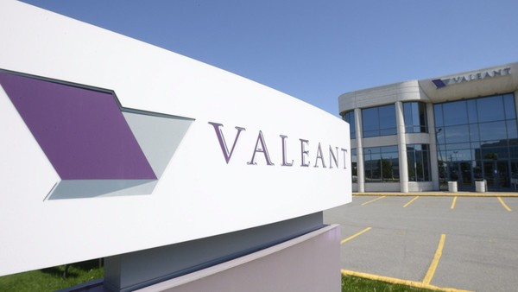©AP
W
hat is the right way to build up a drug company? Do you take the traditional route, investing in your own research and development and seeking to discover the remedies that you intend to sell?
Or is it smarter simply to dispense with all that tedious effort and buy other pharmaceuticals businesses? Then you not only get to skip the development time and uncertain expenditure. You can also jack up prices for proven medicines and thus maximise the value of each portfolio that you acquire.
Until recently, the modish answer in the US was to go for the latter option. The best example of the “buy not build” tendency — Valeant Pharmaceuticals — was also one of North America’s fastest-growing drug companies.

John Gapper
The financial tide has turned for Valeant
As the company has recently found, investors’ perceptions can change fast in this environment
Read more
Under its hard-driving boss, Mike Pearson, the group has over the past eight years bought one drug company after another, including well-established businesses such as the eyecare group, Bausch & Lomb, and the gastrointestinal treatment specialist, Salix Pharmaceuticals.
It seemed an infallible model. Valeant snapped up the target, funded largely by debt. Costs were stripped out largely by shutting down research and development, which was kept to a tiny proportion of sales (3 per cent as against the 15 to 20 per cent normal for drug groups). It then raised prices to maximise the value of what it had bought.
The approach worked partly because the bet was not on world-beating on-patent remedies. Valeant went after long-established branded drugs — hopefully with few competitors. Consolidation over many years had reduced the number of generic manufacturers. That meant it could raise prices — even for an extended period — without attracting additional competition on to its chosen turf.
Valeant has taken maximum advantage of the licence it has been given. It has acquired a reputation for ferocious increases. This year alone the company has raised the price of 81 per cent of the drugs in its portfolio, by an average of no less than 66 per cent.

More

ON THIS TOPIC
- Valeant severs ties with pharmacy group
- Pharmacy groups cut ties to Valeant unit
- Valeant tries to untangle pharmacy web
- Valeant urges SEC to probe Citron claims

INSIDE BUSINESS
- IBM deal is a test case for new economy
- Eastern European shale boom turns to bust
- China web rivals see benefits in merging
- Thiam introduces a quiet revolution

Sign up now
FirstFT is our new essential daily email briefing of the best stories from across the web
It would be nice to say these practices were unusual. But they have attracted imitators, and not just among companies that share Valeant’s yen for roll-up acquisitions, such as Endo Pharmaceuticals. Higher prices have become the norm across the industry.
Take generic drugs, which account for nearly 80 per cent of all US prescriptions. According to the research firm Elsevier, out of 4,421 drug groups, the price of 222 increased 100 per cent or more in the year to November 2014. Indeed so ubiquitous is the price raising that the tactic has started to suffer from the law of diminishing returns.
Not only are politicians now complaining on behalf of their constituents. The Democratic presidential challenger, Hillary Clinton, has floated the idea of capping prices to stop patients being ripped off.
Aggressive pricing is also encouraging insurance companies to accelerate consolidation. The two latest deals — Anthem’s purchase of Cigna and Aetna’s for Humana — could reduce the number of big health insurers to just three. That may spell higher rates for consumers. But it would at least also bolster insurers’ buying muscle when it comes to purchasing drugs.
Insurers are already taking a tougher line. Some drug companies have responded by adopting more aggressive sales strategies. These include teaming up with pharmacies to take the reimbursement hassle off those doctors who are willing to prescribe highly priced remedies. In some cases, it even means underwriting the cost of their own medicines if the insurers would not ultimately pay.
Inducing insurers (and ultimately patients) to fork out for unnecessarily expensive remedies is at best ethically questionable. Valeant has recently come under fire over its inadequately disclosed and now terminated relationship with Philidor, a mail-order pharmacy.
Valeant troubles cast light on speciality pharmacies’ murky side
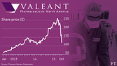
Short sellers allege group’s sales practices are being used in a complex scheme to inflate revenues
Read more
But the practice also prompts questions about how much of the price rises actually feed through to sales. Mr Pearson has given the numbers for one drug whose sticker price Valeant recently lifted by 20 per cent. The actual increase realised by the company was just a tenth of that amount.
Short-term returns are ultimately critical, of course, because Valeant is in reality a pharmaceutical company in name only.
Its true role is more akin to the sort of corporate raider that swept through rust belt America in the 1980s, the objective being principally to strip the capital patiently built up by target companies over many years.
Such strategies depend critically on two criteria: a high multiple and a ready supply of undervalued prey.
Valeant’s plunging stock price has certainly put paid to the former. Less clear is the damage it and its imitators have inflicted on the broader pharma sector.
Relatively unfettered pricing has made America the capital of global drug research. Dent public confidence and you risk changing that — at a cost to innovation. In the long run that can only harm the interests of patients around the world.
jonathan.ford@ft.com
Copyright The Financial Times Limited 2015. You may share using our article tools.
Please don't cut articles from FT.com and redistribute by email or post to the web.
- Share
- Author alerts
- Print
- Clip
- Comments

Mumsnet chases digital millenials

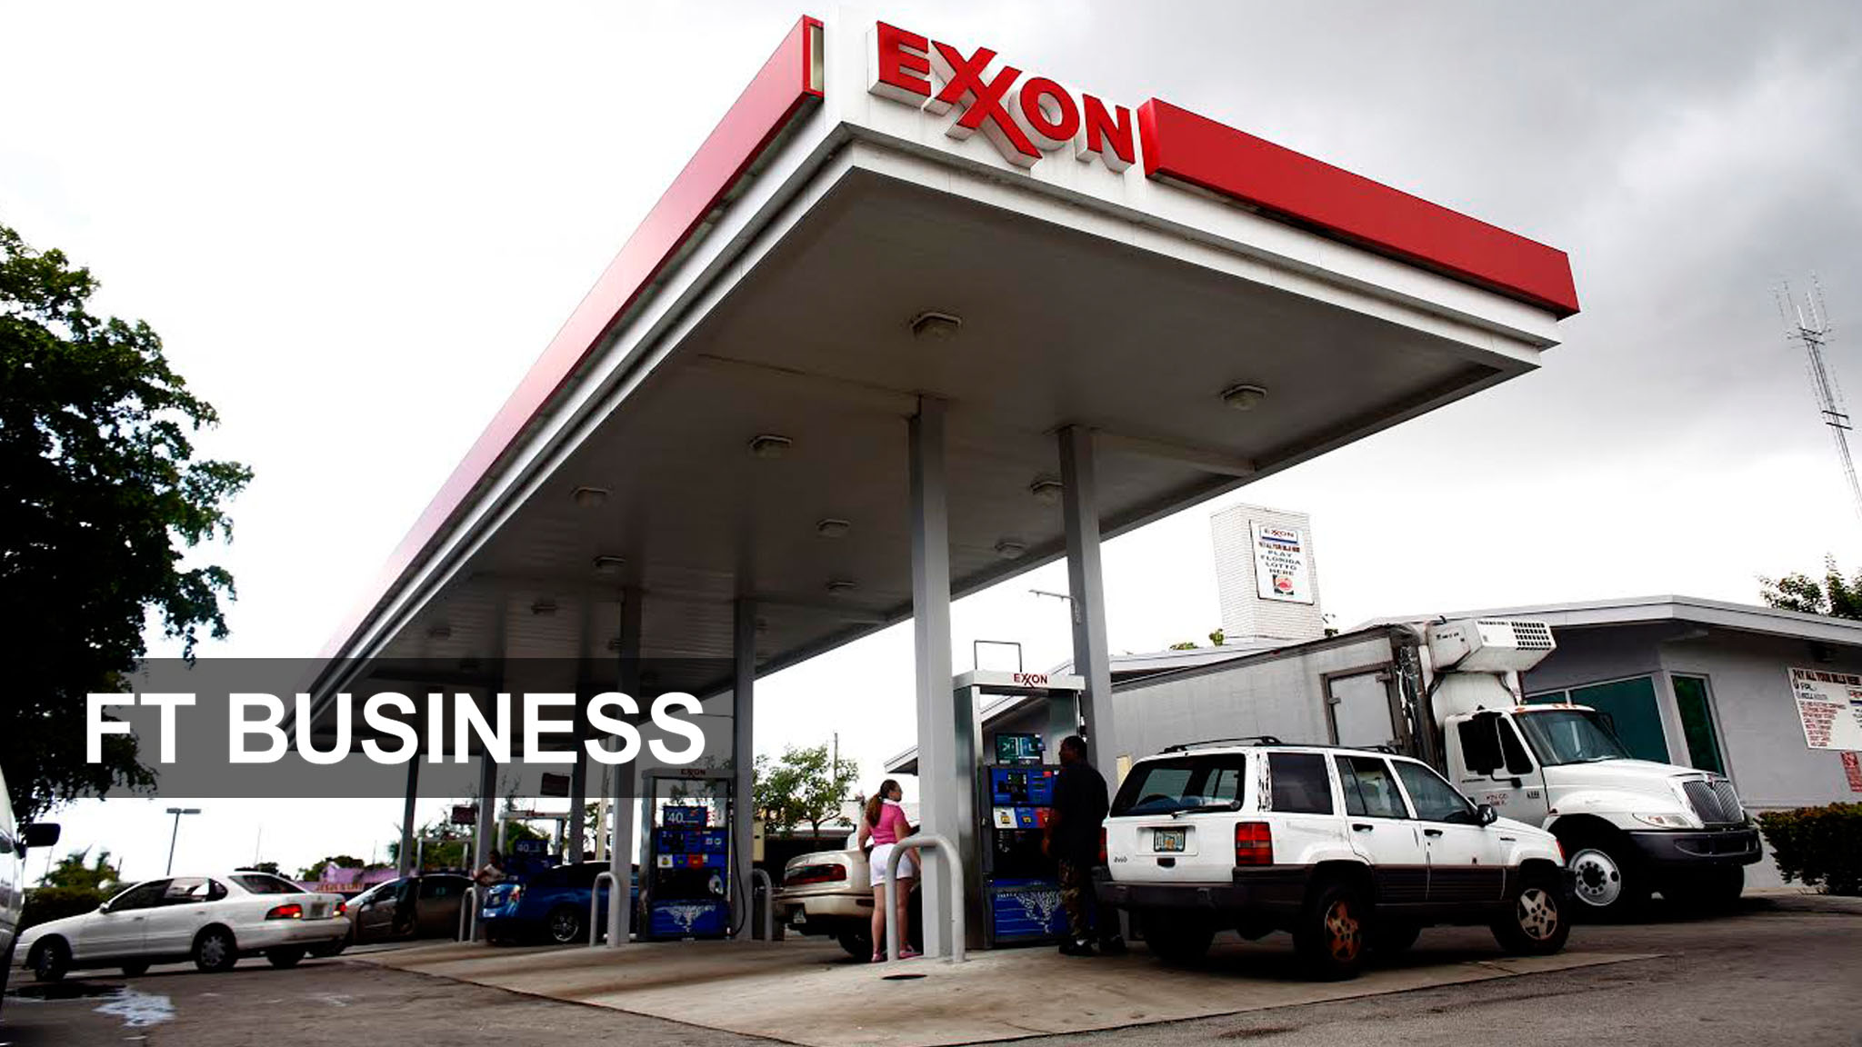
US oil majors show resilience

Bank of Japan — trick or treat?

COMMENTS (4)
Sign in

+ Follow
Submit Comment
By submitting this comment I confirm that I have read and agreed to the FT Terms and Conditions. Please also see our commenting guidelines.
Newest | Oldest | Most recommended
earlysitter7 hours ago
I think tis is the story of the power of honesty. One man at R & O Pharmacy did the right thing and refused to rollover when they steamrolled by the affiliate, Philidor, the shell corporation for Valeant Pharmacy. A single honest businessman stops the dishonest giant. Doesn't happen often enough, but it is great to see it happening this time! I hope this put a speed bump in place to all the imitators that have arisen to copy Valeant business plan.
ReportShare
2RecommendReply
Mr.Hulot19 minutes ago
@earlysitter Nice to believe but not the case. It’s more a story of greed. Emails prove Reitz knew what he was getting into. He didn’t anticipate the volume and realized he sold his company short. He wanted more than the $350K they had agreed to so he stopped depositing the cheques to add pressure. He didn’t anticipate Valeant suing him.
ReportShare
RecommendReply
Nobby7 hours ago
Also worth mentioning that these sorts of roll-ups leave investors pretty much clueless as to the strength of the underlying business owing to the use of pro-forma accounting and the freedom to adjust goodwill...
Of course, these firms provide a lot of fees to the big banks, so they never raise questions.
http://www.nytimes.com/2015/11/01/business/valeant-shows-the-perils-of-fantasy-numbers.html?smid=tw-nytimesbusiness&smtyp=cur
ReportShare
1RecommendReply
Hyerophant4 hours ago
@Nobby And there they were, asking the S.E.C. to swiftly investigate the analyst who called them 'the next Enron'... typical Mafia omerta.
ReportShare

A Response To Sequoia Fund's Letter On Valeant Pharmaceuticals
Oct. 30, 2015 8:40 AM ET | 41 comments | About: Valeant Pharmaceuticals International, Inc. (VRX), Includes: GILD
Disclosure: I am/we are short VRX. (More...)

Summary
Sequoia Fund wrote a letter to its shareholders with respect to its investment in Valeant.
I have several issues that I would like to raise with that letter.
If Sequoia thinks a 7 forward multiple on VRX is cheap despite its heavy debt burden and pending legal, political and operating issues, then GILD would be even better.
Sequoia Fund has been taken to the woodshed recently as its largest holding, Valeant Pharmaceuticals International, Inc. (NYSE:VRX) has sharply declined over various allegations. Some of those allegations may have been blown out of proportion but others have merit. This has prompted Sequoia to write aletter to its investors explaining its position while trying to defend VRX as two of its five independent board members quit. I have made no secret of my bearish view on VRX through my article published two days ago. I will follow that one up with a paragraph-by-paragraph rebuttal of the Sequoia letter as I believe this large investor has significant biases in favor of Valeant that needs to be addressed.
Paragraph 1:
(click to enlarge)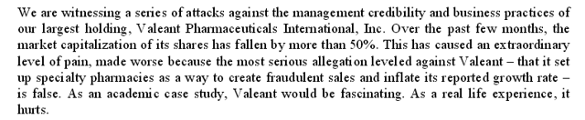
Unfortunate. No one likes to see others suffer from bad investments. However, if Sequoia has had a good few years from holding onto VRX shares then it is simply giving back gains made in this questionable company. If VRX is "patient stuffing" - meaning giving patients drugs they don't need while billing payers exorbitant amounts - then Sequoia has been financially benefiting while customers of private insurance policies have been paying higher rates due to Valeant's aggressive and possibly fraudulent (TBD by courts not myself) techniques being passed onto them by their providers.
Paragraph 2:
(click to enlarge)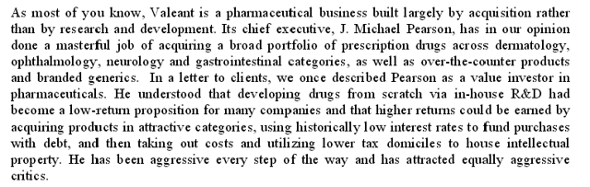
The problem now is that due to political pressures and burdensome debt load, VRX has stated its new directive is to sell certain divisions to reduce debt and expand R&D while limiting price increases. Can Sequoia trust Mr. Pearson to be the right person to lead VRX in a nearly opposite direction as it has been doing for the past several years since he has led the company?
Paragraph 3:
(click to enlarge)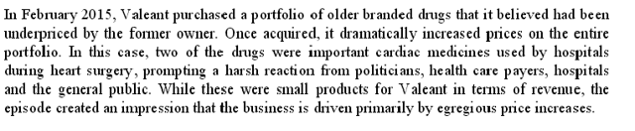
I take issue with this line of thinking. Sequoia just said in its previous paragraph that Mr. Pearson has done an excellent job in running Valeant. If he was really the brilliant value investor in pharma as Sequoia and Ackman say he is, perhaps he would have had the foresight to not egregiously raise prices on life-saving drugs. They comprise such a small portion of VRX's portfolio and therefore would have been a drop in the bucket in terms of revenue growth so leaving them be to avoid raising the ire of politicians or social activists would have been a prudent move that an experienced pharma investor would have done. This action shows that VRX is either reckless or hopelessly greedy, both of which usually result in a bad ending for the company in question (Lehman, AIG, any highly leveraged mid cap oil company right now, etc). Mr. Pearson and the rest of the VRX management team made a huge error in judgment, and VRX is paying an appropriate price for this mistake.
Paragraph 4:
(click to enlarge)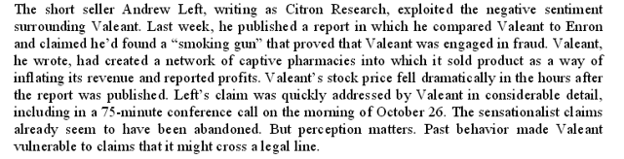
I thank Citron for their efforts in popularizing the bearish argument on VRX, but most of the research was done by Bronte Capital and SIRF as Citron correctly gave credit towards. The accounting fraud allegations may have been addressed, but the speculation over insurance fraud remains. As I write this article, CVS has just pulled Philidor from its network. Sequoia's letter is paying attention simply to the pieces that VRX addressed while ignoring what VRX has ignored to this point. There appears to be a lot more skeletons about to fall out of VRX's closet. With the debt load, VRX doesn't need to be an Enron to be deemed to have worthless shares. It just needs to be deemed to be worth less than $30 billion in enterprise value.
Paragraphs 6-8:
(click to enlarge)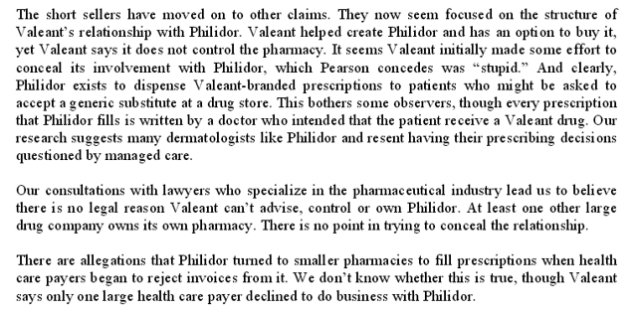
Sequoia's lawyers are absolutely right. Valeant SHOULD have no legal reason to conceal the relationship with Philidor. The fact that VRX has gone to extraordinary lengths to hide that relationship then explain the Philidor relationship as "immaterial" should raise a lot of red flags to Sequoia as a large investor.
I am disheartened to see Sequoia use the term "We don't know" with respect to Philidor turning to smaller pharmacies. Indeed, this may be a bit too granular of a detail, but if I owned billions of dollars in one particular investment, I would hire a few people to scour every detail possible in this investment. I am sure Sequoia's outside investors don't like seeing the term "We don't know" even more than I do. This should be a lesson to all investors. "Big money" is not always "smart money" and don't base your investment on large funds backing a particular stock under the assumption they have done their due diligence any more than you have. Bronte and SIRF have discovered issues with VRX's business model in a matter of weeks or months. Perhaps Ackman and Sequoia also knew about these issues as large investors in Valeant for years, but if they didn't that would have been a huge oversight on their parts and now they are paying dearly for it. A personal thumbs up and a handshake by Pearson does not qualify as due diligence.
Paragraph 9:
(click to enlarge)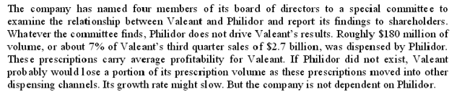
This is narrow-minded thinking to assume that the problem lies 100% with Philidor. The Philidor-Valeant relationship has grown steadily with time. Valeant explained that Philidor hired former Valeant employees, presumably with the "Valeant corporate culture" ingrained in them as that relationship has developed. As Sequoia stated, Michael Pearson was brought in to do things a certain way. If the issue with Philidor is bottom-up, then maybe Sequoia's assumption that's it's only a problem with 7% of the revenue is correct. But if the issue is a top-down edict from Valeant, then there is a potential issue with up to 100% of Valeant's revenues, depending on how fast Valeant's corporate culture has infiltrated its recent large acquisitions.
Paragraph 10:
(click to enlarge)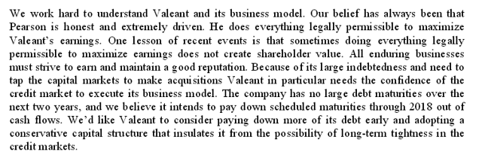
Not everything legal is moral or smart. Again, I point to the issue above where if Pearson was 100% in tune to the pharma market, VRX would not have raised the ire of Hillary Clinton and Bernie Sanders and put its whole existence at risk for some puny amount of revenue in obscure life-saving drugs. Other companies have risen drug prices yet Valeant is the face of it. Rather than playing the "why me" game, Valeant and its large investors should take some time to reflect as to why it's suddenly the poster child for this cause.
Making reference to the maturity date of the bonds is nothing more than a red herring designed to calm investor fears where they shouldn't be calmed. Dendreon, the company for which Valeant played the role of the vulture tearing off the last bit of meat from the dead carcass, did not have bonds maturing until 2016. And yet its shareholders have been wiped out and its IP has been sitting with VRX since early 2015. If enough events move against VRX, we could be sitting here next year talking about vultures picking the meat off of a bankrupt Valeant well before 2018.
Paragraph 12:
(click to enlarge)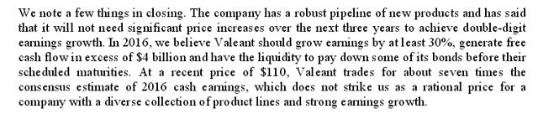
According to my estimate, EV/EBITDA is actually 8.8 times, and Gilead Sciences (NASDAQ:GILD) actually trades at a EV/EBITDA multiple of just over 7. And it does so without the stench that VRX has caused for itself. So if Sequoia is looking for a value play I suggest they do some research on Gilead.
About this article
Expand

Clear and hard-hitting analysis. When the (coal) dust settles Cloud Peak Energy is probably last man standing.

Coal is now at all time low, nat-gas is very close to a ten year low, and then Cloud Peak Energy comes along with this astounding 3Q result while maintaining its clean balance sheet.

If this is not the time to buy Cloud Peak Energy, when is it?
29 Oct, 06:43 AMReply! Report AbuseLike6
J Mintzmyer
, Premium Contributor
Comments (6106)| + Follow| Send Message

Author’s reply » Thanks for the comments, I agree fully. It's not uncommon for stocks to sell off indiscriminately due to negative macro factors, but CLD has been taken to the extreme.
29 Oct, 08:51 AMReply! Report AbuseLike3
Da Bears
Comments (9)| + Follow| Send Message

Alright I'm new to CLD but I've seen enough that I bought some of there 2019 bonds. Wish I had some more funds to buy the stock though
30 Oct, 04:57 PMReply! Report AbuseLike0
Snowball30
Comments (8)| + Follow| Send Message

What price do they get for exports?
29 Oct, 09:42 AMReply! Report AbuseLike1
wilibear
Comments (328)| + Follow| Send Message

60% of Newcastle, delivered. Here is copypasta of a comment of mine from a few months ago. Notice CLD has, in fact, re-negotiated these contracts since I wrote the comment.

Their export business is small. 4MM tons in 2014 and set to be 6MM in 2015. Their logistics segment has a lot of revenue, 200MM, but relatively little EBITDA, 4MM, or profit, (1.6MM). The high revenue comes from the fact that, for customers in this segment, CLD arranges for the transportation. So there is revenue when the customer pays CLD for transport and offsetting costs when CLD pays the railroads, export terminals, and sometimes ocean shippers. Or at least this is what I think must be going on.

I don't find the segment description clear and extensive enough to do counterfactuals on it. They have long-term contracts with the sea terminal they use and an ocean shipper. How much would it cost them to break these contracts? I don't know. Maybe the contracts are in the exhibits to the 10-K, but there are limits to how much time I am willing to devote to this.

Worst case scenario, they are just on the hook to deliver 6MM tons of coal a year at 60% of Newcastle benchmark. If you assume that their costs are fixed but their revenue moves at 60% of Newcastle, then EBITDA moves in line with revenue, and I suppose you reduce their EBITDA from this segment by 0.6*6*(Change in Newcastle benchmark since 2014).

What to plug in for the change in Newcastle benchmark? I couldn't find a convenient, free source for this price index historically. Piecing together news stories, it seems to have been a bit under 70 in 2014. It's 60 on the futures market now. So, put in 10. You get a downward revision to EBITDA of 36. This is almost certainly an overestimate of the loss, though. I assume they can pay less than 36 million dollars to get out of their contracts. If, indeed, their contracts are that restrictive.

The whole analysis seems implausible to me, though. How likely is it that CLD, which managed to go through the coal boom without taking on some gigantic burden of debt, leveraged themselves up this way (for a decade in the future) in what was not a very profitable sideline? Of course if they did do this, then the stock price movement is not so crazy. 36 million a year times ten years is a lot.
29 Oct, 12:01 PMReply! Report AbuseLike2
J Mintzmyer
, Premium Contributor
Comments (6106)| + Follow| Send Message

Author’s reply » It's only an unprofitable sideline if you take the 2014-2016 pricing and extrapolate that out for a decade. With full hindsight applied, it's obviously a tough place to be. Stock is down almost $1B on what in the worst case scenario would be a $360M loss discounted over 10 years.

Difficult to really model without seeing the new contracts, probably won't get much clarity expect from Q-1 flows when the full quarter is effective, but I believe my placeholder for a loss of $35M is fairly conservative.
29 Oct, 12:25 PMReply! Report AbuseLike1
Joshua Heller
Comments (385)| + Follow| Send Message

J M,

I am long CLD stock and bonds but am wondering how you came up with 35M as being fairly conservative?

In the call, CLD mentioned that they paid 11.3M in take or pay in the period and had EBITDA losses of 19M which was offset by 2.8M in hedging gains.

CLD also mentioned they had 7M in hedging gains available for 2016. So the run rate looks like it could be 80M and mitigated somewhat by the new agreement announced a day later. I am hoping for more clarity after an agreement is reached with their rail partners.

On the extreme side, I modeled in 80M and was thinking (based on Westshore cutting its dividend) that it might be closer to 50-60M.
30 Oct, 03:19 PMReply! Report AbuseLike0
J Mintzmyer
, Premium Contributor
Comments (6106)| + Follow| Send Message

Author’s reply » Joshua- thanks for the good questions.

During 9M-15, CLD had EBITDA losses of $34M- I'm expecting $50M for the run-rate this year. The export flows aren't proportional throughout the year, Q3 had a larger impact than I expect to see modeled forward 4x.

At $50M for 2015- moving forward to slightly higher hedges and the latest agreement (although I don't know the specifics), I came up with a $35M estimate for losses. You are right that there are a lot of moving parts and it is certainly a TLAR estimate.

I don't see $80M as anywhere close to a reasonable EBITDA loss though. How did you come up with that figure?
31 Oct, 02:26 PMReply! Report AbuseLike0
Joshua Heller
Comments (385)| + Follow| Send Message

J M,

We are both talking about 2016 right? 80M is from the conference call that I will cut and paste below.

----------------------
Mark Andrew Levin - BB&T Capital Markets
Thanks, guys. Congratulations also on the cost performance this quarter. Two questions. The first, I guess, I'll hit with the first one, which is worst-case EBITDA headwind from the Logistics business in 2016. Can you maybe frame how to think about what that might look like especially if Newcastle prices were to remain here? I think you mentioned you have about $7 million of hedges remaining for 2016. So maybe the math on how to think about how that might impact 2016 EBITDA?

Colin Marshall - President, Chief Executive Officer & Director
Well, I think we've explained before that the full take-or-pay commitment is in the order of $120 million. The other things in hedges and Logistics would probably bring that down by $10 million or $15 million again.

Heath A. Hill - Chief Financial Officer & Executive Vice President
And we did talk about the amendment previously in the last quarter, where we brought the committed volumes down in the next year through Westshore. So don't have a specific, but it's probably somewhere in the neighborhood of $80 million as it stands right now. It's about 4 million tons of commitment. And we talk about the take-or-pay loss being about $20 per ton.
1 Nov, 01:24 AMReply! Report AbuseLike0
J Mintzmyer
, Premium Contributor
Comments (6106)| + Follow| Send Message

Author’s reply » Joshua,

Thanks for posting that and putting it into context. When I read through the transcript on Wednesday, I clearly misinterpreted that question.

I thought the $120-$80M was the shift in total revenue liability (I.e. 100% nondelivery on the take or pay). It was my understanding that they are still far from 100% stuck on that.

In the context here though, it seems like that's a possibility and that $80M is certainly a bearish scenario outcome, adjusted of course for the recent agreement. Sorry for the flip response earlier on $80, should have went back through the transcript.
1 Nov, 09:39 AMReply! Report AbuseLike0
Nathan_T_Alexander
Comments (31)| + Follow| Send Message

Would be hilarious if Rio buys it back for under $6/share. If someone acquires CLD at these prices, they will actually have a net increase of liquidity.
30 Oct, 06:46 AMReply! Report AbuseLike1
J Mintzmyer
, Premium Contributor
Comments (6106)| + Follow| Send Message

Author’s reply » That would be a very ironic outcome; however, if there was even just a rumor about a takeover occurring, I'd expect the stock to rally very fast. Probably not possible to take out CLD for less than $9-$10.

The common stock has very little support right now from both retail (scared of coal) and institutions (also down on coal PLUS Cloud is a microcap so not worth the time). Despite this, the company itself is not in distress and any sort of serious buyout sniffing would serve as a firm catalyst in my opinion.
30 Oct, 07:28 AMReply! Report AbuseLike3
Hector V
Comments (630)| + Follow| Send Message

I'm long CLD, but even so, this is a bit too sunny of an outlook:

"Due to CLD's focus in the low-cost and low-sulfur powder rim basin (PRB), the company was mostly isolated from the major woes hitting the Appalachian miners and metallurgical coal producers from 2012 to 2014."

CLD didn't get over-extended, like a lot of miners, but until we see actual mine closures in the PRB, the oversupply and hence poor pricing will persist for CLD. Bankruptcy is no guarantee of mine closings - the mines could simply remain open with new owners. Supply reduction is what's needed for the industry to return to health. CLD has taken some tons off, but what's really needed is one of the other players in the regions to shut in a mine - an expensive proposition.

Also, one should keep in mind the 9.15/ton cost in Q3 is not representative of what will be seen going forward - the CEO said as much on the conference call. Q3 volumes were high due to a back up of Q2 deliveries due to flooding in the region. It was stated that high 9's is more realistic on an ongoing basis.
30 Oct, 08:16 AMReply! Report AbuseLike3
J Mintzmyer
, Premium Contributor
Comments (6106)| + Follow| Send Message

Author’s reply » Hector,

Thanks for the comments and you make several good points. I also agree that the $9.15 is very low and I also read the transcript from the call prior to working on this follow-up report.

I have $9.50 and $10 modeled for 2016 and 2017. The biggest factor here is going to be oil prices and the second factor is the level of production. At 75M tons and sub-$60 total realized fuel (market adjusted for CLD's potential hedges), I think $9.50 and $10 are reasonable. Obviously if the cuts go deeper, say to 70M tons and oil goes to say $70, then we'd see higher figures, hard to say for sure but probably close to $10.50-$11.

I'm of the macro view that oil is going to be struggling for quite some time, but I do agree this is certainly a moving part. I believe CLD will actually pay less for fuel costs in 2016 than they paid in 2015.

-------

Regarding the PRB oversupply, I think we're already seeing this as CLD, BTU, and ACI are all slightly reducing supply from an already decreased year of production. ANR's primary mine (Belle Ayr) is not economically feasible at these rates, and I think there's a significant chance it gets mothballed if 2016 rates hold as low as 2015. With bankruptcy they now have that flexibility.

Arch and Peabody mines are much more efficient, but are still higher-cost than Cloud Peak's assets. I certainly agree there are no guarantees of closure, but I think we'll see some progress with the Alpha assets for sure. With ACI likely to go bankrupt in December, there's more opportunity there as well.

People often tout bankruptcy as a bad thing for the survivals, using the airline analogy of tougher competition. In this market environment, that's absolute nonsense when referring to general mine economics and the decision to close or not. If a mine isn't profitable on a direct cash basis (before even considering overhead or interest), then it doesn't magically become "more profitable" post-bankruptcy. The exceptions would be hefty labor contracts and dumb fuel hedges (cough-cough: Peabody!!), but these are a smaller factor for all the PRB players.
30 Oct, 08:41 AMReply! Report AbuseLike3
Hector V
Comments (630)| + Follow| Send Message

Thanks J, appreciate the thoughtful response. If/when the ANR mine closes, I'll be more sanguine. My entire rationale for holding CLD is that the bankruptcies of the high levered players should result in production capacity coming out of the PRB. Not just production, which can be easily reversed, but production capacity, i.e. mine closure(s).
30 Oct, 09:38 AMReply! Report AbuseLike1
J Mintzmyer
, Premium Contributor
Comments (6106)| + Follow| Send Message

Author’s reply » Always enjoy a good dialogue- thanks Hector for the great points earlier as well.

I doubt we will see significant closures (of major mines) beyond the Belle Ayre. Production cuts should continue though.

However, CAPP is essentially dead and will see dozens of closures over the next year or two. Doesn't directly compete with PRB, but it will impact the domestic coal markets to some degree- probably much better for those with mines in the I-Basin and NAPP exposure, but might see a tiny uptick in the supply/demand routing (domino impact, CAPP to IBasin to PRB).

One bullish note I failed to mention for CLD is that capex. for 2016 and 2017 is likely to be lower if production does drop below 75M tons. Also note that 2015's $40-$50M figure included that dragline shift. I modeled $50M for 2016 and 2017, but $35-$40M might be feasible. I tried to keep the numbers as neutral as possible, but since you mentioned the operating costs and production declines, I think the capex upside is also worth a look.
30 Oct, 09:50 AMReply! Report AbuseLike2
Michael Borisov, CFA
, Contributor
Comments (20)| + Follow| Send Message

"CLD had total available liquidity of $669M versus a current enterprise value of only $690M."
Where do you see those figures? Could you provide a link, please?
I only see 123.5m in cash, and a commensurate amount of current liabilities.

Thank you!
30 Oct, 08:21 AMReply! Report AbuseLike0
J Mintzmyer
, Premium Contributor
Comments (6106)| + Follow| Send Message

Author’s reply » Thanks for the question Michael- directly from the Q3-15 report:
http://tinyurl.com/qfv...

"Cash and cash equivalents as of September 30, 2015 were $123.5 million and our total available liquidity increased during the period to $668.7 million. At September 30, 2015, there were no borrowings outstanding under our revolving credit facility or our accounts receivable securitization program."
30 Oct, 08:31 AMReply! Report AbuseLike0
Michael Borisov, CFA
, Contributor
Comments (20)| + Follow| Send Message

Thank you for the link. However, I have nowhere found an explanation as to what is this liquidity (in excess of 123.5m of cash). In fact, I have a strong feeling that the term "available liquidity" refers to an outstanding undrawn revolver facility. Which kind of changes the whole valuation point...
30 Oct, 09:08 AMReply! Report AbuseLike1
Hector V
Comments (630)| + Follow| Send Message

Michael: Liquidity is indeed cash + capacity on the revolving credit facility
30 Oct, 09:30 AMReply! Report AbuseLike0
J Mintzmyer
, Premium Contributor
Comments (6106)| + Follow| Send Message

Author’s reply » Michael,

The credit facility is of course the additional major source of liquidity.

How does it change the valuation point? Never made a case to value CLD on "total available liquidity." I wasn't trying to make some sort of net-net argument.

My point was that this is fairly unprecedented and represents the extreme bearish slant of the equity pricing and bond market trading.

In fact I was very generous on my EV, as I didn't mark the debt to market. If you do this, you'll see that liquidity easily surpasses EV.

Find me another (actively operating) firm with total available liquidity surpassing EV and a firm prospect of positive FCF over the next two years. There might be others, would be happy to see them.
30 Oct, 09:36 AMReply! Report AbuseLike1
Michael Borisov, CFA
, Contributor
Comments (20)| + Follow| Send Message

Sorry if I misunderstood you, I indeed thought you were making a net-net like argument. Thanks for the analysis.
30 Oct, 09:47 AMReply! Report AbuseLike0
mills43
Comments (6)| + Follow| Send Message

JM...

Why own BTU equity when their bonds are selling at 17.
30 Oct, 08:40 AMReply! Report AbuseLike0
J Mintzmyer
, Premium Contributor
Comments (6106)| + Follow| Send Message

Author’s reply » With the bonds at 17, the discussion shifts a bit, but when I first started picking up shares the bonds were much higher- in the 50s/60s.

I viewed the equity as a long shot (greater than 50% bankruptcy odds), but with significant upside in excess of 10x (at $2-range, $30-$40 post split). Meanwhile if things get worse and BTU goes belly-up, the 'senior notes' (actually quite junior to a lot of things) are unlikely to get much of a recovery.

At 17, the risk/reward tradeoff is not so clear. There have been a few good reports on the BTU debt. Willing to discuss more, but would rather stick to CLD on this page.
30 Oct, 08:48 AMReply! Report AbuseLike1
borisb
Comments (1029)| + Follow| Send Message

Cloud mgmt. hasn't show any interest in buying back their $300 million 2019 notes which would be a 20% ROI.
30 Oct, 08:42 AMReply! Report AbuseLike1
J Mintzmyer
, Premium Contributor
Comments (6106)| + Follow| Send Message

Author’s reply » Thanks for the comment boris.

To do this, they'd have to sacrifice precious cash. With the stock where it's at, if they wanted to throw $50M at something, I'd rather see an equity repurchase.

Their debt levels are fine- obviously repurchasing far below par is a nice outcome, but really no rush for them right now. Equity is trading at a far larger discount.

If their cash position improves over the next 3-4 quarters (it should increase by at least $30M-$50M), and the debt continues to trade poorly, then I agree it'd be nice to retire a decent chunk if possible.
30 Oct, 08:50 AMReply! Report AbuseLike3
Carolina1954
Comments (267)| + Follow| Send Message

JM,

What is your take on Alliance Resource Partners (ARLP)? Good management, reasonable leverage, secure 13% distribution well covered by GAAP earnings and cash flow, low cost producer--not much not to like except it's a coal company.

Maybe less potential upside % than CLD, but less risky and you get paid lavishly to wait.

C. David Kirby (long ARLP)
30 Oct, 09:59 AMReply! Report AbuseLike2
J Mintzmyer
, Premium Contributor
Comments (6106)| + Follow| Send Message

Author’s reply » Thanks for the comment David.

I don't find ARLP to be attractive to my personal risk/reward requirements, but for a more conservative speculator in coal I can see the attractiveness here.

Its always difficult to quantify exact upsides versus risk-adjusted downside potential, but I estimate that CLD is roughly 2x as attractive on these terms. BTU is by far the most attractive by this criteria.

Then again a 1:10 chance of winning a 25x return would be an amazing opportunity. Would you want to mortgage your house for this bet? Obviously not. If you are worried about losses effecting your lifestyle, then these sorts of speculations are not attractive at all.
30 Oct, 01:53 PMReply! Report AbuseLike2
homerun
Comments (54)| + Follow| Send Message

Very disappointing price action. This one should be moving higher or at least stabilizing. Punishing this stock even in this environment doesn't make any sense.
30 Oct, 11:04 AMReply! Report AbuseLike1
J Mintzmyer
, Premium Contributor
Comments (6106)| + Follow| Send Message

Author’s reply » Yeah it's a rough day in the market. This is the type of investment you need to reasonably allocate 2-3 years for. Really doubt CLD will surge anytime soon. Happy to be wrong of course.
30 Oct, 01:56 PMReply! Report AbuseLike0
- 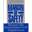
Understanding Businesses
, Contributor
Comments (133)| Following| Send Message

Great article J!

Two things: Are they primarily met or thermal based?

Also, how much of that liquidity actual available? I tend to doubt they could utilize all of it before busting a covenant and going into technical default. Not sure what kind of financial covenants they have, but I would guess they have some fixed cost, or leverage covenant that they would breach at some point before utilizing the full draw down.
30 Oct, 01:04 PMReply! Report AbuseLike1
J Mintzmyer
, Premium Contributor
Comments (6106)| + Follow| Send Message

Author’s reply » Thanks for the kind words.

100% low sulfur thermal coal.

Obviously it would be crazy/dumb to use a large portion of that liquidity on equity repurchases or acquisitions for example, but it's my understanding that 100% of that credit facility is currently available for use (without busting covenants).
30 Oct, 01:58 PMReply! Report AbuseLike0
Nick Mumford
Comments (8)| + Follow| Send Message

When industries are as distressed as the coal industry, I believe you need to analyze whether the company can repay its debt without external refinancing. It is a draconian scenario but useful to define the worst case.

CLD has $123 mm of cash and $300 mm due in 2019. It would be pointless to draw the revolver to pay down the bonds since the maturity date of the revolver is the September 2019 and the bonds mature December 2019.

Attempting open market purchases will probably be difficult since the issue is not widely held. When I search HYG holdings I find BTU and ACI but not CLD. I did a Trace search and the bonds have only traded 15 times in $1mm lots in the month of October. Can the company buy some of their bonds back in the open market definitely but certainly not significant amounts.

IF CLD uses all its cash to pay off the bonds it needs to generate $177 mm by December 2019 to pay off the bonds.

No Federal Lease payments is an incremental $$64 mm per annum which will help. If we take the last 9 month cash flow statement the company will produce $40 mm of cash per annum without the Federal lease payments leaving them $17 mm short of the $177 mm target over the next four years. This suggests that a few well timed purchases of the bond or a $50 mm bank line will see the bonds repaid. This is consistent with the authors FCF estimates

This analysis suggests that the combination of buying $40 of stock and $100 face of bonds for a price of $60 produces an investment with a downside of 8.5% per annum and an upside of $260 per $100 invested assuming that the stock goes to $12 and bonds go to par. The bond stock combination essential produces a high coupon synthetic convertible.
30 Oct, 02:23 PMReply! Report AbuseLike4
J Mintzmyer
, Premium Contributor
Comments (6106)| + Follow| Send Message

Author’s reply » Thanks for sharing your leg work on this.

I find the 2019 bonds to be very interesting- surprised to see them trading much below par.
31 Oct, 07:02 PMReply! Report AbuseLike0
Mitch Zeitz
Comments (1705)| + Follow| Send Message

Didn't they just buy their way out of some take-or-pay contracts?http://tinyurl.com/nso...
30 Oct, 02:26 PMReply! Report AbuseLike2
Blue Sky & Sunshine
Comments (601)| + Follow| Send Message

Mitch Zeitz: They have renegotiated their contract with their Pacific loading terminal (Westshore) and presumably lowered their shipping cost to Asian buyers. Good news.

They are also discussing current terms with BNSF to lower domestic shipping costs.
31 Oct, 01:00 PMReply! Report AbuseLike0
J Mintzmyer
, Premium Contributor
Comments (6106)| + Follow| Send Message

Author’s reply » BNSF contracts are obviously far above their 'worth,' but its a tough contract to renegotiate due to the lack of obvious competition.

I doubt they will disclose the exact details of the new contracts, but we should see the evidence in the cash flows during Q1-16.
31 Oct, 07:04 PMReply! Report AbuseLike0
pantherdoc
Comments (638)| + Follow| Send Message

Powder River Basin
31 Oct, 10:20 AMReply! Report AbuseLike0
J Mintzmyer
, Premium Contributor
Comments (6106)| + Follow| Send Message

Author’s reply » Thanks for being the first to point this out. I guess I've always just said "PRB" and never really had the nomenclature down.

Will be sure to correct in future discussions.
31 Oct, 07:07 PMReply! Report AbuseLike0
jlb7777
Comments (74)| + Follow| Send Message

PBR transportation cost to markets aren't going away for the next 3-5 years.
31 Oct, 12:58 PMReply! Report AbuseLike1
J Mintzmyer
, Premium Contributor
Comments (6106)| + Follow| Send Message

Author’s reply » You're right that the PRB is a difficult segment to transport from. Would be nice to see more power plants built in that area, but will be extremely doubtful due to the huge compliance costs in developing new coal plants.
31 Oct, 07:05 PMReply! Report AbuseLike0

