Valeant's Sum Of Parts Liquidation Value
Nov. 2, 2015 8:49 AM ET | 6 comments | About: Valeant Pharmaceuticals International, Inc. (VRX)
Disclosure: I/we have no positions in any stocks mentioned, and no plans to initiate any positions within the next 72 hours.(More...)

Summary
Valeant's fair value is calculated based on what it would be worth to an acquirer.
Difference between liquidation value and current market value is explained.
Revenue numbers for various divisions in Q3 are used for a sum of parts valuation.
Promoter extraordinaire Bill Ackman said on Friday that Valeant (NYSE:VRX) needs more PR and investor relations. I disagree. Valeant's CEO is a PR and shareholder communications genius. I believe he is the best writer of letters to shareholders.
Let me cut to the chase. I will calculate the sum of parts liquidation value for Valeant. Valeant has four main divisions, dermatology, ophthalmology, GI, neurology. Valeant also has small dental, oncology and emerging market divisions. What would Valeant be worth to an acquirer?

1. GI
This is the Salix acquisition (products are Xifaxan, Relistor, Uceris, Apriso, Moviprep, Glumetza). Salix was in trouble because its executives had stuffed the channel. They did not even know how much inventory their distributors had. Their CFO got fired and the CEO resigned. Soon Salix was auctioned and there was a bidding war. Valeant won it at an enterprise value of around $15 billion, paying $173 per share for roughly 80 million Salix shares. Only Endo (NASDAQ:ENDP) was prepared to pay more.
Endo was prepared to pay $185 per share (including the $5 per share breakup fee). Therefore, if the GI division were to be auctioned, we can give it a value of $15 billion plus $1 billion, i.e. $16 billion.
GI is the fastest growing division with the least exposure to generics.

2. Neurology & other generics
This division is too toxic for even Valeant. Valeant revealed that 61% of this division's revenue is exposed to generics. Its volume growth this quarter was negative, -7%. Its net weighted average price increase was 30%.
The question is who would step in to buy an asset that even Valeant doesn't want because it is completely dependent on price increases. This division had$546 million revenue in Q3 (see figure below), presumably this includes the Marathon drugs. The Marathon drugs are going to get generic competition quite quickly because applications are pending at the FDA and the Senate is asking questions.
Since this revenue has a lot of competition, and had shrinking volume growth, and any buyer will have a big PR problem on their hands if they want to price-gouge even more, I would put a generous multiple of five times revenue. That is $11 billion.
Actavis sold its generics division to Teva at less than six times revenue, and that was considered a very high valuation at the peak of the market.
(click to enlarge)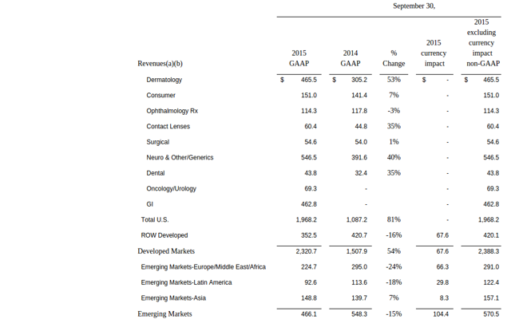

3. Dermatology
Except for Jublia, Zyclara and Elidel, Valeant's top 10 dermatology products are genericized. Zyclara is not even in the top 30 revenue generators for Valeant. Philidor was critical for dermatology. Until Philidor, dermatology had negative organic growth. In a previous article I have shown that most of the dermatology revenue comes from branded generics. Jublia showed almost no growth in Q3 versus Q2 (the growth has decelerated spectacularly).
(click to enlarge)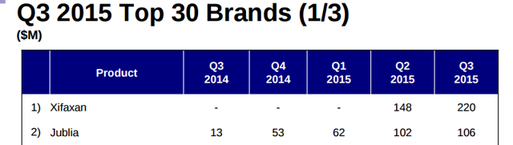
If we go back to negative organic growth for dermatology, and there is a big revenue fall because there is no Philidor, this would be a shrinking business too. Last year, in Q1 and Q2, ex-Bausch and Lomb organic growth was very bad for Valeant. These are the excerpts from their earnings releases of Q1 and Q2 last year:
Q1 2014:
(click to enlarge)
Q2 2014:
(click to enlarge)
In Q3 2014, perhaps due to Philidor being launched, there was a sudden drastic improvement:
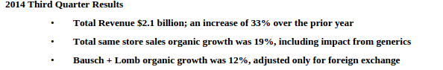
Given that the top 10 products were 62% of dermatology revenue, I would generously estimate that dermatology revenue would have been a $1.3 billion business in 2015 without Philidor. Say we give it a multiple of 5, it would be $6.5 billion.

4. Ophthalmology Rx, contact lens, consumer, surgical devices
This is barely growing (see the Q3 numbers), which is probably why Valeant does not break out Bausch and Lomb organic growth any more. The Q3 revenue annualizes to $1.5 billion. The FTC has started investigating Valeant's contact lens business for monopolistic practices and price-gouging.
With a multiple of five, that would be another $7.5 billion.

Final Value
The sum of the four divisions above is (16 + 11 + 7.5 + 6.5) = $41 billion.
Valeant also has a Dental division whose revenue is mostly from Arestin which is Minocycline Hydrochloride. This came via the Orapharma acquisition and was approved in 2001, so generic competition must be close). Oncology was the Dendreon acquisition. Let us be very generous and assign a value of $2 billion to these two combined.
That makes the total $43 billion.
8% of Valeant's "segment profit" comes from Emerging Markets. All the numbers so far dealt with "Developed Markets", most of which is US
Whereas the Developed markets segment profit was $690 million in Q3, Emerging was just $60 million.
(click to enlarge)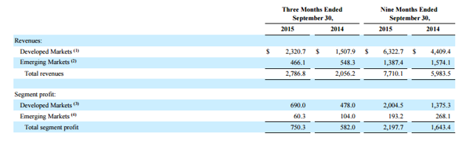
Suppose we give our current total of $43 billion an 8% boost from emerging markets. That gives us a total of $46.5 billion.
Valeant's net debt is around $29 billion. So the equity component of the enterprise value of $46.5 billion would be $17.5 billion. Dividing this by 350 million shares gives us a round number - $50 per share.

The discrepancy with market value
I believe the rest of Valeant's market cap comes from various factors:

1. Valeant pays almost no tax
Nobody knows how they do it. If they are transferring IP to Bermuda, Bahamas or Luxembourg, they need to pay a one-time transfer tax. If they attribute most of their profits to IP, the transfer tax must be high and their ongoing income tax must be low. But in Valeant's case everything is low and nobody knows how they do it.
Valeant is undergoing an IRS audit.

2. Cash EPS
Here, we should recall Charlie Munger's quote:
I think that, every time you see the word EBITDA, you should substitute the word 'bullshit' earnings."
If Valeant's revenue is 100% durable, which it isn't, you could add back the amortization of intangibles. Valeant, regardless of durability, adds it back (of course every serial acquirer claims their purchased assets are durable, like Mallinckrodt (NYSE:MNK) for instance). For example, if accumulated finite-lived intangibles are $27 billion and they are amortized over 10 years, for a charge of $2.7 billion per year, Valeant would add it back to get cash EPS.
(click to enlarge)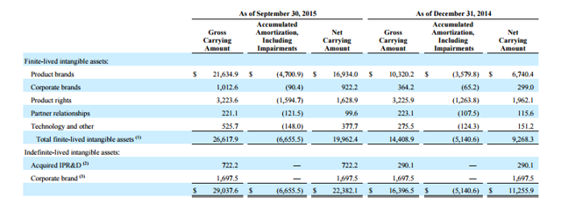This is very silly and I have written about it in more detail in the past. But with 350 million shares and an annual amortization charge of $2.7 billion, we can add back $7.7 per share in cash EPS.
Of course there are even more writeoffs from time to time, impairment charges, restructuring charges, etc. These too boost cash EPS.
Cash EPS is not representative of reality as many have written about in the past. But Valeant continues to market cash EPS and investors chased the momentum until things blew up. By ignoring GAAP, investors' imaginations have become unhinged from reality.
A Warren Buffett quote (just replace depreciation with amortization):
Trumpeting EBITDA (earnings before interest, taxes, depreciation and amortization) is a particularly pernicious practice. Doing so implies that depreciation is not truly an expense, given that it is a "non-cash" charge. That's nonsense.

3. Great shareholder letters
Valeant's CEO is the best writer of shareholder letters in my opinion. I believe this is how investors who stayed away from the drug industry all their life, such as RCG (Ruane Cunniff Goldfarb), Ackman, etc. were attracted to Valeant.

Caution to shorts
Valeant has been the fourth-highest payer of investment banking fees over the last five years. Only ultra-large companies GE and Verizon, and pipeline company KMI have paid more in investment banking fees.
Valeant's price targets were close to $300 a month ago. In my opinion, Wall Street analysts face career risk if they put out a more realistic price target.The New York Times article has a nice discussion:
At the same time, however, going along with a numbers game may also be a way to stay on good terms with a company's executives. Analysts who exert independence can find that managers may refuse to answer their questions or otherwise turn off the crucial information spigot.

Conclusion
I believe Valeant is overvalued, even at the current market price of $93 per share. My calculation shows a liquidation value of $50 per share. But shorts should be cautious because this is a momentum stock with a lot of sponsorship from Wall Street analysts. Those analysts have put up with the "cash EPS" nonsense.

Another article

The Keys To Valeant's Future
Nov. 2, 2015 8:59 AM ET | About: Valeant Pharmaceuticals International, Inc. (VRX)
Disclosure: I am/we are long VRX. (More...)

Summary
VRX has been deservedly under fire for its questionable relationship with Philidor, which it has now terminated.
On Friday, short seller Citron Research put out a Twitter message saying that VRX had a chance of going to $0 and that they had more news.
Sunday it was reported that Citron wouldn't offer any major new news.
By Parke Shall with Thom Lachenmann
A good amount of news has broken on Valeant (NYSE:VRX) since we asked the question of whether or not the short thesis was running out of steam. We released that article to timing that we could only find humorous, as just minutes after the article was published it was announced that CVS and Express Scripts had both dropped Philidor as a customer.
The following morning, VRX put out what we believe to be an obligatory press release and statement saying that they had severed all ties with Philidor. This is a decision that we thought was going to happen all along, and despite the wary terms and backwards nature of the company's option to buy the pharmacy, it now gets specialty pharmacy Philidor off the plate. VRX's specialty pharmacy business hangs in lingo, while it likely has begun a search for a new, more conservative suitor, to allow it to at least continue to make baseline specialty pharma sales.
On Friday, one of the short-sellers behind exposing some of the truths about VRX tweeted that he was going to have more information to release on Monday, and that this information may be the most damning in nature that the market has seen yet. This sent the stock into a tailspin, even while William Ackman was finishing up a presentation laying out the bull case for the company.
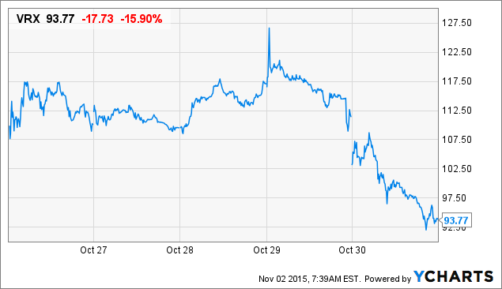
VRX Price data by YCharts
On Sunday evening, it was reported by the Wall Street Journal and by others that this short seller, after a couple of days, has said that he would "dial back "the information that he was going to be releasing to market. It's a far cry from what he had forecast on Friday,
A short seller attacking Valeant Pharmaceuticals International Inc. has pulled back on hints that he would unleash new bombshell revelations Monday about the drug company.
Andrew Left, who heads short-selling research firm Citron Research, on Sunday in an interview with The Wall Street Journal said investors shouldn't "expect anything earth-shattering" when he issues a new report on Canada's Valeant on Monday. He said he plans to update his view of the company, including with comments about the company's "corporate culture." Short sellers wager against stocks.
Mr. Left had tweeted Friday that he planned a new report on Valeant on Monday, following his Oct. 21 report that accused the company of using specialty pharmacies for "phantom sales" to inflate its financial results. In the tweet Friday, he said Citron would "update full story," adding: "Dirtier than anyone has reported!!"
With a major revelation looking like it may not happen, we continue to focus intensely only on the evidence that we have been provided on VRX.
There has been evidence of poor disclosure, and there has been evidence of what looks like insurance fraud from Philidor. But the key to VRX's future is going to lie in how much liability is going to fall on VRX from Philidor's wrongdoing. We know that these two entities are seemingly the same, but on paper and legally, is there going to be a straight line that we can draw from Philidor to VRX's executives?
VRX dropping Philidor last week could be a great development for VRX or it could be a horrendous development. Everything is going to depend on how much secondhand liability VRX has to Philidor. Whether or not this is going to negatively affect VRX stock is going to depend on how involved VRX was in these types of reported practices. While we admit that faking prescriptions and such are very illegal practices, and that the news on an absolute basis is not good for VRX, getting rid of this division of the company could be like severing off the wounded limb of a soldier in battle. It's going to be painful, but it may be the right choice in the long term.
Even in this morning's downgrade, Goldman said they were surprised that the market didn't view VRX's dropping of Philidor more positively.
In order for the stock to be driven lower now, investors are going to have to speculate that insurance fraud, reported by an ex-employee, is part of a bigger umbrella of fraud at VRX. Otherwise, if this is the first step in cauterizing the wound, the news may not be terrible for VRX. It was our opinion, and the opinion of several analysts we spoke with over the last few days that this was going to have to be the next step regardless. Even with taking off their specialty pharmacy business, the company is still undervalued just based on fundamental earnings valuation.
This certainly does not mean that there is no more risk. As we said in our last article, when we talked about our long position, we made a point over and over that there is still a risk on the table here. It is very important to be cognizant of that. When you are in a dynamic situation such as this one, the best an investor can do is try to figure out whether or not a stock is properly pricing in the risk to the fundamentals moving forward. We know it is not popular, but this is how we came about our decision of being long VRX days ago.
The news of the company dropping its specialty pharmacy takes the wind out of the sails of last weeks news that CVS and Express Scripts had dropped their relationship with Philidor. None of that is relevant anymore. The only relevant thing now, the keys, are,
1. How much legal liability to Philidor does VRX have?
2. How is the underlying portion of VRX's business performing?
We had started to write an article last week asking the question of how much liability is going to be transferred to VRX from what goes on at Philidor. We still believe this to be extremely pertinent, because if there are no other allegations of fraud that stem from systemic accounting fraud or major malfeasance at the executive level, then it is almost time for VRX to continue thinking about business as usual while the regulatory narrative begins to play out.
Sure, there remains a lot of risk. There are many short-sellers and bears that are out for blood, and VRX isn't helping themselves at all with the way that they have been conducting business or the way that they have been handling this inquiry. The company brought on a new public relations firm and has hired some former government officials in order to try and "clear up communications" between them and the government. We think that if the negative headlines start to slow down this week, the mainstream could start to introduce a different, less critical, view of the company and the equity may begin to come off life support.
We are not condoning the company's actions in hiding their specialty pharmacy segment, nor are we condoning the company's actions from an ethical standpoint. However, there are many oil and energy companies, as well as banks, that we own that we are sure we would not approve of from an ethical standpoint 100% of the time. When we look at VRX, we look at it from the perspective of whether business is going to continue and whether the company is going to survive the next year. We believe that they will, as long as there are no other major negative headlines that come out.
--

R&O On Valeant: 'A Lot More Is Going To Be Coming Out'
Nov. 2, 2015 8:41 AM ET | 1 comment | About: Valeant Pharmaceuticals International, Inc. (VRX), Includes: CVS, ESRX
Disclosure: I am/we are short VRX. (More...)

Summary
The tete-a-tete between Valeant, Bill Ackman and Citron Research over Valeant's "channel stuffing" has been great theater.
Valeant has since cut ties with Philidor which represents 7% of the company's Q3 revenue (about $195MM).
R&O, the pharmacy at the center of the scandal, has accused Valeant of "massive fraud".
If regulators follow up on R&O's fraud allegations, potential damages for Valleant could extend beyond a loss of revenue through Philidor.
VRX could free fall.
(click to enlarge)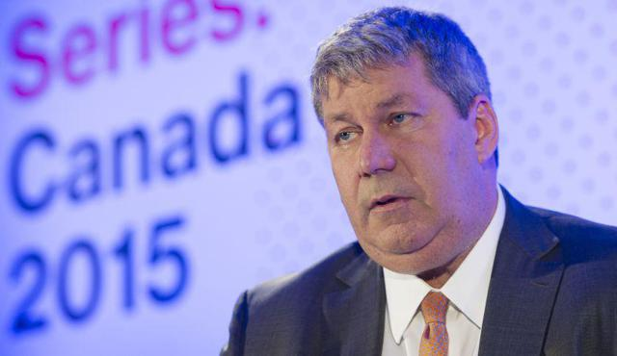
Valeant CEO Mike Pearson. Source: forbes.com
Valeant (NYSE:VRX) is an all too familiar story of how a company grew rapidly through acquisitions and cheap credit, only to unravel after the economy turned down or its business model came into question. Since a short articlefrom Citron Research claiming "channel stuffing" to boost revenue, VRX is down 35%. There have been a bevy of television appearances by Citron's Andrew Left and conference calls by Valeant and its lead investor, Bill Ackman. Valeant later cut ties with Philidor, the specialty pharmacy accused of being party to the channel stuffing.
However, little has been made of the event that triggered all the drama -- acomplaint filed against Valeant by R&O Pharmacy ("R&O") pursuant to a $69 million invoice. R&O owner, Russell Reitz, recently told the LA Times, why he decided to leave the reservation:
In the last two months, Reitz has filed papers in two Los Angeles courthouses laying out details of what he and his lawyer call "a massive fraud."
"I saw personal risk to my future, so I had to take action," the 64-year-old pharmacist said in an interview last week at his office ... Reitz declined to say whether he had spoken to law enforcement or regulatory officials."A lot more is going to be coming out," he said.
Personally, I never could ascertain why Valeant did not respond to R&O's initial claim. Over the past few days things have become more clear. Here is my take on Reitz's conversation with the L.A. Times:

LA Times On Specialty Pharmacies
Specialty pharmacies such as Philidor are part of a little-known strategy by Valeant and other pharmaceutical companies to sell high-priced drugs that insurers otherwise wouldn't pay for.
Many of Valeant's expensive brand-name medicines - including Jublia for toenail fungus and Solodyn for acne - are similar to generic medicines available for far less. When patients fill those prescriptions at the pharmacy, insurers often require the druggist to switch to the generic - causing Valeant to lose the sale.
Shock Exchange Interpretation:
The LA Times states explicitly that specialty pharmacies' strategy is to "sell high-priced drugs that insurers otherwise wouldn't pay for." The smoking gunin the tete-a-tete between Citron and Valeant was the aggressive sales practices that Philidor was using to boost sales. Such sales practices included [i] tinkering with a drug's price, [ii] lowering a patient's copay, [iii] lowering a drug's quantity or [iv] using another pharmacy's identification in cases where Philidor did not have a contract with the insurer.
Pharmacy benefit managers like CVS (NYSE:CVS) and Express Scripts (NASDAQ:ESRX) dropped Philidor from their networks due to its noncompliance with their provider agreement. Valeant then cut ties with Philidor after "losing confidence" in Philidor's ability to operate in a manner acceptable to Valeant and "being disturbed" about reports of its improper behavior. It all begs the following questions:
- How did Valeant think Philidor would convince insurers to pay for high-priced drugs they normally would not pay for if not via "back door" sales tactics?
- Certain members of the media questioned whether Valeant should cut ties with Philidor shortly after the Citron report.
- Was Valeant "disturbed" by Philidor's sales tactics or did it simply find it politically expediant to distance itself after CVS and Express Scripts sacked Philidor?
- Reports have also surfaced that Valeant had seconded employees to Philidor under assumed names. It could be difficult to convince pharmacy benefit managers that Valeant was totally unaware of Philidor's sales tactics.

Reitz On Philidor's Use Of R&O's Identification Number
In court papers, Reitz detailed how he had discovered that Philidor was using his national pharmacy identification number on prescriptions being filled at other pharmacies - and even on some that were filled and billed before he signed the agreement to sell R&O on Dec. 1.
Shock Exchange Interpretation:
Reitz's claim that Philidor was using R&O's identification number on prescriptions being filled at other pharmacies is consistent with Philidor's aforementioned backdoor sales tactics. In dropping Philidor from their networks for noncompliance with provider agreements, CVS nor Express Scripts singled out Philidor's use of another pharmacy's identification number in securing payment for drugs. However, according to the Journal, industry experts described the practice as "unusual."

Valeant On R&O Claim
Valeant said that Reitz's lawsuit "is without merit."
"We operate our business based on the highest standards of ethics, and we are committed to transparency," J. Michael Pearson, its chief executive, said in a conference call with stock analysts last week.
Shock Exchange Interpretation:
The devil is in the details here. Legally, Reitz's claim may or may not be without merit. It could be part and parcel of the "improper behavior" Valeant referenced as rationale for cutting ties with Philidor. Moreover, I find it hard to believe that Valeant could dismiss R&O for complaining about Philidor's use of its identification number, and then cut ties with Philidor for the same practice.
Secondly, Reitz's claims came in early September, so Valeant was aware of at least some of Philidor's "backdoor sales practices" then. Only after [i] Citron and others made an issue of them, and [ii] CVS and Express Scripts sacked Philidor that Valeant admitted to "being disturbed" by such sales prices, and a desire to "make things right."
My impression is that Valeant will only admit to what it is "commercially obligated" to admit to in order to assuage clients and distributors. There could be other issues that we will learn about later that could drive sentiment towards VRX even lower. Management's posture only buttresses my short position.

R&O On Philidor's Intentions
What Reitz hadn't known at the time he signed the sale agreement was that Philidor - and Valeant - were facing a hurdle in getting prescriptions filled in California, the largest market for medicines among the states. State Atty. Gen. Kamala Harris' staff had denied Philidor's request for a California pharmacy license, charging that the company had falsified information in its application ...
Reitz said he believes that Philidor had targeted his pharmacy because it needed access to his licenses, which he has in California and 33 other states, as well as to the contracts he had negotiated with insurers.
Shock Exchange Interpretation
If Philidor was using another pharmacy's license or operating in states it was not licensed to do business in, it could be considered as perpetrating insurance fraud. Secondly, if Philidor had been denied a pharmacy license and later tried to circumvent state regulators by doing business under R&O's license, the state regulators could look askance on that behavior.
The bigger question is, "Was Valeant aware of Philidor's behavior and was it party to any of it?" Based on management's prior posture, I believe it will only answer the questions that you ask, and only when it thinks that by not answering those questions, it could lose business. That said, asking narrow questions may only generate narrow responses.
To get answers, California Attorney General Kamala Harris (or others) may have to [i] accuse Valeant of the broad accusation of being party to Philidor's sales practices -- even insurance fraud, if it comes to that -- and await Valeant's response. Regardless of the fact pattern, the mere mention of Valeant's participation in Philidor's abuses could conjure up images of fines, penalties or even having its products banned from certain states. The stock would freefall in that scenario.

Conclusion
Philidor represents about 7% of Valeant's Q3 2015 revenue of $2.8 billion (about $195 million). Based on R&O's claims of "massive fraud," Valeant's potential damages could extend beyond a loss of revenue and earnings on products sold through Philidor. If state regulators follow up on R&O's allegations, VRX could sink. I am short the stock.
About this article
Expand
--

An Open Letter To Valeant's Michael Pearson
Nov. 6, 2015 8:11 AM ET | 26 comments | About: Valeant Pharmaceuticals International, Inc. (VRX), Includes: JNJ
Disclosure: I am/we are long VRX. (More...)

Summary
In A Crisis, The Buck Stops With The Company's CEO.
You Must Do Whatever Is Necessary To Redress Any Wrongdoing By Valeant Employees.
The Current Crisis Is Surmountable, But You Must Heed Certain Crisis Management Lessons From The Past.
Honesty Is Always (Repeat, Always) The Best Policy.
Dear Mr. Pearson,
I have watched with fascination from the sidelines the stunning and abrupt drop in Valeant's (NYSE:VRX) stock price in light of the recent scrutiny regarding the company with respect to Philidor Rx and the company's drug pricing policies, as well as unfortunate and unfounded accusations from a certain short seller that VRX is the "next Enron". In addition, I have listened to the company's most recent conference call on the foregoing and Bill Ackman's marathon call from last Friday regarding the same. In light of this, please allow me to offer you the following unsolicited advice on how best to deal with the situation at hand.

Take Full and Unconditional Personal Responsibility for What Has Happened at Valeant in Recent Weeks
Please know that as CEO, whether or not you had anything to do with the apparent shenanigans at Philidor, the buck (as they say) stops with you. That means that you must accept full and unconditional responsibility for anything and everything legally or morally questionable that has happened at the company. That also means that you should unreservedly apologize to anyone who has been hurt by the company's actions and that you will personally insure that redress is made for the same. Finally, that means that if the issues that have plagued the company in recent weeks are not fully addressed in due course, you will do the right thing and resign as CEO.
When Johnson & Johnson (NYSE:JNJ) was engulfed in the Tylenol scandal in the early 1980s, the then CEO James Burke took full control of the situation. According to the following postmortem from nj.com:
James Burke was extremely hands on, communicating directly with reporters. He was the face and the brand of Johnson & Johnson during the company's most difficult public hour. Johnson & Johnson immediately informed the Chicago Sun Times-no cover-up here. Burke then conducted a press conference that was transmitted to nearly 30 different locations where reporters had gathered from around the country. He allowed them to ask questions and answered each one as directly as he could given the information he had."
Another analysis of the JNJ - Tylenol crisis concluded that the following rules in crisis management must be adhered to:
- Be forthcoming and honest;
- Act quickly and decisively;
- Take responsibility, even if you don't have to;
- Treat people with respect; and
- Good behavior pays dividends.
I believe you should follow JNJ's example, as well as the lessons learned therefrom, to the fullest. Get all the facts out in the open as quickly as possible. Apologize for any wrongdoing. Personally guarantee that anything that has happened at Valeant that shouldn't have happened will never happen again.
Please do not mistake my meaning. I believe that you are an immensely talented and capable CEO. And I certainly hope and expect that you will remain CEO and do the right thing by the company, its customers, its shareholders and its employees. But the proof of this must come in the weeks and months ahead.

Get Rid of the Lawyer-Speak
In times of crisis, companies tend to circle the wagons. They become closed-lipped and refuse to answer questions dealing with legal issues, citing "the lawyers". Personally, I believe that this is a completely idiotic strategy for dealing with a crisis. For routine legal matters, perhaps such a strategy is fine. But for a crisis imperiling the entire future of the company and its thousands of employees, I believe that it is entirely unacceptable.
Candor should rule the day. When a shareholder or an analyst asks about an going investigation, please dispense with the scripted answers full of lawyer-speak. The lawyers aren't in charge of the company, you are. And shareholders have every right to know what your thoughts are and strategy is for dealing with vital issues facing the company. Thus, instead of constantly saying "Sorry, we can't discuss anything to do with the government investigations", try something like the following instead: "Although we unfortunately can't get into specifics on every detail involved, please know that we're investigating everything as we speak, that we absolutely accept responsibility for anything we've done wrong and that we are unconditionally willing to do whatever is necessary to remedy it. If we've screwed up in any way, we'll take responsibility and fix it, simple as that." And then deliver on those promises. Also, as an aside, please avoid the passive voice ("mistakes were made", etc.), it just makes the speaker look guilty and unwilling to accept personal responsibility.

Be Uncompromising in Dealing with Valeant Personnel Who Were Involved with Aiding and Abetting Philidor
Sadly, in a company employing as many people as are employed at Valeant, there will always be a few who try to bend or break the rules that everyone else follows. Obviously, whether any laws were broken at Philidor or otherwise, Valeant has abysmally failed the "New York Times test", as cited by Ackman on his call.
I thus urge you to heed the words of Warren Buffett from 1991, when he was testifying before Congress with respect to the then ongoing crisis at Salomon Brothers (which eerily echoes today's crisis at Valeant):
Mr. Chairman, I thank you for the opportunity to appear before this subcommittee. I would like to start by apologizing for the acts that have brought us here…. My job [as Chairman of Salomon] is to deal with both the past and the future. The past actions of Salomon are presently causing our 8,000 employees and their families to bear a stain. Virtually all of these employees are hardworking, able and honest. I want to find out exactly what happened in the past so that this stain is borne by the guilty few and removed from the innocent. To help do this, I promise to you, Mr. Chairman, and to the American people, Salomon's wholehearted cooperation with all authorities. These authorities have the power of subpoena, the ability to immunize witnesses, and the power to prosecute for perjury. Our internal investigation has not had these tools. We welcome their use.
As to the future, the submission to this subcommittee details actions that I believe will make Salomon the leader within the financial services industry in controls and compliance procedures. But in the end, the spirit about compliance is as important or more so than words about compliance. I want the right words and I want the full range of internal controls. But I also have asked every Salomon employee to be his or her own compliance officer. After they first obey all rules, I then want employees to ask themselves whether they are willing to have any contemplated act appear the next day on the front page of their local paper, to be read by their spouses, children, and friends, with the reporting done by an informed and critical reporter. If they follow this test, they need not fear my other message to them: Lose money for the firm, and I will be understanding; lose a shred of reputation for the firm, and I will be ruthless." [Emphases added]
To be sure, I don't believe that what has happened with respect to Philidor and/or Valeant's drug pricing issues approaches in any way the severity of the misdeeds that occurred at Salomon Brothers several decades ago, which nearly caused that company's bankruptcy. However, the spirit of the response to the Philidor scandal should mirror Buffett's from 1991. Benjamin Franklin said that "Honesty is the best policy". Certainly, that should prove true here again as well. And anyone at Valeant who has committed acts of wrongdoing should, in my opinion, have their employment terminated.

Disengage From the Short Sellers to the Extent Possible
While Valeant appears to have been smeared by falsehoods from certain shortsellers, I strongly urge you to refrain from commenting on them, except to the extent necessary to correct any false or misleading statements. Engaging in a "debate" with misinformed shortsellers is not worth your time. If any shortsellers have broken securities laws by spreading false information about the company in order to manipulate the stock price, rest assured that the SEC will deal with those people eventually. That's their job and they do it well. Instead, I would urge you to get back to running the business of Valeant to the best of your ability. Any false statements spread by others must be corrected immediately to prevent harm to the company, however going beyond that is a needless waste of resources and mental energy.

Conclusion
Mr. Pearson, I opened my letter by stating that I had been watching VRX from the sidelines. That was true until today. However, as of this writing I am now a shareholder of the company. As such, I believe that VRX shares are woefully undervalued, given the company's valuable assets. Further, I believe that the issues facing the company can be fully dealt with. As Ackman said on Friday's call, "Life will go on for Valeant." But how prosperous that life is depends in great part on whether your response as CEO to the current crisis meets the criteria I've tried to outline above. Although I can only speak for myself, this (brand new) shareholder trusts and believes that you will do the right thing in the days ahead on behalf of us, the shareholders, as well as on behalf of Valeant's thousands of employees and the patients and doctors they serve. Please don't let us down.

