VALEANT PHARMACEUTICALS INTL VRX
August 13, 2012 by
elke528
 |  |  |  |  |  | 2012 | 2013
Price: |  | 49.96 |  | EPS |  | $4.58 | $5.03
Shares Out. (in M): |  | 313 |  | P/E |  | 11.0x | 10.0x
Market Cap (in M): |  | 15,617 |  | P/FCF |  | 11.0x | 10.0x
Net Debt (in M): |  | 7,700 |  | EBIT |  | 1,805 | 1,970
TEV: |  | 23,047 |  | TEV/EBIT |  | 12.5x | 11.5x

Description
It’s only a slight exaggeration to say that Valeant Pharmaceuticals is a private equity firm masquerading as a specialty pharmaceutical company. But it’s not an exaggeration to say that Valeant is a different type of pharmaceutical company whose primary mission is to generate cash and create value for shareholders. Despite strong performance over the past four years, it remains an undervalued and underappreciated company. Based on continued growth, cost reduction plans, and modest acquisitions, over the next few years Valeant should trade into the mid-$70s and potentially into the high-$80s or even higher.
Before 2008, Valeant was a typical specialty pharmaceutical company with an over-reliance on a handful of drugs, significant investments in R&D, and a global infrastructure built out on the hope that R&D would pop out a number of valuable drugs. After the stock declined to around $11 in late 2007, a new board replaced the existing management team. The incoming CEO, Michael Pearson, had run McKinsey’s global pharmaceutical practice for over 20 years.
Based on his experience of advising JNJ, Teva, and countless others, Pearson had and has a different vision of the pharmaceutical business. He believes that too many pharma companies are run or held hostage by bureaucrats or scientists, who become attached to the potential of a drug and continue to throw good money after bad. Pearson’s strategy was to (a) get out of bad markets with government-controlled reimbursement and exposure to patent cliffs (i.e.: Western Europe) and invest in good markets with drugs with enduring lives (OTC/branded generics in Eastern Europe, Mexico, Brazil); (b) streamline operations; (c) acquire undermanaged drugs from companies that don’t appreciate them; and (d) acquire and gut companies who were overinvesting in R&D and SG&A on the promise of new drugs that probably wouldn’t live up to their hopes. For more detail on their strategic principles, see page 10 of Valeant’s recent investor day presentation.
In 2010, Valeant did a transformational merger with Biovail, a company that was somewhat similar to the pre-Pearson Valeant. It had a handful of valuable drugs that were facing stiffer generic competition or patent cliffs, and a recent board/management turnover that was more focused on creating shareholder value. Importantly, however, Biovail, a Toronto-based company, had a very low cash tax rate since its intellectual property (the core value of a pharmaceutical firm) was in Barbados and the company took advantage of a tax treaty between Canada and Barbados. Even though Valeant was the slightly larger company at the time, the deal was structured in a way to give a large dividend to Valeant shareholders so that the acquiring company was technically Biovail, preserving the tax structure. (That’s why, if you look at a historic chart, you’re actually looking at Biovail before the merger. You would need to look up the old Valeant for Pearson’s pre-merger stock chart.)
The merger with Biovail made Valeant what it is today: a globally diverse pharmaceutical company with strong positions in their niches, with a very low tax rate, and an acquisition machine that reinforces the core areas and adds additional platforms for further growth. A platform could be either geographic (such as Russia, where they got exposure through the PharmaSwiss acquisition in 2011) or in therapeutic area (such as U.S. podiatry or U.S. dental).

Why does this opportunity exist?
1) Roll-up taint: While Valeant has been described as a roll-up, and it certainly has made a lot of acquisitions (33 over the past 3 years, excluding Biovail, ranging in annual revenues from $2m to $250m), there is generally a common theme to the acquisitions. First, the acquisitions are made in a disciplined fashion. Valeant generally doesn’t participate in auctions (or if they do, they generally disrupt the auction process). In their Q311 earnings presentation, they showed how the major deals going back to 2008 had grown in the aggregate at a 22% revenue CAGR since acquisition (pages 11-12; presentation here: http://goo.gl/Nucam), and only 3 out of 18 were behind their expectations on a cash basis. Second, the business is run on a decentralized basis so the management teams at the business units are responsible for sourcing and executing on their deals. It’s not all reliant on Mike Pearson (though it can seem that way). Third, usually, there is something strategic about the acquisitions. For example:
- In late 2008, VRX acquired Dow Pharmaceuticals, which had had 10 dermatology drug approvals in the prior 4 years – a great track record. In addition, they had a contract service business utilized by many top dermatology companies which helped to subsidize their own R&D spend.
- Valeant had a Mexico plant with an old facility. With their acquisition of Tecnofarma in 2009, they not only expanded their generics business, they also acquired a new plant which was and is the source of improving margins.
- In Australia, from 2008 to 2010, Valeant consolidated many skincare and suncare products. If the Australian business had remained small, Valeant could have sold that logical collection of assets at a higher multiple than the various acquisitions that they had done. But in late 2011, they doubled their Australian business with a new acquisition, so they will be taking the skincare products to a new footprint in Southeast Asia.
2) Skepticism over continued presence of good acquisitions: While it’s possible, Valeant’s advantage is that it can source acquisitions from nearly every corner of the globe. If a target in the US wants to hold out for more, Pearson can take his cash to Russia or Brazil. If someone in Australia wants more, he can look to Mexico. Valeant’s increasingly diverse platform allows for more potential for a proper fit at the right price.
3) Specialty pharmaceutical skepticism: Specialty pharmaceutical analysts like to analyze pharmaceuticals and track prescription trends from IMS or Wolters Kluwer. For Valeant, it almost doesn’t matter. With the largest drug representing ~7% of revenues (and getting smaller as acquisitions take place and grow) and more and more of Valeant’s business coming in disparate places like Brazil, Australia, and many countries in Eastern Europe, it becomes impossible to analyze the typical way. Nonetheless, as a “specialty pharmaceutical company”, Valeant’s multiple is dragged down by traditional specialty pharmaceutical companies that can trade as low as 4x EPS.
4) It’s confusing: Valeant does so many deals and largely does them by raising debt, it’s hard to keep track of everything. Over the past few years, there have been concerns about: (a) how organic growth is calculated; (b) drug reimbursement in Poland; (c) accounting related to an asset-deal completed last year; (d) add-backs of acquisition-related expenses; (e) financial weakness of distributors in Slovenia (or was it Slovakia?). Every time, management has responded by disclosing more, usually in more detail than I’ve seen in any other public company.

Investment Thesis:
1) Valeant has a strong and diversified global platform from which to continue to grow: Valeant’s revenues come from over 30 countries and over 500 products (seehttp://goo.gl/X0WY0 for a slightly dated list of their drugs by country).
Here is a summary of each of their business units (Note that here I cite Pro Forma organic growth. I suggest you take a look at Valeant’s recent investor day slides and their Q212 earnings release for some background on the two ways they calculate organic growth.)
- U.S. Dermatology [~$1b revenues estimate; latest PF organic growth +29%]: Valeant has had a dermatology business for years, but in the past year it has been transformed into one of the three largest dermatology companies in the U.S. The big leap came with December’s acquisition of Dermik and Ortho Dermatologics. To give you a sense of Valeant’s efficiency, prior to close, Valeant let the Dermik sales force promote one of Valeant’s drugs, and it let the Ortho sales force sell another. This way Valeant could evaluate the effectiveness of its new sales forces and optimize them as soon after close as possible. Dermatology is attractive because (a) drugs are often paid for in cash, (b) it is more difficult for generics to prove bioequivalence to topicals, and (c) there aren’t that many dermatologists out there.
- U.S. Neurology and Other [~$700m revenues estimate; latest organic growth -10%]: The biggest component in this segment is Wellbutrin XL, an anti-depressant which has faced generic competition for years but still has a loyal, though declining, following. This segment has characteristics of typical specialty pharma companies: lots of drugs, many in run-off or slow-growth mode. Nonetheless, it is a significant source of cash and has some potential in a niche ophthalmology platform. In the latest quarter, the organic growth was -10%, though the decline should slow down as they were hit with some patent cliffs on smaller drugs in the last 12 months.
- Canada / Australia [~$600m 2012E revenues; latest organic growth 4%]: Valeant and Biovail both had good-sized businesses in Canada, and now they are one of the largest drug companies in the country, which has made them a good partner for many smaller drug companies looking to enter the country. In Australia, Valeant has a significant presence in skin-care and sun care, with many OTC products. Their Australian business was transformed last year with the acquisition of iNova, which gave them OTC brands for weight management, cold and cough. Neither Canada nor Australia will grow very fast, but they generate a lot of cash.
- Emerging Markets: Central/Eastern Europe [~$760m 2012E revenues; latest PF organic growth 14%]: Through a series of acquisitions over the past four years, Valeant is now the 15th largest pharmaceutical company in the region, which stretches from the Czech Republic to Russia. Their focus is on branded generics, which, as the name suggests, are a hybrid of branded drugs and generics. In many emerging market countries, truly generic drugs are not trusted for safety, so a brand is important. Since existing drugs have a long tail but do not grow faster than the economy, the key to faster growth is bringing new drugs into the market. This year, Valeant will bring over 250 new branded generic drugs to their markets (think of these as drug-country combinations). In addition, it’s important to note that only about 30-40% of their revenues are subject to government reimbursement. Valeant is now focused on growing Russia and shifting to more OTCs and other niche markets where they have strengths in the U.S, like dermatology and ophthalmology.
- Emerging Markets: Latin America [~$360m 2012E revenues; latest PF organic growth 15%]: Currently, Latin America is comprised of operations in Mexico and Brazil. They sell a combination of OTC and branded generics in those countries. In Mexico, only about 25% of revenues get government reimbursement. In Brazil, the number is zero. Also, in Brazil, the largest drug represents less than 7% of revenues. Their most recent large acquisition there was for Probiotica, which is the largest sports nutrition and supplement company in Brazil (31% share). Brazil should be a target market for some of Valeant’s dermatology expertise as well.
- Emerging Markets: Southeast Asia/South Africa [~$100m 2012E revenues; latest PF organic growth 40%]: Valeant acquired this business unit with the iNova acquisition last December, and it gave them a foothold across a wide region. South Africa is the largest part of this (~35%); but other important countries include Malaysia, Thailand, Singapore, Philippines, and Japan. The drugs sold in these regions are largely cough, cold, and pain management medicines from iNova’s portfolio. As time goes on, expect Valeant to bring to this region some of its global OTC brands for skin and sun care.
2) Valeant is a cash flow machine. The model is quite simple, and consists of:
- A diversified platform without much reliance on any single drug provides stable revenue foundation,
- High gross margins (~75%), modest R&D, and efficient SG&A result in very high EBITDA margins,
- Low tax rate derived from multiple locations (largely Bermuda and Switzerland; they pulled out of Barbados recently)
The cash funds acquisitions of undermanaged and underappreciated assets and companies in geographies around the world. Valeant then runs those acquisitions better and typically with a lower tax rate, further increasing cash flows.
Their acquisitions often have something special that either creates a new platform for additional growth and acquisition (such as iNova’s South Africa/Southeast Asia business or the Russian business in Sanitas) or something that can benefit the rest of Valeant’s distribution (like the state-of-the-art topical manufacturing facility from Dermik or a sports nutrition business like Probiotica).
3) Excellent and highly-aligned management team, with significant insider buying over the past 12 months. Mike Pearson sets the tone here. He is extremely hard-working, but spends a significant amount of time making sure the right people are in the right positions in the company – and then holding them accountable for their results. The COO, Rajiv De Silva, worked with Mike at McKinsey for many years. Their CFO, Howard Schiller, joined at the end of 2011 after 24 years at Goldman Sachs, where his last role was COO of the Investment Banking Division.
The management team’s and board’s stock ownership is clearly outlined in the proxy. Pearson owns 2.28m shares, 4.9m options, 1.4m time-vesting restricted shares; and 1.1m performance-vesting shares (more below). All executive officers have to own shares representing 2x the combined amount of their salary and target cash bonus. In addition, there is a restricted share matching program (three or four-year time-based vesting). Finally, officers are granted performance-based restricted shares, for which vesting is based on the annual rate of return of the stock price over three or four years, or Total Shareholder Return (“TSR”). For TSR below 15%, nothing vests. For 15% TSR, 100% of performance shares vest. For 30% TSR, 200% of performance shares vest, and for 45% TSR, 300% of performance shares vest. And for Pearson, for TSR of 60%, 400% of performance shares vest.
Since July 2011, seven insiders have purchased shares at prices ranging from $38 to $53. Notably, Pearson purchased an additional $1.6m worth last August. The new CFO purchased $4m soon after starting work. The head of HR (who had worked with Pearson at McKinsey) bought $476k. And four directors have purchased shares in the last three months. The most noteworthy of those is ValueAct, who helped bring Pearson in.
4) Right approach to corporate governance, capital allocation, and shareholder communication. As you would expect, Valeant’s board has the requisite pharmaceutical, biotech, international, and financial experience. What’s different, however, is that the proxy actually reports how many committee meetings occur and what the attendance is (see the table on pages 17-18 of the proxy). You get the sense that this is how Valeant measures everything, from the board on down.
On capital allocation, Valeant understands that the stability of the business should be able to support a large and consistent debt load, so they fund their acquisitions with debt, and on occasion use excess cash to buy back stock (their current plan still has $1.1b remaining). At the latest investor day, Pearson mentioned that the pipeline of good acquisitions is so large, however, that they will likely use their cash for those rather than for stock buybacks in the near future. For their acquisitions, they target 20+% IRR – excluding the benefit of their lower tax rate. Capex is light, at maintenance levels of ~$60m/year (to be increased slightly in the next 18 months, explanation below). It’s worth noting that the new Valeant has abandoned the luxurious headquarters of both the old Valeant in California and Biovail in Toronto. Headquarters are now in Montreal since they have a number of operations there and the provincial government gave them a $6m incentive to move.
On shareholder communication, despite all the moving parts, Valeant tries very hard to be transparent. When the stock sold off last August, there were lots of theories around about what the problem was. On their Q3 2011 call, Valeant came straight out with the list of questions they were getting from investors and set the record straight. When the Street didn’t like how they were reporting their organic growth (pro forma vs. same-store sales basis), Valeant started reporting it both ways. When they heard complaints about all the large amount of adjustments between “Free Cash Flow” and “Adjusted Free Cash Flow” due to the acquisition-related adjustments, they began to show the detail of the adjustments on a deal-by-deal and categorical basis. I have never seen this level of disclosure from a public company before. Furthermore, they do a lot of little things that should speak to value investors. For example, they write off any receivables over 90 days and in their calculation of cash net income, the do not add back stock-based compensation.
5) Attractive current valuation and free option on additional acquisitions: Based on 2012 Cash EPS (excluding one-time items), Valeant is trading at 8.5% FCF yield or below 12x P/E. Excluding additional acquisitions, I believe that over the next couple of years, Valeant will trade at least in the mid-$70s. Assuming they continue with the smaller-type acquisitions they have done this year, the stock could trade into the $80s. And there’s probably a good chance that Pearson does something even bigger that creates even more value.
Valeant reports a Cash EPS number that adjusts for acquisition-related amortization and restructuring expenses. Cash EPS tracks pretty closely with FCF since depreciation has historically tracked capex. This year they are expecting and on track for Cash EPS per share of $4.18 to $4.38, which excludes some one-time items (clearly disclosed in their Q212 earnings presentation). Rolling that forward into 2013 and 2014 with decent but slowing organic growth, and no improvement in gross margins, Cash EPS should be about $4.75 and $5.50, respectively. Longer-term, with more modest organic growth (~6%), Valeant should be generating well over $7 per share by 2016 – excluding any additional acquisitions.
In addition to leaving out acquisitions, this assumes no benefit from improvements in gross margin. On the latest quarterly call, Valeant offered their plan to increase gross margins by about 500 bps to 80% over the next few years. Valeant is quick to get cost synergies out of SG&A and R&D, but wisely slow with manufacturing processes. Now that they own multiple plants in Canada, Brazil, Australia, Mexico, and Eastern Europe, they are going to consolidate manufacturing further. This will cost another $50-60m in capex in the next 18 months, but since each 100 bps of gross margin represents about $25m of cash, the investment is well worth it.
On the upside, with modest amounts of acquisitions (say $200m in revenues/year) and 80% gross margins, Valeant Cash EPS could approach $9 by 2016.
On the downside, given the diversity of the Valeant’s businesses, it’s unlikely that something could derail them permanently (though see the risks below). If something negative happens in the short run, based on past experience, I would expect to see management and directors purchase more shares and the company buy back its stock, giving it some support.
If you’re going to dig into the numbers, I suggest you start with the June 21 Investor Day presentation, especially the CFO’s section. http://goo.gl/d31rb. Another good presentation is their debt market presentation from May 31. Think of it as a “greatest hits” of the investor day, which is quite long. http://goo.gl/J8o66

Risks:
1) The acquisition strategy requires access to the debt markets: Valeant’s debt/cash flow ratio is about 5.7x. (Debt/EBITDA isn’t so relevant due to the low tax rate.) Getting new and low-cost debt has not been a problem, but it’s certainly a risk, since acquisitions are key to Valeant’s strategy.
2) Execution, execution, execution: They’re trying to do a lot of things in many regions of the world. So far, acquisition integration has gone smoothly (at least seen by outside shareholders). So far they have done good due diligence on the deals they’ve done. Will this track record continue?
3) Zovirax generic?: Zovirax is a cold sore ointment that represents about 7.5% of Valeant’s current revenues and has been a large contributor to growth in the past 12 months (that will slow as they anniversary a packaging and pricing change they made). Some recent draft guidance by the FDA eased the pathway for a generic to compete with Zovirax. Valeant does not know where this came from or whether or not anyone is working on a Zovirax generic. Valeant has a backup plan should something come up, but this is another risk.
4) Regulatory/reimbursement environment: Valeant is diversified across geographies, but a major change to a large market could have a negative impact on them.
5) Currency fluctuations: Valeant has minimal exposure to the Euro, but they do to lots of other currencies (most importantly are Australia, Canada, Poland, Serbia, Mexico, Brazil)
6) Changes to tax environment: Considering that Valeant has diversified even its tax strategy, it is hedged here, but one never knows what governments might do.

Catalyst
1) Continued execution and cash flow generation
2) Accretive acquisitions, and in the absence thereof, continuation of stock buyback plan.
3) Data released on IDP-108, a topical nail fungus drug that supposedly has very good potential (not explicitly in the financial forecasts outlined above).
Back to top
gb48
3/06/14
RE: Any thoughts after Chanos disclosed short?
reply
anyone has a link to chanos comments?

· reply
6 | cgnlm995  1/13/14  RE: Math  reply
half the value creation day one, but consider tax rate is zero so all future cash flows are untaxed, etc..... the synergies in branded generics should be huge
· reply
3 | cgnlm995  1/13/14  merger partner  reply
just for fun, guesses? mine is Abbott
· reply
2 | zzz007  8/14/12  RE: surprised  reply
Yeah, per majic's comment, given what a hedge fund hotel this is I've looked at it (very briefly) a few times in the past as I've seen it crop up on numerous 13Fs. I've been surprised at what horrible consolidated returns on capital this company generates. The ROEs are reasonably attractive, which supports elke's point that this is effectively a publicly-traded PE platform company. Without the financial engineering there wouldn't be much of a story here. That raises the attendant risks (leverage, integration, organic growth) in the investment, and (IMO) makes timing more critical than usual so that you're not the last man standing when the music stops.
· reply

Valuing Valeant
Must Read | Aug. 18, 2015 8:11 AM ET | 26 comments | About: Valeant Pharmaceuticals International, Inc. (VRX)
Disclosure: I/we have no positions in any stocks mentioned, and no plans to initiate any positions within the next 72 hours.(More...)

Summary
Valeant's businesses seem more fairly valued in the $76-$157 range.
The fair value of the intangibles is sensitive to management assumptions.
Company performance is intimately intertwined with the health of the credit markets.
A key margin of safety is the availability of a strategic buyer.

1. Recommendation
Short Valeant (NYSE:VRX) to PT of $117. To be clear, I have read many articles on SA, VIC and other sites where the recommendation appears to be to short now. I would never short a stock unless it satisfies technical criteria (my strategy is pretty close to O'Neil's). Given VRX has strong positive momentum, it may be a while before the opportunity presents itself to short it.

2. Business Overview
Valeant Pharmaceuticals is a specialty/generic pharmaceutical and medical device company headquartered in Quebec.

3. Brief History
Valeant has a colorful history, which can be reviewed here.
Valeant's predecessor was ICN Pharmaceuticals, founded by Milan Panic. Panic had a knack for taking advantage of shareholders. A hedge fund called ValueAct took a 5.5% stake, kicked Panic out, and hired Mike Pearson as a consultant. Pearson came from McKinsey where he had built a reputation helping big pharma cut its in-house R&D programs and outsource development. The model was to buy approved drugs, cut R&D, slash SG&A, and hike prices. ValueAct liked his plan so much they hired him to be CEO in 2008. They structured his pay package much like that for a PE firm portfolio company, with RSUs attached to share price appreciation and other metrics (discussed later). He started by refocusing the portfolio toward more private pay dermatology/branded generic products and cut R&D incrementally to under 10% of sales. Then in 2009, he started a string of acquisitions:

3.1 Acquisition Table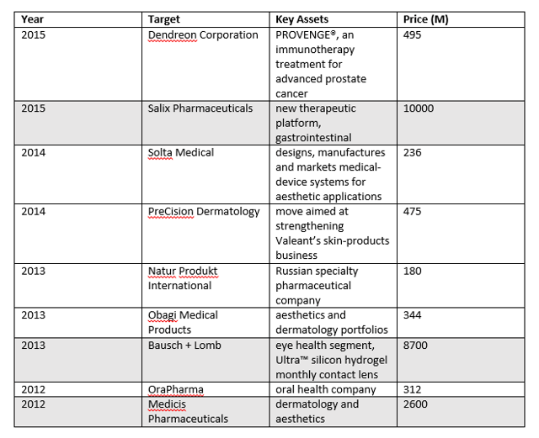
(click to enlarge)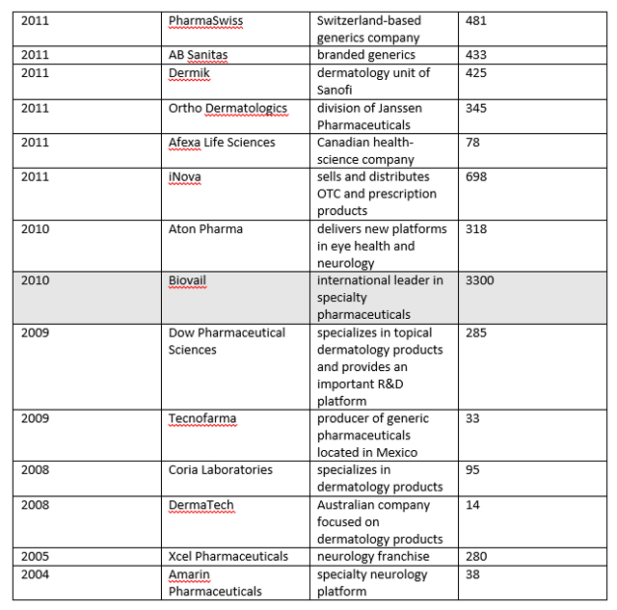
Note that Pearson started in 2008 (Coria and DermaTech acquisitions above).

3.2 Current Operations
The company breaks down its sales by product area and geography:
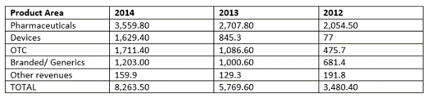
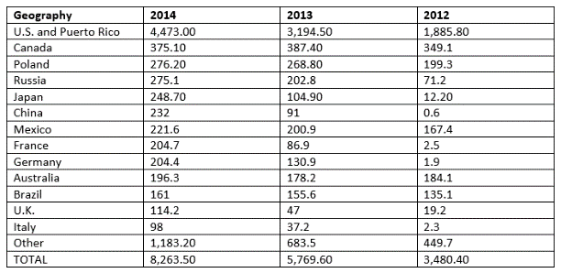
The company's subsidiaries are listed:
(click to enlarge)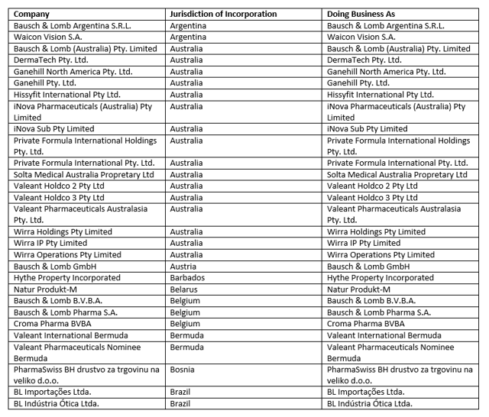
(click to enlarge)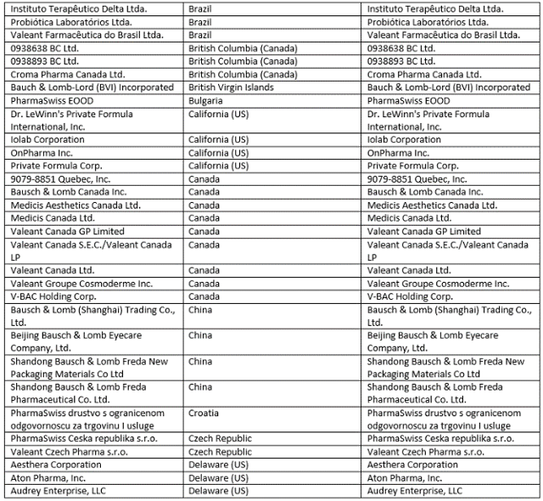
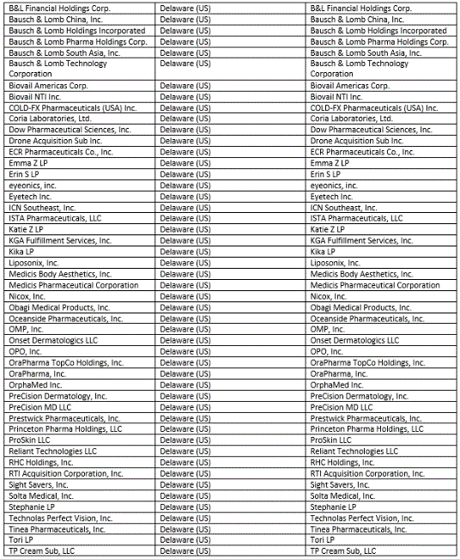
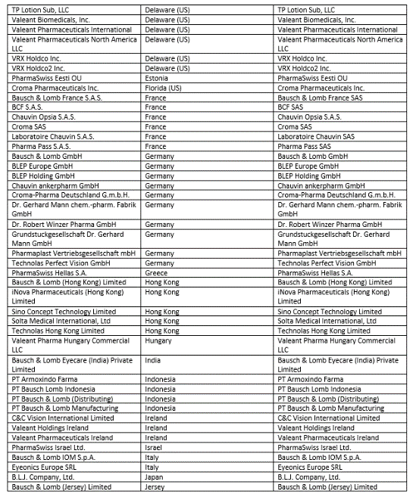
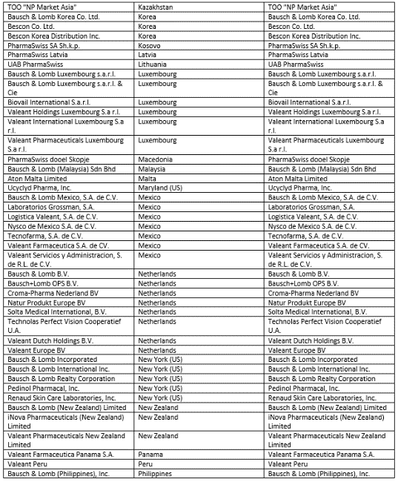
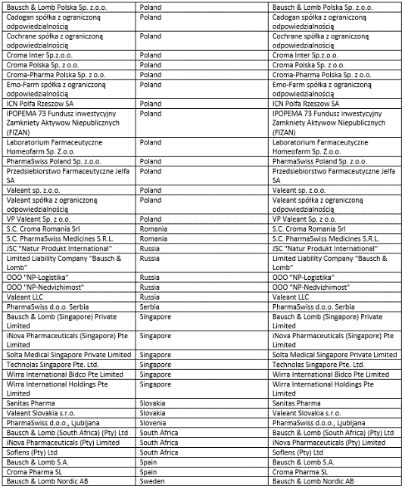
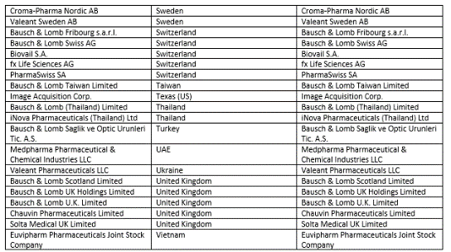

4. Numbers
EV: 118B
Cash and Equivalents: 958M
LT Debt: 31B
Cash to Cap: 0.013
Debt to Equity including Goodwill/Intangibles: 0.40
Price to Tangible Book: -2.6
EV/Rev: 13
EV/EBITDA: 28
EV/EBIT: 53
EBIT/Interest: 1.9
ROE: 15%
ROIC: 3.1%
5Y Rev Growth: 59%
5Y Tang Book Growth: NA
IS:
(click to enlarge)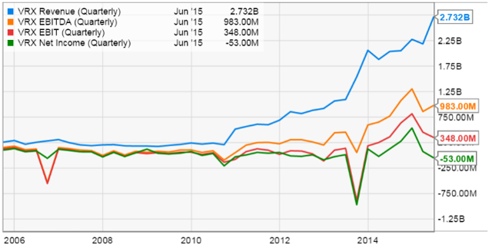

CFS:
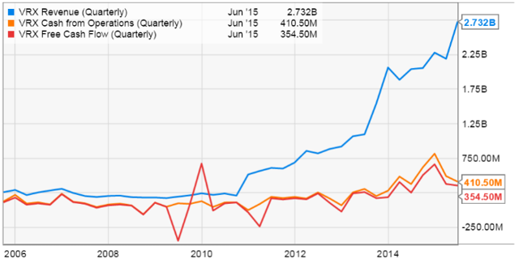
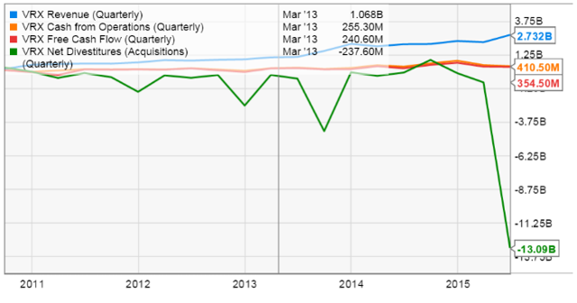
BS:
(click to enlarge)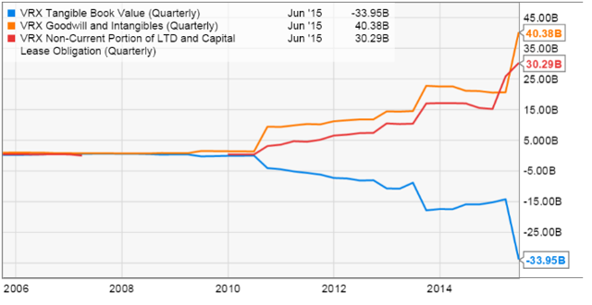
EV/ Rev c/w industry:
(click to enlarge)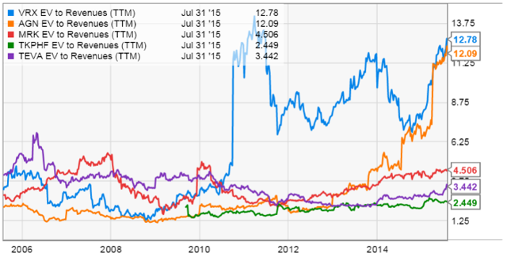
Debt/ EBITDA c/w industry:
(click to enlarge)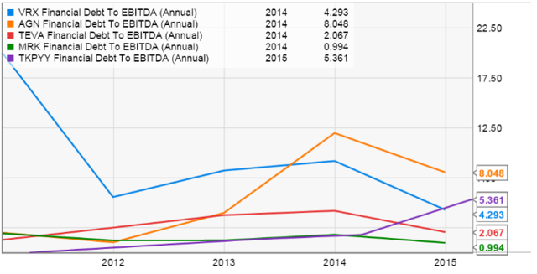
R&D/Rev c/w industry:
(click to enlarge)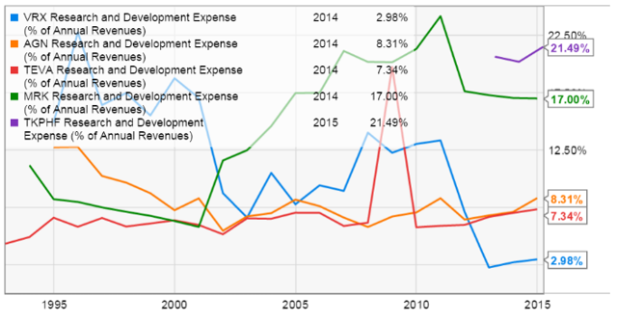
EBITDA and EBIT coverage of interest:
(click to enlarge)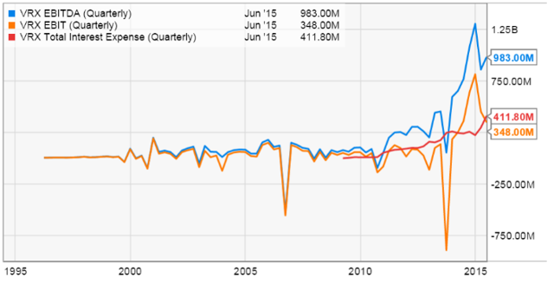

5. Key Drivers

5.1 Is VRX a Pharmaceutical Conglomerate or a Financial Institution?
VRX looks and feels much like a financial institution. To see this, let's run a screen of companies >100B market cap with assets >5x revenue. The results are shown below:
(click to enlarge)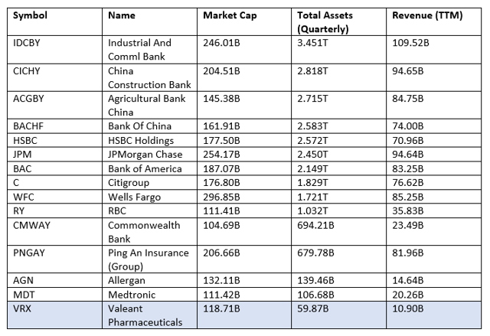
One can view rev/assets as a kind of "gross" version of ROA or ROIC. It shows us how many $s of sales a company can generate per $ of assets. What we can see is that among mega cap firms, Allergan (NYSE:AGN)/VRX/Medtronic (NYSE:MDT) have the least productive assets of non-financial institutions.

This has a couple of important implications. First, why are those assets so unproductive? In the case of a financial institution, interest rates are standardized and hence it makes sense that a bank will need to expand its asset base to generate more revenue. Granted, in the case of pharmaceutical and medical device manufacturers the margins are way higher. Still, the assets should be more productive based on peer comparisons, including other sub-100B generics:
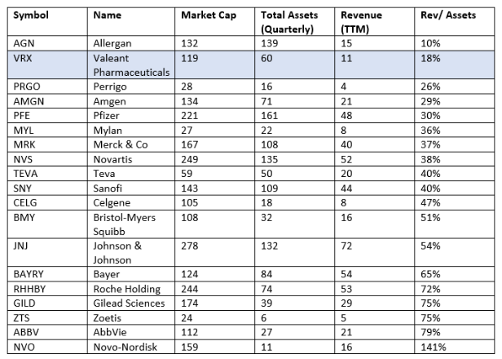
It would seem that AGN and VRX's assets are of a fundamentally poorer quality than most of the other companies in this list. As we'll discuss, I think the reason is that VRX (like AGN) has accumulated large quantities of "hot-air" intangibles on its balance sheet during its acquisitive history. These unwieldy intangibles produce a trailing nuclear fallout of write-downs and charges to earnings.
There is another important implication of the comparison with financial institutions. In the case of a bank, the assets are (nominally) tangible, and various regulatory protections have been established to ensure those assets (hopefully) don't evaporate. In the case of a pharmaceutical company, the assets are primarily intangible. Indeed, many of them are "mark-to-model" intangibles based on management's value assumptions. A simple change to a discount rate for IPR&D (say from AGN's 10% to the more standard 16-22%) could erase billions in shareholder equity. In this sense, VRX/AGN's asset quality is reminiscent of the telecoms and banks prior to their collapse in the 2000s.
A third general comment should be made. Essential to transactions in the pharmaceutical industry is the "strategic buyer." The intangible values above depend heavily on the presence of such buyer in order to realize a sale. If conditions in the credit or equity markets should change such that the few available strategic buyers should dry up, the liquidity of VRX's assets may dry up as well. This is important since (as discussed below) VRX's cash flows don't appear sufficient to cover its interest and principal requirements. As long as VRX can sell assets or do a share offering to raise cash, this isn't a problem. But the financing window isn't always open. The combination of high leverage and illiquid assets could threaten debt and equity holders alike.

5.2 What is the Organic Sales Growth Rate?

5.2.1 Sum of 20 Products
One way to answer this question is using the company's guidance. This is based on sales numbers for its "top 20 products" released by the company each quarter. VRX started providing more granular data a few Qs ago based on shareholder feedback. I've graphed this out below:
(click to enlarge)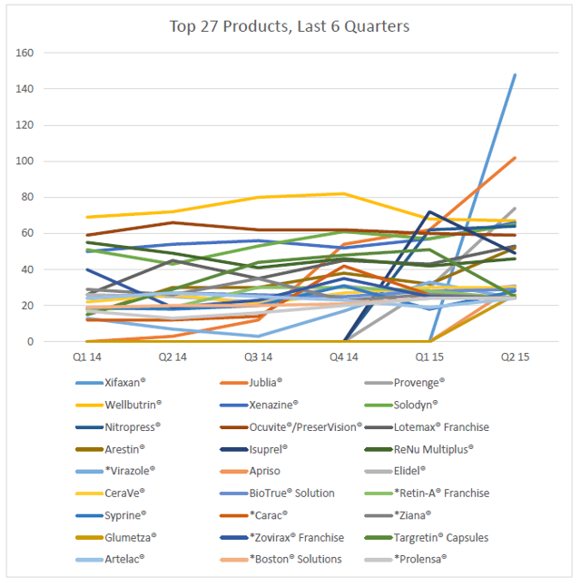
Of note, I made an important assumption. The starred products didn't have data available for the full period. The reason is that, as you'd expect, products join or fall off the top 20. I filled in the gaps in the most complementary way possible, i.e. by assuming the sales numbers for the missing quarters were equal to the lowest product on the top 20 list (i.e. the max possible value it could be).
Now we can sum up the above values to get a picture of the guidance on organic growth:
(click to enlarge)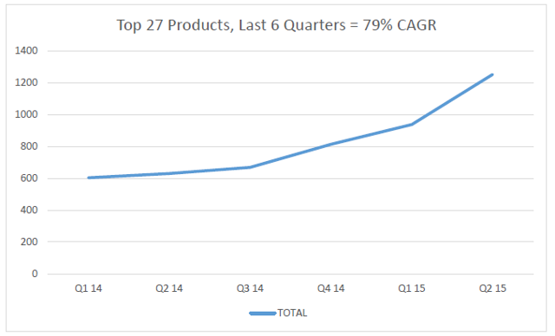
Not bad. But there are a couple of problems with the assumptions used. The most obvious is that products that face-plant tend to get dropped from the list, whereas recent successful launches tend to get added. In other words, negative growth is underweighted and positive growth is overweighted. The other obvious problem is that due to VRX's diversified portfolio, the top 20 are under 20% of VRX's revenues (not the case with AGN by the way). Also the data only go back a few quarters.
To look at the face-plant problem, let's have a look at the patent expiry/growth forecasts for the top 20 products listed above:
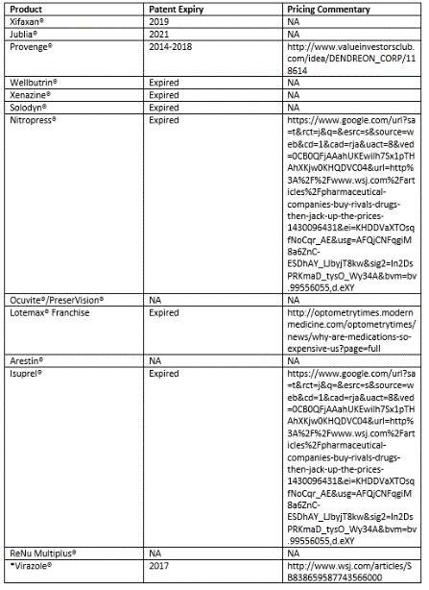
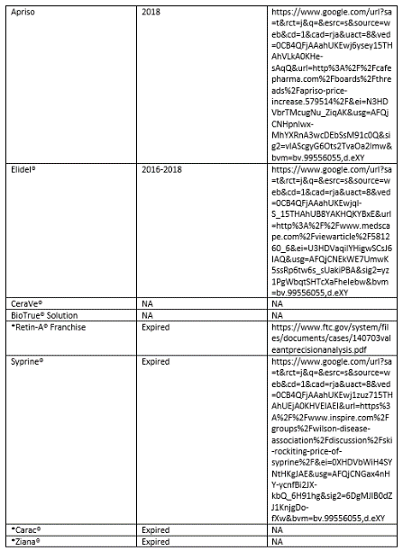
The general impression I get is while Xifaxan and Jublia seem like they'll have nice sales growth the next 5 years, many of the other products are growing revs through aggressive pricing support by market consolidation. Therefore, I worry that the implied CAGR may be biased. Let's try a different approach.

5.2.2 Sum of Acquisitions
Another approach is to look at organic growth of the businesses prior to acquisition. This, of course, assumes that Valeant's does not "transform" the businesses post-acquisition, but merely cuts costs and hikes prices. I'm not saying these are bad strategies, I'm just saying they're likely non-recurring. I've taken pre-acquisition sales figures for VRX's largest 10 acquisitions and projected those growth rates forward to estimate the growth rate for the overall conglomerate:
(click to enlarge)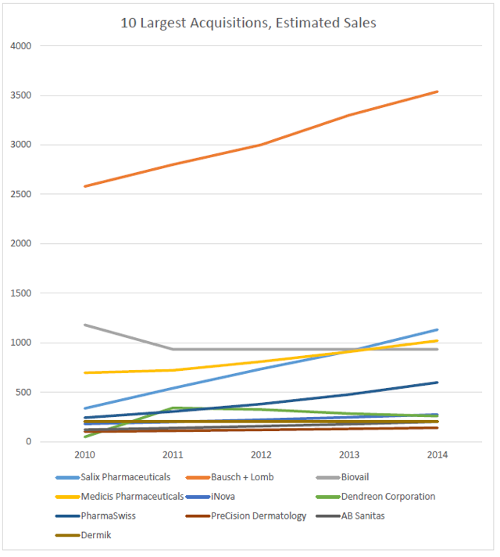
Here I used past filings if available and, if not, VRX's estimate of growth the past few years in order to project the business's sales within the conglomerate. In my opinion, some of these growth rates are pretty aggressive, but I'm trying to be as bullish as possible.
(click to enlarge)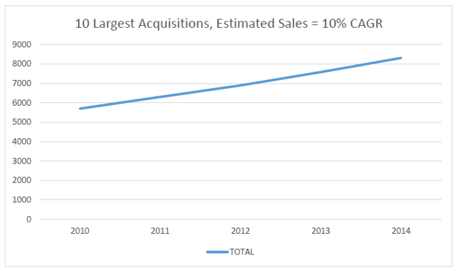
As we can see, this approach suggests a considerably slower organic growth rate. I will leave it to the reader to do his own analysis. But I will subsequently assume that Valeant's organic sales growth rate is 10%, and base my comps/valuation on that.

5.3 What's Wrong with the Accounting?
To keep things organized, I've used a checklist based on Schilit's Shenanigans.

5.3.1 Recording Revenue Too Soon
B&L got nabbed for pretty aggressive channel stuffing in the contact lens unitback in the 90s. VRX still used B&L's old auditor (PWC) that approved this activity.

5.3.2 Boosting Income Using One-Time or Unsustainable Activities

5.3.2.1 Boosting income using one-time events
Examining the 2014 statements, we can see that pretax income was $1,092.60M. Of this, $286.70 (26% of pretax income) was recorded as "gain on investments" from the sale of Allergan Shares in PS Fund 1. Additionally $323.90M of "other income" (30% of pretax income) was booked from gain on sale of Galderma facial aesthetic fillers.

5.3.2.2 Impairments and write-downs
With over 40B in intangibles stashed in the attic, chunks of the ceiling are liable to fall from time to time. These include (ignoring amortization for now):
(click to enlarge)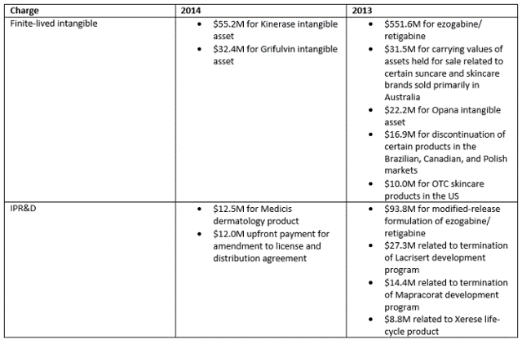

5.3.3 Shifting Current Expenses to a Later Period

5.3.3.1 Risk of substantial goodwill writedowns once the amortizable intangibles asset is deemed impaired based on model assumptions
The company makes the following comment regarding its impairment policy in the 2014 10-K:
An interim goodwill impairment test in advance of the annual impairment assessment may be required if events occur that indicate an impairment might be present. For example, a substantial decline in the Company's market capitalization, unexpected adverse business condition, economic factors and unanticipated competitive activities may signal that an interim impairment test is needed. Accordingly, among other factors, the Company monitors changes in its share price between annual impairment tests to ensure that its market capitalization continues to exceed the carrying value of its consolidated net assets. The Company considers a decline in its share price that corresponds to an overall deterioration in stock market conditions to be less of an indicator of goodwill impairment than a unilateral decline in its share price reflecting adverse changes in its underlying operating performance, cash flows, financial condition, and/or liquidity. In the event that the Company's market capitalization does decline below its book value, the Company would consider the length and severity of the decline and the reason for the decline when assessing whether potential goodwill impairment exists. The Company believes that short-term fluctuations in share prices may not necessarily reflect underlying values.
It troubles me that management considers a decline in share price as a reason to make write offs. This is prone to reflexivity.

5.3.3.2 Contingent liabilities
The company does not recognize contingent payments (payments which are contingent on approvals, sales milestones, or other events) on the balance sheet. This is fairly typical for the industry. What is the magnitude?
As of December 31, 2014, the Company estimates that it may pay potential milestone payments and license fees, including sale-based milestones, of up to approximately $1 billion over time, in the aggregate, to third-parties, primarily consisting of the following:
· Under the terms of a July 2013 collaboration and option agreement with Mimetogen Pharmaceuticals Inc. ("Mimetogen"), the Company will have either the right or the obligation, depending on the results of clinical trials, to exercise an option to obtain a worldwide exclusive license to the MIM-D3 compound for development and commercialization of products for the treatment and/or prevention of ocular conditions, disorders and/or diseases. The exercise of the option would trigger an initial license fee payment by the Company of up to $95.0 million, plus potential regulatory, commercialization and sales-based milestones over time of up to $345.0 million, in the aggregate, and royalty payments on the future sales.
· Under the terms of a March 2010 development and licensing agreement between B&L and NicOx, the Company has exclusive worldwide rights to develop and commercialize, for certain indications, products containing latanoprostene bunod, a nitric oxide donating compound for the treatment of glaucoma and ocular hypertension. The Company may be required to make potential regulatory, commercialization and sales-based milestones payments over time up to $162.5 million, in the aggregate, as well as royalties on future sales.
· Under the terms of amendments entered into in August 2014 to the agreements with Spear with respect to the authorized generic for Retin-A® and the authorized generic for Carac®, respectively, the Company may be required to make uncapped sales-based milestones over time, which the Company currently estimates will not exceed $150 million, in the aggregate, within the next five years.
· Under the terms of an October 2013 agreement with SMG Pharmaceuticals, LLC ("SMG"), the Company licensed the rights to commercialize, in specific fields in the U.S., Bensal HP®, a topical medication to treat skin irritations and infection. The Company may be required to make potential sales-based milestone payments over time up to $80.0 million, in the aggregate, as well as royalties on future sales.

5.3.3.3 Capitalizing payroll expense
VRX has noted that it operates more efficiently than industry comparators. While superficially true on a R&D basis, it does not appear superficially true for SG&A. If anything VRX is middle of the pack:
(click to enlarge)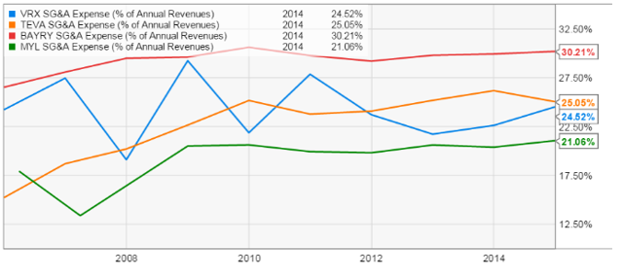
Superficially. If we look at the composition of restructuring charges, the lion's share are employee termination costs. Smaller components are contract termination, facilities closure, etc. So to first approximation we can consider restructuring under SG&A. Making the adjustment:
(click to enlarge)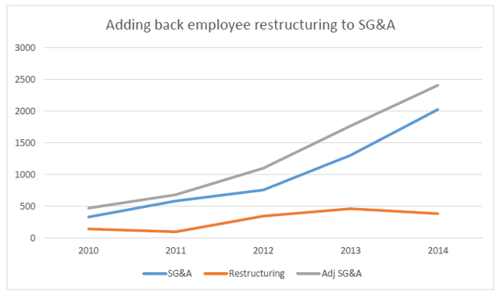
... we can produce a more appropriate SG&A/Rev trend for VRX:
(click to enlarge)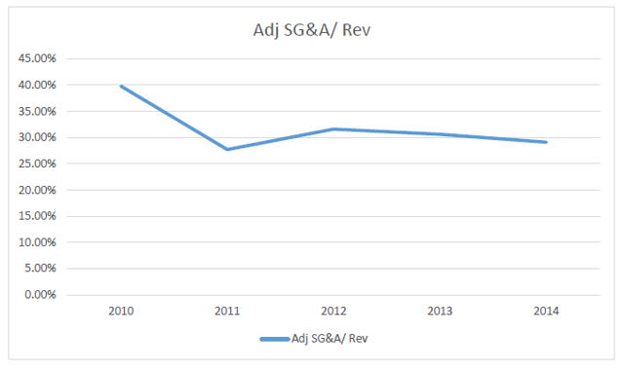
Turns out VRX is up there with Bayer as one of the least efficient players in the industry from an SG&A standpoint.
What about R&D? Again, excluding capitalized costs, VRX has brought R&D/Rev way down the past few years:
(click to enlarge)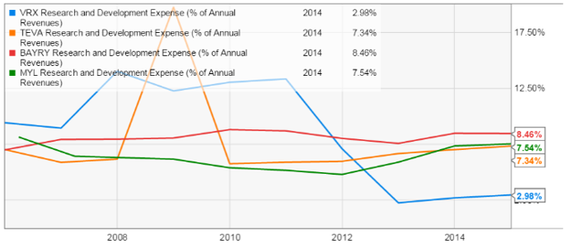
Adjusting for IPR&D, which I consider rightly part of VRX's R&D since it is just absorbing those operations, it looks like this:
(click to enlarge)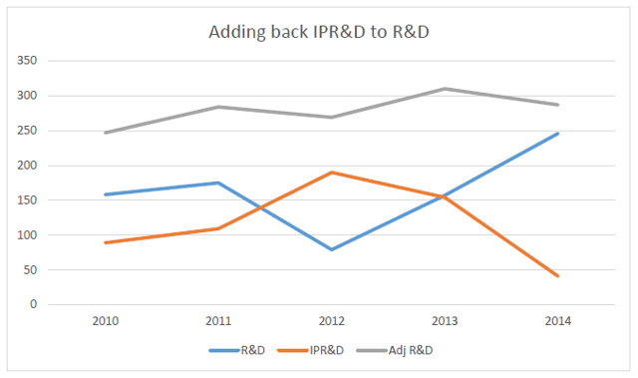
We can see that VRX is still below the industry average, but by quite a narrower margin:
(click to enlarge)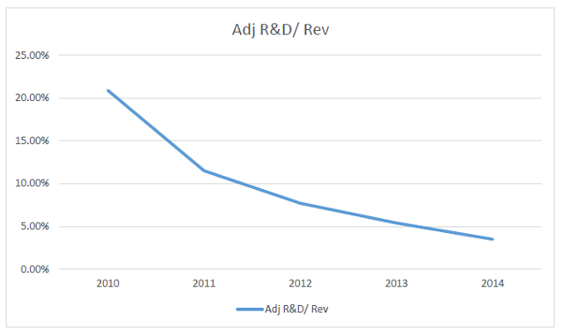

5.3.3.4 Stock-based compensation
This is what a PE-style compensation package means to me as a shareholder:
(click to enlarge)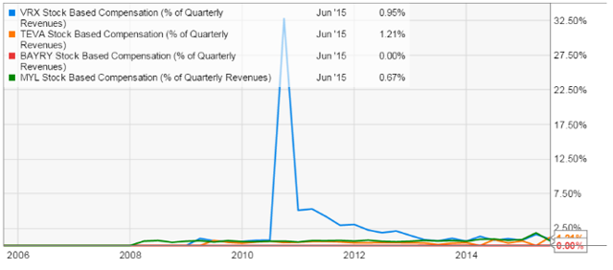
Still, from a stock price appreciation standpoint, the strategy has worked well. We'll look at compensation in more detail later.

5.3.3.5 Amortizing costs too slowly
I have no evidence to say VRX is doing this, since the composition of intangibles is mostly not disclosed. Allergan has certainly made accusations but they do not provide much detail.
Another point is that although VRX does not disclose its discount rates used to price the intangibles (e.g. current medicinal products, IPR&D), AGN does. AGN often uses discount rates in the 9-11% range for these, well below the industry standard of 16-22%. I worry that VRX may be utilizing similar optimism to value its intangibles.

5.3.3.6 Discrepancy between net income and operating cash flow
Amortization is the biggest single adjustment to NI on VRX's CFS. We can see the discrepancy has skyrocketed the past few years, due in large part to increasing amortization (again related to rising intangibles/goodwill).
(click to enlarge)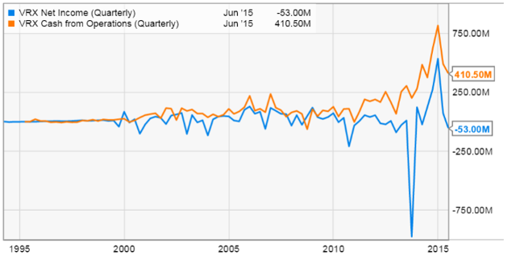

5.3.4 Employing Other Techniques to Hide Expenses or Losses

5.3.4.1 Options backdating
Valeant was busted for backdating back before Pearson's time. It seems unlikely they're still doing it post Sarbanes-Oxley, but I still view it as a red flag.

5.3.4.2 Release of restructuring/inventory reserves into income
VRX's accounting for inventory step ups is thoroughly confusing to me. I haven't been able to substantiate Allergan's accusations based on the financials.

5.3.5 Shifting Current Income to a Later Period

5.3.5.1 Lower revenue at a target company just before it is acquired to boost revenue after the acquisition
This is harder to validate for the B&L purchase, but it was rather blatant in thecase of Salix.
Here's SLXP's revenue and NI in the 4 quarters prior to the acquisition, when SLXP apparently hit a rough patch:
(click to enlarge)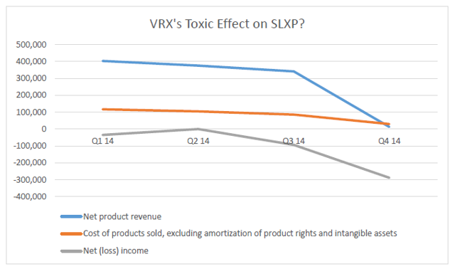
SLXP explained the abysmal performance thus:
Historically, we have not had distribution services agreements with any of our major wholesale distributors and accordingly have had no control over their buying patterns, which have fluctuated in response to, among other things, their inventory levels of our products, discounts we have offered, anticipated future price increases or other factors that did not directly correlate to end-user demand. We announced in November 2014 that we were negotiating with our principal wholesalers to enter into distribution services agreements for each of the products in our portfolio and that we expected these distribution services agreements to be finalized and become effective in the first quarter of 2015, but we have subsequently agreed in our merger agreement with Valeant that we will not enter into any distribution services agreement pending the completion of the merger without Valeant's consent (such consent not to be unreasonably withheld, conditioned or delayed). As a result, if we do not enter into these distribution services agreements, we will be delaying the benefits of the distribution services agreements we had intended to enter into prior to entering into the Valeant merger agreement, which included enabling us to better forecast revenue and expenses. (2014 10K)

5.3.6 Shifting Financing Cash Inflows to the Operating Section

5.3.6.1 Pro forma CFO metrics
Here's a summary of VRX's adjustments to CFO to obtain their "adjusted cash flow":
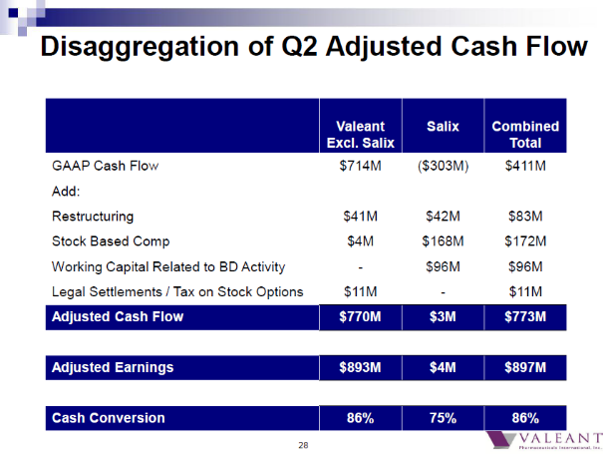
As we've seen, restructuring is mostly SG&A expense. SBC is a legitimate operating expense. And the working capital benefit of acquiring a business shouldn't be added to operating results. So in my opinion, VRX's GAAP CFO is a better (albeit still imperfect) measure of their operating performance.

5.3.6.2 Complicated OBS structures that may engage in RPTs to inflate CFO
As we saw, VRX has a HUGE number of subsidiaries. As we'll review in the tax section, these subs do all sorts of neat things like pay local taxes, guarantee debts of the parent, own/trade IP, and buy/sell inventory. The disclosure on these subs is extremely limited. It is not inconceivable to believe operations of subs could blur the boundary between operating and financing cash flows.

5.3.7 Shifting Normal Operating Cash Outflows to the Investing Section

5.3.7.1 Biovail purchases
Interestingly, Biovail was already good at making noncash purchases per Schilit's book. They noted:
In 2003, non-cash investing and financing activities included the long-term obligation of $17,497,000 related to the acquisition of Ativan and Isordil, and the subscription to $8,929,000 Series D Preferred Units of Reliant in repayment of a portion of the loan receivable from Reliant. In 2002, non-cash investing and financing activities included long-term obligations of $99,620,000 and $69,961,000 related to the acquisitions of Vasotec and Vaseretic, and Wellbutrin and Zyban, respectively, as well as a long-term obligation of $80,656,000 related to the amendments to the Zovirax distribution agreement.
The result was inflated CFO.

5.3.8 Inflating Operating Cash Flow Using Acquisitions or Disposals

5.3.8.1 Using acquisitions to create strong CFO
As Schilit notes, one of the great things about acquiring businesses is it automatically boosts your CFO. In real life (outside the acquisition accounting world) it takes money to make money - you have to cover upfront costs in order to make sales. But in an acquisition, you don't pay those upfront costs - at least not out of your operating cash flow. That goes in the investing section. Conversely, when you sell the inventory, finish the research, and collect the receivables for the acquired company, that goes in CFO. Hence VRX's excellent operating cash flow. The acquirer also benefits from liquidating the target's working capital. That's why FCF after acquisitions is a better metric than CFO or FCF for serial acquirers:
(click to enlarge)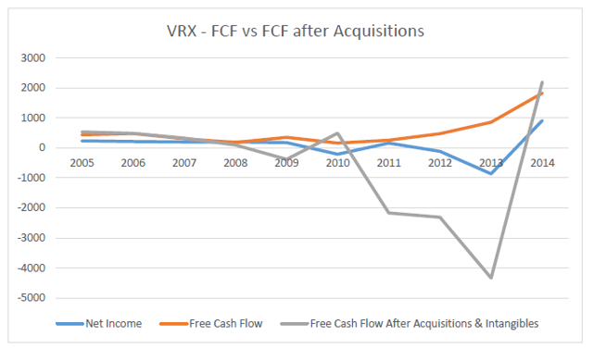
Another thing to note is that, if we sum up all the acquisitions listed at the start of this article, it comes out to about 30.2B, not too far off from the current debt load (30.9B). Of course, there are hundreds of small acquisitions not included in that list. The implication here, however, is that VRX is doing a rather crappy job of paying off its debt. Re-fi, rather than repay, seems to be the name of the game for now.

5.4 Are Cash Flows Sufficient to Cover Interest and Principal Repayments?

5.4.1 Debt Maturities
Given the amount of debt VRX carries, Pearson has done probably the best possible job of managing the cash flow implications:
(click to enlarge)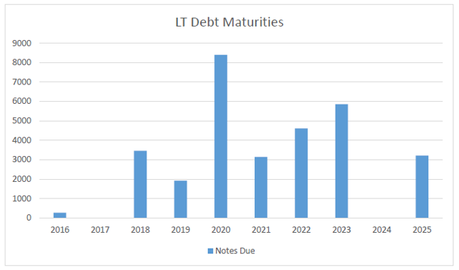
As such, I'm actually more worried about the ratings agencies, floating interest rates, and re-fi capability.

5.4.2 Debt Covenants

5.4.2.1 Debt/EBITDA
The trouble with EBITDA for VRX is the "A" is huge due to that mountain of "mark to model" intangibles. Not your typical collateral. Moreover, acquisition accounting turns intangibles into a waste heap for all sorts of capitalized expenses that are then pureed and churned out as amortization. Hence, it's totally inappropriate IMO to disregard amortization when assessing the company's creditworthiness. I might recommend Debt/EBIT as a surrogate:
(click to enlarge)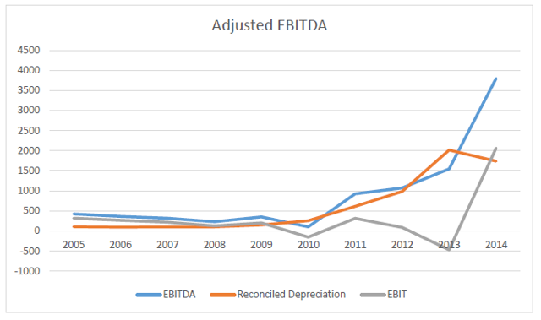
(click to enlarge)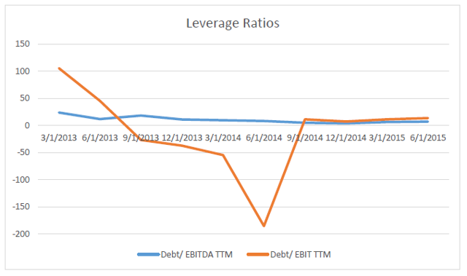
(click to enlarge)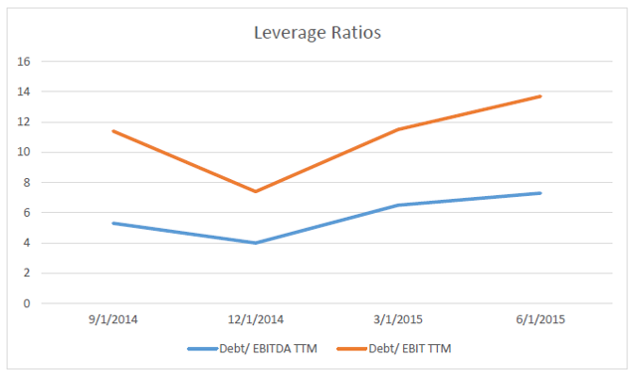
Not only are VRX's creditors a bit oblivious, but their obliviousness seems to be proportionate to VRX's EV. Take a look at what VRX pulled off for the Salix acquisition, courtesy of Moody's:
In addition to waiving the 5.25x total leverage and 3x minimum interest coverage tests to allow solely for the incremental loans to help finance the acquisition, Valeant is seeking covenant changes through the first quarter of 2016, including a modification of the interest coverage ratio to 2.25x, allowing for the incurrence of $750 million of additional unsecured debt, waiving of the 5.25x leverage governor in connection with any incremental borrowings, and altering the consolidated EBITDA definition to allow for add-backs of restructuring charges and fees and expenses tied the Salix purchase. The amendment package would also:
· Waive mandatory prepayments from equity issuance used in the Salix deal or 2014 excess cash flow proceeds of roughly $250 million;
· Modify the restricted payments covenant so that refinancing of Salix's convertible notes and settlement of related warrants won't be deemed RPs;
· Permit the administrative agent under the credit agreement to enter into certain intercreditor agreements;
· Increase cash netting from $350 million to $600 million;
· For future permitted acquisitions change the no default and pro forma compliance conditions to the incremental from "at closing" to "at signing," and waive incremental total leverage ratio conditions so that only the senior secured leverage ratio applies.

5.4.2.2 Debt/Equity
VRX's D/E is high:
(click to enlarge)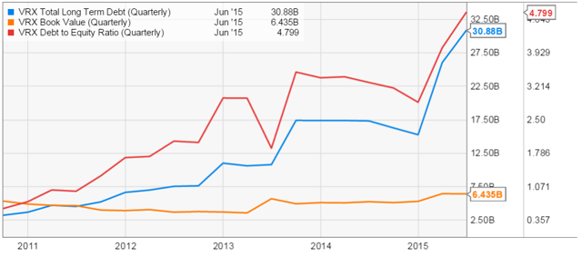
Again, the problem is intangibles and their contribution to equity. Depending on the assumptions management makes in valuing those intangibles, the D/E could take on practically any value.

5.4.2.3 Interest coverage
VRX is generally not covering their interest:
(click to enlarge)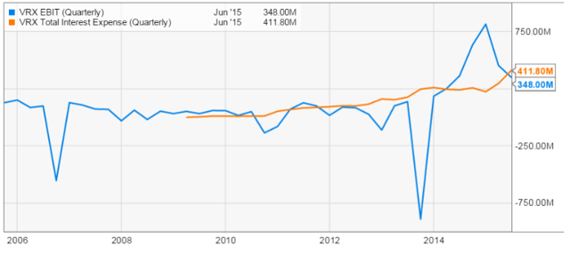

5.4.3 Escaping a Cash Crunch
We've seen that VRX's recurring cash flows from existing businesses are not sufficient to cover interest or principal repayments. This means the cash needs to come either from shareholders or from an outside buyer. VRX has tried to avoid secondaries in favor of debt, and my two cents is they will continue to do so. That leaves the second option recently exercised by VRX's friend AGN: sell a business. In the present frothy M&A marketplace, it seems probable that VRX could unload one or more of its units at an attractive valuation, if not at the purchase price. This would "reload the balance sheet." From an accounting and valuation perspective, such a maneuver carries certain market risks. For one thing, the transaction will reduce the size of VRX's operating business, which is being valued on a revenue growth basis. This could reduce VRX's share price and hinder its ability to purchase with stock. For this reason, I think it's reasonable to assume the de-levering event would be quickly followed by a larger acquisition. Let's face it: management is incentivized to execute transformational deals and boost the share price, not create a sustainable integrated entity for long-term holders (see the compensation section).

5.5 What is the Tax Benefit, Really?
Valeant's post-inversion tax rate (around 3%) could be the topic of a book, and I'm not going to go crazy trying to explain it or model it out. However, I do want to summarize some key points made in this article.
As we can see, VRX's tax strategy is closely tied to its debt and mountain of intangibles.
The debt side is easy enough to understand. Interest and debt payments reduce taxable income, resulting in a low or negative tax provision. To this extent, VRX's approach resembles a PE firm. Since VRX has been acquiring so fast, it's hard to say what their effective rate will look like once they pay off the debt.
The other side is intangibles. Canadian tax law provides companies more flexibility to shift their IP to low-tax domiciles and pay little to no tax when repatriating profits. We've seen how VRX's amortization expense likely includes everything but the kitchen sink owing to capitalized R&D/SG&A. This too reduces VRX's taxable income. But as the article notes, VRX has reduced the effective rate even further by migrating its IP (read: intangibles) into a number of offshore entities (e.g. Barbados, Bermuda) and then redistributing profits to lower-tax countries. A good article on transfer pricing can be foundhere.
Effectively, VRX's ability to conveniently migrate the jurisdictions of its intangibles makes it very difficult to track and tax the profits "owned" by those intangibles.
So you can see how low taxes is closely tied (some would say required for) VRX's acquisition strategy. The company can boast great EBITDA to the Street (maintaining the stock price) while using the tax benefit to make huge debt repayments. Now, the "cash tax rate" should be "the percent of pre-tax operating profits a company would pay in cash taxes to governments assuming it was 100% equity financed." But given the complexity, it's impossible for an outsider to verify whether VRX's calculation is representative of the terminal rate once the acquisitions stop and the debt is paid off. As the article notes, VRX clearly states the risk of taxable profit reassessment in its filings.
Also note the whistleblower case.

6. Valuation
The above evidently represents a complicated picture from which to draw conclusions on intrinsic value. Factor in the importance of the "strategic buyer" to realize market value, and the problem gets more difficult. We'll take the simple approach here and assume the company is worth the premium typically assigned by the present market for companies with comparable organic growth rates. It is left to the reader to apply the appropriate discount if those market conditions should no longer exist. The other complicating factor is the discount rate typical in the industry is not appropriate for VRX given the significantly higher leverage. However, I'm going to ignore that factor too. My goal is to be bullish on every assumption and still reach the bear conclusion. Anyway, VRX's D/E ratio is baloney in my view since the quality of the assets (and hence shareholder equity) is in question.
Let's consider the following comps universe above rev 5B:
(click to enlarge)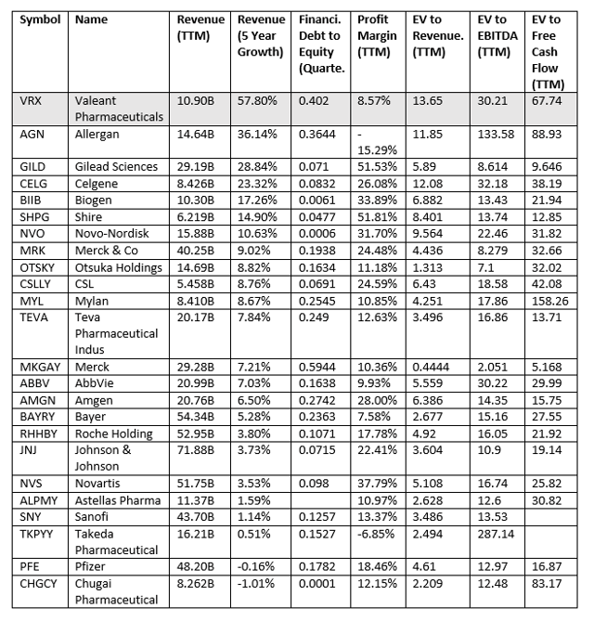
We can see that since VRX is doing poorly on margins, using EV/rev will be on the optimistic side. We'll use EV/EBITDA as backup, but for the reasons mentioned VRX's EBITDA concerns me for use in valuation (it's not directly comparable to other companies' EBITDA).
As we saw the best-case organic growth rate for VRX in total is probably around 10%. Let's construct industry comps with comparable organic growth rates:
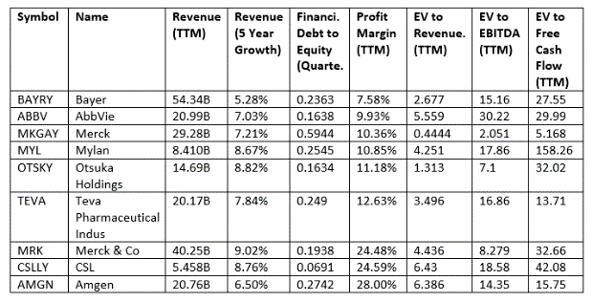
Let's give VRX the premium EV/Rev of the set (about 6x). Taking VRX's TTM revs of 9.3B, this gives us an EV of 56B. Taking LT Debt 31B, Cash 1B, and 344M Diluted Sh Out, this gives us a PT of $76/ sh. Let's repeat the calc with EV/EBITDA, taking 20x as favorable. With VRX's TTM EBITDA of 4.2B, this gives EV 84B or $157/sh. Take the average of these ($117) as the ballpark PT for a short position. Of course, if the capital structure changes or the liquidity situation changes those factors would need to be taken into account.

7. Management

7.1 Current Team and Backgrounds
VRX's management team is gradually being overrun by McKinseyites (Pearson, Rosiello, Kellen). Not necessarily an issue but does raise the question of checks and balances.

7.2 Recent Turnover
In addition, although the money is good, management doesn't seem to stick around for long:
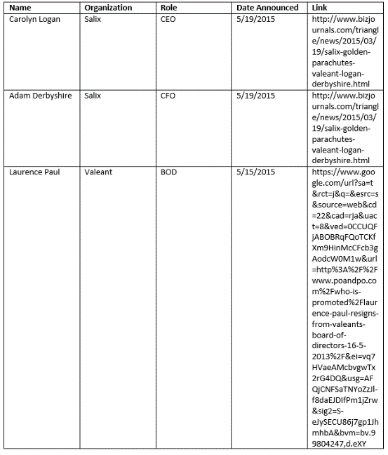
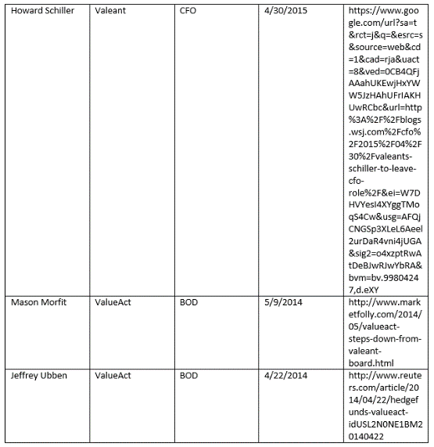
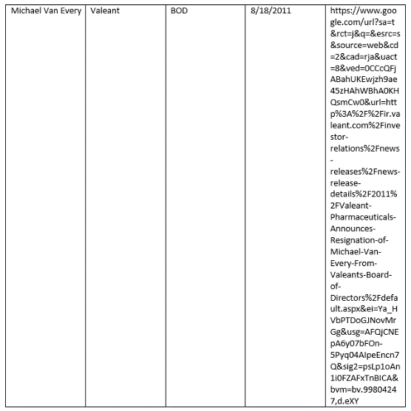

7.3 Compensation Package

7.3.1 Share Ownership to Date
ValueAct designed a PE-like compensation package for Pearson to keep him motivated. Total share ownership by management/BOD as of the most recent proxy is below:
(click to enlarge)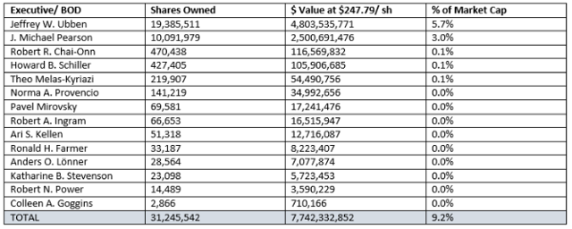
In addition, management was required to buy shares:
For some Named Executive Officers, there are minimum required purchase amounts. For example, when Mr. Pearson was hired in 2008, he was required to purchase at least $3 million worth of shares and he voluntarily purchased $5 million.
Originally, Pearson couldn't sell stock until 2017. But as of 2015 that has changed:
Mr. Pearson is contractually committed to hold all of the shares covered by his equity awards (other than shares necessary to cover his taxes, 3,000,000 shares which he is permitted to transfer and 1,000,000 shares which he is permitted to transfer in charitable contributions) until 2020.

7.3.2 Incentive Compensation
Incentive compensation has two axes: market performance ("TSR") and company performance.

7.3.2.1 Market performance
Let's have a look at how TSR affects Mr. Pearson's pay:
PSUs - PSUs that vest based on the three, four, five or six year compounded TSR thresholds as follows and linear interpolation is applied for TSR performance between the following thresholds applicable to grants made after November 2012:
· No vesting for compounded annual TSR less than 10%;
· 100% of PSUs vest for 10% compounded annual TSR;
· 200% of PSUs vest for 20% compounded annual TSR;
· 300% of PSUs vest for 30% compounded annual TSR;
· In the case of Mr. Chai-Onn and Mr. Pearson, with respect to certain of their PSUs, 400% of PSUs vest for 40% compounded annual TSR; and
· In the case of the PSUs granted to Mr. Pearson under the 2015 Employment Agreement, 500% of PSUs vest for 50% compounded annual TSR.
The Company's pay philosophy was designed and implemented in 2008 for Mr. Pearson, the then-newly hired Chief Executive Officer and his executive leadership team of Valeant Pharmaceuticals International ("Old Valeant"). In 2010, Valeant Pharmaceuticals International merged with Biovail Corporation ("Biovail"). Biovail was the surviving company, but it was renamed Valeant Pharmaceuticals International, Inc. ("New Valeant," which is the Company). The pay philosophy of Old Valeant was adopted by the Company and its management team.
Mr. Pearson signed an original 3 year employment agreement with Old Valeant in February 2008. His salary was $1 million per year, his bonus opportunity was up to 200% of salary, he received 1,024,591 options, 407,498 PSUs and was required to buy at least $3 million of Company shares, with a matching RSU granted for each share he purchased up to $5 million. The PSUs had a minimum compound annual TSR trigger of 15% and a maximum of 45%.
By November 2009, the share price of Old Valeant had a TSR of 168%, compared to a decline of 21% for the S&P 500 index. Mr. Pearson was nearing the trigger point for the maximum amount of PSUs achievable under the contract. The Talent and Compensation Committee and Board of Directors decided to proactively amend Mr. Pearson's employment agreement with the goal of retaining Mr. Pearson beyond his 3 year agreement and to motivate him to continue to drive Valeant's TSR by first, preventing him from monetizing shares in the Company, and second, by granting new equity with higher TSR hurdles. The outcome of this negotiation was that Mr. Pearson agreed not to sell any net shares in Valeant until 2014 even if he were to voluntarily leave the Company. The Board of Directors believed this was a more effective and enforceable retention tool than any non-compete agreement, as well as being highly motivating to drive TSR. In return for sacrificing his liquidity, Mr. Pearson' salary was raised to $1.5 million. The Board of Directors also granted Mr. Pearson new stock options and PSUs, with the option exercise price and the PSU measurement base price set at the price equal to the 45% 3-year TSR price under the original contract (which was approximately 15% higher than the stock price on the date of grant).
In March 2010, Mr. Pearson and Old Valeant entered into an amendment to his employment agreement to reflect tax law changes, with such amendment reflecting provisions that were economically equal to, or less favorable to, Mr. Pearson.
In September 2010, Old Valeant merged with Biovail to form New Valeant. This was a change of control and under Mr. Pearson's employment contract all his equity grants should have vested. The Board of Directors negotiated with Mr. Pearson and he waived his rights to vest in return for a new tranche of PSUs at a 60% 3-year TSR trigger price.
In 2011, the Board of Directors again amended Mr. Pearson's employment contract, with the goal of extending his employment beyond 2014. Mr. Pearson's salary was increased to $1,600,000. In addition, given that most of the performance hurdles associated with previous equity grants had been achieved, the Board of Directors determined that it was in the shareholder's best interests to award an additional equity grant (stock options and PSUs) to support the Company's aforementioned goal of increasing long term shareholder returns. In addition, Mr. Pearson also agreed to certain restrictions on not selling shares up to February 1, 2017.
In 2012, given the significant growth and success of the Company, the Talent and Compensation Committee updated the industry-based peer group of companies to more appropriately reflect the size and scope of the Company. Coincident with the update of this peer group and in recognition of the Company's continued growth and success, Mr. Pearson's salary was increased to $1,750,000 and his target bonus opportunity was increased from 100% of base salary to 130%. In 2013, after a further review of Mr. Pearson's compensation and performance of the Company, Mr. Pearson's target bonus opportunity was increased to 150% effective April 1, 2013.
By December 31, 2013, the share price of Valeant had a TSR of 351.5% since the time of the Biovail-Valeant merger. In light of the continued growth and success of the Company and after a further review of Mr. Pearson's compensation, the Talent and Compensation Committee increased Mr. Pearson's salary to $2,000,000 and his target bonus opportunity from 150% of base salary to 200% of base salary (and his maximum bonus opportunity to 400% of base salary), eliminated the tax gross-up related to the personal use of the corporate aircraft by Mr. Pearson and his family and consented to allow Mr. Pearson to donate up to 1,000,000 shares to charity.
In January 2015, the Company and Mr. Pearson entered into a new employment agreement providing for:
· a five year extension of the existing term; Mr. Pearson will not be entitled to severance by reason of the expiration of the employment term or the Company giving notice not to renew the employment agreement;
· no annual base salary;
· 100% of annual cash compensation to be performance based, with a target bonus opportunity of $6,000,000 and a maximum annual bonus opportunity of $10,000,000 to be earned based on the achievement of corporate and individual strategic goals;
· a five-year front-loaded grant of PSUs with the potential of vesting up to five times the base amount should the compounded annual TSR of the Company equal or exceed 50% over the period (which is equal to a share price of $1,067.89);
· a reduction in Mr. Pearson's severance multiplier following a change in control from three to two times the sum of base salary and target bonus, up to a maximum severance amount of $9,000,000;
· removal as a "good reason" trigger the requirement that Mr. Pearson be chairman of the Board of Directors of the surviving company following a change in control;
· permission for Mr. Pearson to sell 3,000,000 of his net shares and to transfer 1,000,000 net shares in charitable contributions; and
· a commitment by Mr. Pearson to hold 1,000,000 net shares for two years beyond the termination of his employment with the Company.

7.3.2.2 Company performance
Company performance metrics (not directly related to share performance) are:
(click to enlarge)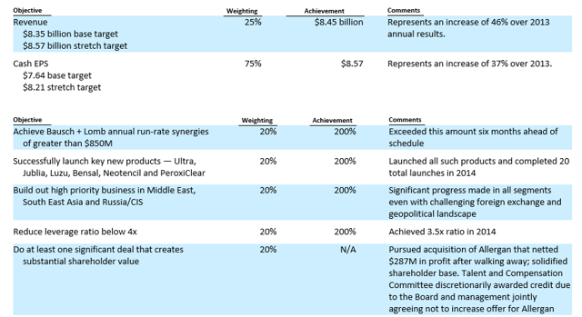

7.3.2.3 Summary
There you have it folks. Management is getting paid (1) to increase the share price, (2) to increase revenue, (3) to improve cash EPS (excluding restructuring, SBC, etc.), (4) make transformative and bolt-on acquisitions, (5) launch new products, and (6) reduce leverage ratio (Debt/EBITDA). TSR is far and away the most important indicator. In the absolute sense, they've done a fantastic job. On a risk-adjusted basis, that return has been significantly lower in my view.

8. Insiders
Recent transactions are most notable for significant dumping of the ValueAct stake (Ubben is CEO):
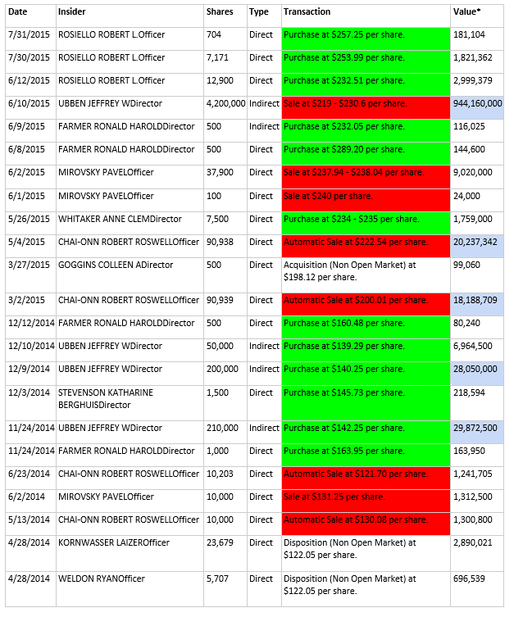
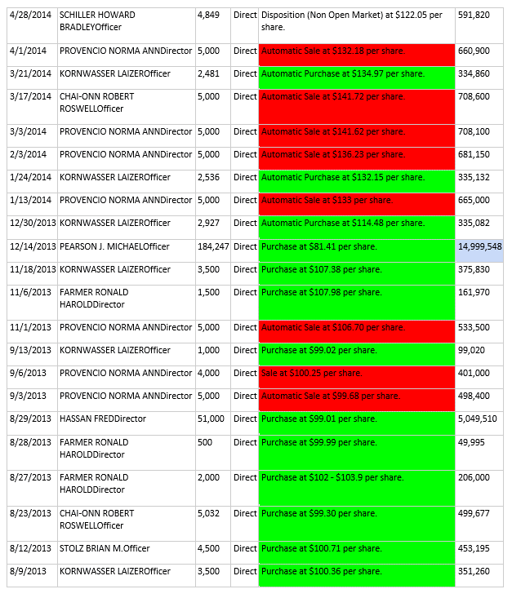

9. Institutions
Top holders are:
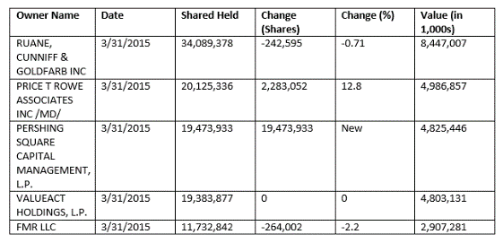
3 of the 5 are unloading stakes (ValueAct most aggressively as of these dates). Ackman is the outlier, taking a large stake and comparing Valeant to Berkshire (NYSE:BRK.A) (NYSE:BRK.B). I have to admit I don't really understand Ackman's position fundamentally after his MBIA coup. But then, nor do I understand Paulson's position in AGN after a similar home run in the 2000s.

10. Catalyst/Risk
The catalysts to the upside are obvious - just more of the same. More acquisitions, continued revenue growth and continued growth in operating cash flow as a by-product. Valeant is helped here by their failure to consummate the Allergan deal, hence I expect they could pull off a very large deal later this year (e.g. Zoetis). As we've seen, Pearson's compensation depends on it. To stand in front of this market machine is a great way to get run over.
What about risks to the downside? We've also seen that Valeant will, at some point, need to sell a business or raise significant equity capital to meet its obligations. If the buyer market should dry up due to credit conditions, this could abruptly become rather difficult. VRX would then, in return, face pressures from its creditors. Similarly, if VRX's notes were downgraded, this could block it from raising additional debt to fund a transaction, which might in turn affect the stock price.
Some kind of SEC or IRS accounting scandal would be a boon to bears.
I do not think it realistic to assume Valeant's organic growth difficulties will be the catalyst in its downfall. VRX is operating like a PE firm, buying and selling assets at a rate which will prevent us from ever assessing the business organically. In my view, bulls don't really care about the organic business anyway so long as the buys keep coming and the revenue keeps growing. But the money to fund these binges has to come from somewhere, and when that money dries up, the purging must begin.
great effort on your exhaustive research. I have traded in and out of vrx for the last six months, between 194 and 245. you do realize that your short thesis would get plenty of holes poked in it by no other than bill ackman and ruane and cundiff hedge fund. these are two of the sharpest minds in the investing world today with an inside track that neither you or I will be able to obtain. I believe the latter is a ben graham disciple and went to Columbia with warren buffet. I'm sure I will wish I had stayed long but I must confess your short may put investors in a precarious position imho.
18 Aug, 09:04
Graham Osborn
, Contributor
Comments (25)| + Follow| Send Message

Author’s reply » Hi rusty, thanks and I agree. Just to get this thing started, I may be partially or totally wrong on any or all of the above. What I've learned by now on SeekingAlpha is you post something and immediately 10 people show up 10x smarter than you are and destroy you. That's part of my reason for posting - I want to see where I am wrong.

Just so it's out there, I already realize the argument on interest coverage/ ability to repay debt organically has some holes thanks to feedback from the editors. I will try to add something in the comments when I get a sec.

Ackman is a genius IMO and extremely thorough as an analyst. On this one I just don't get it. On Ruane I'll need to read up more on their justification, most of what I've seen has been here on SA. I think for ValueAct the investment has worked beautifully and they're taking profits at the ideal time.
18 Aug, 11:25 AMReply! Report AbuseLike3
dicksonpau
Comments (67)| + Follow| Send Message

Great post and great attitude
We could use a lot more of that

You are raising a lot of interesting issues here
I need to do my own homework to see

But have you read the presentation given by Ackman on valeant?
20 Aug, 09:50 AMReply! Report AbuseLike0
Graham Osborn
, Contributor
Comments (25)| + Follow| Send Message

Author’s reply » Hi dicksonpau, no I'm embarrassed to admit not :) I'll add that to my reading list with the AZ article and Chanos' article. There is so much to read on this one
20 Aug, 02:38 PMReply! Report AbuseLike0
BenedictGomez
Comments (6)| + Follow| Send Message

Excellent write-up!

I think it's clear to everyone that VRX is extremely aggressive with their accounting, yet nobody seems to care as long as the stock is a rising staircase. The possibility for inventory step-up shenanigans via all the acquisitions is, IMO, particularly interesting.

I'm not sure I understand the bit about shifting operating expenses to Investments though. You cant turn an expense into an asset, so what am I missing there?
18 Aug, 02:32 PMReply! Report AbuseLike1
Graham Osborn
, Contributor
Comments (25)| + Follow| Send Message

Author’s reply » Hi BenedictGomez, thanks and I think you could, for ex, have IPR&D as an asset to be amortized over the project or converted to intangible at the time of completion.
18 Aug, 09:01 PMReply! Report AbuseLike1
giofranchi
Comments (8)| + Follow| Send Message

1) the market cap you showed is in CAD, compared to the others which are in USD...

2) they report both their organic growth for the largest 20 products and the organic growth for the WHOLE company: organic growth for the whole company has been higher than 15% for the last 4 quarters.

3) they have a net debt of $29 billion and have deployed over $40 billion since 2008. Also comparing the two numbers doesn't make any sense, because debt doubled with the Salix acquisition which has still to meaningfully contribute to their cash flow. Before the Salix acquisition they clearly showed their ability to decrease debt if they want to: it went down from 4.5x EBITDA to 3.5x EBITDA in a matter of months!

4) they have over $5 billion in EBITDA and little more than $1 billion in interests... And EBITDA is growing 30% annually! To say they cannot cover their interest payments doesn't make any sense...

5) Take a look at the cash payback period of the 140 acquisitions made since 2008 and their IRR... They are very satisfying numbers! Actually, they are great! To say those acquisitions are not performing well means you don't believe those numbers!

And on this I agree: the only way to be a bear about VRX is to think Pearson is a lier... The next Madoff... And therefore VRX is a fraud...

Gio
18 Aug, 03:19 PMReply! Report AbuseLike4
Graham Osborn
, Contributor
Comments (25)| + Follow| Send Message

Author’s reply » 1) Yeah you're right I suck.. VRX.TO 112B, VRX 87B. I think the valuation calc came out alright but in the "is it a financial" section you'd want to start the cutoff at 85B rather than 100B to be more fair on comparators. I'll have to run that.
18 Aug, 07:46 PMReply! Report AbuseLike0
Graham Osborn
, Contributor
Comments (25)| + Follow| Send Message

Author’s reply » 2) If you could help me out here that would be amazing. I was going to talk about SSS but I searched and searched and couldn't find where VRX defines SSS (e.g. in the Q2 Earnings call they say "Fourth consecutive quarter of >15% same store organic growth"). Can anyone find the definition?
18 Aug, 07:52 PMReply! Report AbuseLike0
Graham Osborn
, Contributor
Comments (25)| + Follow| Send Message

Author’s reply » 3) So yeah, I just summed up the largest acqs but the balance should add up to something substantial. Taking your 40B figure for the moment that would mean they paid off 10B through cash flow, asset sales and/ or dilution. Re the Debt/ EBITDA, I see what you're looking at. Otoh the divide between EBITDA and EBIT has been widening since 2011. I think one really has to dig into the amortization. I tried to do it somewhat but there is a lot of white space..

4) Kinda the same. D&A are awfully cash-heavy and I'm relying on EBIT. Run rate wise they look relatively good right now at ~2B ttm EBIT vs ~1B ttm interest, but that EBIT shot up in Q2 2014. There's a screenshot in there I think. If you average it out over 1-2 years it's closer to 1x coverage. I do realize the interest coverage projection requires more discussion. It's just difficult - one refi and your whole schedule changes.
18 Aug, 08:18 PMReply! Report AbuseLike0
Graham Osborn
, Contributor
Comments (25)| + Follow| Send Message

Author’s reply » So yeah I'm looking at the cash payback slide in the Q2 earnings deck. It's kinda nice because it provides some disaggregation for all the acqs. We know the purchase price per acq and the time of acq, we don't need any discount rate assumption, but we still need CFO disaggregation to calculate these. Otherwise you have to use aggregate CFO which gets tricky with the acquisition accounting. I guess my only other thought is keeping track of all the individual acq CFOs just to produce this quarterly table is a daunting task.
18 Aug, 08:39 PMReply! Report AbuseLike0
giofranchi
Comments (8)| + Follow| Send Message

6) To say that a sale of a business means lower revenues and therefore a lower market cap is simply not true. Any sale, if it is a GOOD sale, might cause VRX's market cap to increase instead... just like the recent sale to TEVA caused AGN's market cap to increase.

Gio
18 Aug, 04:47 PMReply! Report AbuseLike2
omar kiyani
Comments (66)| + Follow| Send Message

The author should immediately warn Bill Ackman of the folly of his ways, since Ackman bought almost $5 Billion of VRX just 4 months ago.
18 Aug, 05:58 PMReply! Report AbuseLike0
Graham Osborn
, Contributor
Comments (25)| + Follow| Send Message

Author’s reply » Hi Gio, you've given me some homework and I'm working backwards here. So my thought here is sale of a business at fair value should be EV neutral. But sale of a business will also reduce revenue. Ordinarily that won't matter. For VRX this gets tricky because there is a debate about how much of the rev growth is "organic" (unit volume) vs "in organic" (through acquisitions and or one-time price hikes). If more rev growth was attributed to organic growth than was appropriate, this would no longer apply because the sale of a business is almost like failing to buy 2 businesses: the one you sold and the one you didn't buy during the time you were selling. We see this happening with AGN right now where they have had to delay guidance to complete a divestiture. So that accounting uncertainty is what drives price risk associated with divestitures IMHO.
18 Aug, 06:50 PMReply! Report AbuseLike0
Author’s reply » The idea is EV/ Rev could change if rev growth attribution changes
18 Aug, 06:58 PMReply! Report AbuseLike0
Graham Osborn
, Contributor
Comments (25)| + Follow| Send Message

Author’s reply » i.e. the equity value assigned by the market could be reduced if there is a lull in acquisitions that enables differentiation of the 2 factors. But if it's a short lull it might not matter much.
18 Aug, 07:07 PMReply! Report AbuseLike0
Graham Osborn
, Contributor
Comments (25)| + Follow| Send Message

Author’s reply » IMO that's why AGN has to be very clear with the Street that they are selling the generics business to prepare for another, even better acquisition
18 Aug, 07:09 PMReply! Report AbuseLike0
ZoeZoe
Comments (154)| + Follow| Send Message

Jim Chanos is in your corner. He had a negative VRX piece in Barrons some time back. I agree it is too early to short, but the price action of the last couple of weeks is encouraging.
19 Aug, 02:24 AMReply! Report AbuseLike0
giofranchi
Comments (8)| + Follow| Send Message

1) The table about cash payback time is not done on a quarterly basis. It is on a yearly basis. I repeat you have to trust what Pearson & Co are saying... If you not already done so, I suggest you read the AZ_Value blog about VRX: he is very bearish like you, but his whole thesis basically is Pearson lies and reports results that are not true... He might be right... Of course, I cannot tell!

2) What I can tell is imo you lie when you are in trouble, when you don't know how to make a profit. Pearson instead is in the best industry in the world and has the best strategy in that industry: and that's exactly how all the greatest entrepreneurs of the past made their fortune! The fact he lies and risks losing it all doesn't make any business sense to me...

3) If you sell a business and the market thinks you received more cash than it is worth, your market cap will increase. On the other hand, if the market thinks you received less cash than that business is truly worth, then your market cap will go down. Imo it is as simple as that... Than of course also the way you are using the cash you have received clearly is important!

Gio
19 Aug, 04:22 AMReply! Report AbuseLike2
Graham Osborn
, Contributor
Comments (25)| + Follow| Send Message

Author’s reply » Hi Gio, agree on 1-3 above. Btw I think AGN got a decent price on the generics biz which was pretty much market cap neutral. Thanks again for taking the time :)
19 Aug, 06:22 AMReply! Report AbuseLike0
Graham Osborn
, Contributor
Comments (25)| + Follow| Send Message

Author’s reply » Just throwing this out there: although I didn't really address it above there are at least 4 mechanisms by which VRX can grow revs through an acquisition:

(1) adding the rev of the new business to existing rev
(2) any deferred revs from the acquired business that are recognized by the parent (e.g. Salix)
(3) unit growth of the acquired product lines
(4) price per unit increase for the acquired product lines

Now the last one is actually tricky when you're making lots of acquisitions of competitors and then hiking the prices (don't get me wrong, the kind of business where you can buy an asset and immediately raise the price by 50% plus is an amazing and value adding business.. I had links to that above but had to take screenshots of the tables to keep the editor from crashing), because if the price hikes are asynchronous, you would get a relatively smooth curve (just considering revenue as a function of this one variable) for as long as the acquisitions continued. This is one reason why I'm classifying large price hikes as "inorganic." But then there are the long-term (hopefully) 5-10% annual increases as long as you've got some patent protection - that I'm considering "organic."
19 Aug, 10:26 AMReply! Report AbuseLike1
Graham Osborn
, Contributor
Comments (25)| + Follow| Send Message

Author’s reply » Again just a random comment - here's a comment from ABC's last earnings call:

"We continue to see the slowdown in generic drug price inflation as a result of fewer drugs having price increases in addition to generic price increases being more modest in comparison to recent history."

This is cited as a headwind for ABC.
26 Aug, 11:25 AMReply! Report AbuseLike0
Graham Osborn
, Contributor
Comments (25)| + Follow| Send Message

Author’s reply » ABC's Q&A on generic pricing trends is really quite insightful, I recommend it: http://seekingalpha.co...
26 Aug, 11:46 AMReply! Report AbuseLike0
Curtis P
Comments (21)| + Follow| Send Message

Great work. A lot of details. I am on the long side of the trade and have followed the company for sometimes now. This is the most misunderstood company. Pearson has the sharpest mind in the pharma field. When you invest in Valeant, you invest in him. Pearson somehow identifies all the opportunities that no one sees. A number of smaller companies tried to copy what he does but could not achieve the same success. Look at cash earnings and ROE. This company is superbly managed. The reason why VRX grows so fast is partly due to this cash generating ability. Pearson does not waste one ounce of company's resource. He is one of a few managers who truly maximizes shareholders' return. If VRX continues on this growth path, this stock is going a lot higher. Stock currently trades at 13x forward earnings vs. stock market's 16x earnings. This is the best investment in the market today IMO. I have seen pharma companies play tricks on investors doing channel stuffing and all that. VRX does not have these problems.
24 Sep, 06:35 PMReply! Report AbuseLike0
Graham Osborn
, Contributor
Comments (25)| + Follow| Send Message

Author’s reply » Hi Curtis, appreciate the comments. A lot of these SI threads have just dried up the past few months. If you bought VRX a while back you have probably made more than I will ever make shorting it (and who knows, you may make some more off me :)). I usually short on the black cross followed by 2nd or 3rd rally to SMA50/ 200 depending so I am still a ways away. Look at 98-00 and how Tiger fund was destroyed. Look at Einhorn and GMCR. Fundamental shorting is a brutal hobby, so my stops are always tight and I don't take more than a 15% profit per entry. And my short positions are smaller than longs to hedge against takeover madness.

One interesting note is Lou Simpson agrees with your assessment. There are a lot of very smart people on both sides of this trade. I even saw people over on COBAF looking at CDS. Will be interesting to see what happens. Markets have a funny way of confounding all expectations.
--

Graham Osborn, BenPicks (8 clicks)
Value, special situations, long/short equity, contrarian
Profile| Send Message|
Follow (47 followers)
Performance

A Prescription For Valeant
Nov. 5, 2015 12:32 PM ET | 50 comments | About: Valeant Pharmaceuticals International, Inc. (VRX)
Disclosure: I/we have no positions in any stocks mentioned, and no plans to initiate any positions within the next 72 hours.(More...)

Summary
Ackman appears to be seeking a turnaround.
Valeant's underlying businesses have value, though less than previously discounted.
These are just some random thoughts I have for what a turnaround would entail.
I was one of the would-be Valeant (NYSE:VRX) shorts a few months ago, although my inability to properly hedge the short or get over my technical hang-up meant I never got in. Here's the original write-up. Still, I've been watching the story with interest. As I mentioned on my website, I generally have a high opinion of Ackman and was puzzled that his usually thorough analysis seemed lacking in some respects on this one. The conference call last week was notable for this. Yet Ackman seemed both frank and unusually candid. The release today (if true) regarding the letter he wrote Pearson would confirm for me that Ackman is basically a well-intentioned and brilliant guy who got it wrong, as all of us do. And his willingness to write a letter that would obviously hurt the stock means he is in this for the long haul - he is going "Ack-tive" on Valeant.

As I noted in my article some months ago, Valeant acquired various real if sleepy businesses at premium prices through leverage. These businesses have some non-zero tangible value, and since the specialty/generic sector is still in M&A frenzy, they likely have strategic value well above this. With this idea in mind, some good measures will be:
1. Fire Mike Pearson and Howard Schiller. Mike is probably a good person, and I have nothing against him personally, but VRX's problems have occurred on his watch and investors will not be placated until he is removed. He owes this to himself as a significant VRX shareholder.
2. Replace the entire board of directors, including ValueAct. ValueAct's hedge fund style pay package for executives created the conflict of interest between short-term executive comp and long-term shareholder interest that led to this debacle. Its permissive neglect of Valeant's problems means it has no place in the new company.
3. Replace the auditors. Valeant's repeated use of the same auditor for years has resulted in a systematic lack of oversight for the hundreds of entities owned internationally by VRX. The accounting mechanisms of these entities must be disclosed to investors and corrected where deficient.
4. Complete disclosure of sales by product for the past 5 years, including sales and volume data. Given recent events, VRX has lost the privilege of hoarding these data for "competitive reasons." It will be needed to accurately assess the value of the component businesses by Pershing Square, among others. These data will also be required by regulators to assess VRX's pricing practices and determine whether penalties or restrictions may be assessed.
5. No more acquisitions, and a disciplined debt repayment plan. As already noted by Ackman, paying down debt should be a priority. This should be done by selling component businesses (once properly audited) where possible since the market will still pay a premium for some of these. Although I have reason to think Allergan (NYSE:AGN) is similarly overvalued, from the perspective of VRX shareholders (of whom I may one day be one if the turnaround materializes) AGN or its acquirer would be a buyer to consider for the generics businesses.

6. Bring in outside industry experts to appropriately estimate FMV for VRX's intangibles and IPR&D. Extensive write-downs will be needed, and these should be done transparently with investors. Failing to do so prior to the sale of the component businesses will only ensure the new owners inherit the problems and pass the losses on to their own investors.
7. Revert to an industry-standard executive compensation package. Executives who contribute sweat or capital equity should be commensurately rewarded. Going beyond that is asking for trouble.
None of this is particularly groundbreaking. I should just say that Ackman's willingness to hurt his investment in the short term to turn the company around is an admirable "Ackt" that raises my already high opinion of him - quite worthy of the guy who called out MBIA (MBIA) some years ago.
Assuming all this gets done (and the stock drops more), I could see it as a value ultimately. I'll continue watching.
sally885
Comments (69)| + Follow| Send Message

5 Nov, 12:49 PMReply! Report AbuseLike0
CJRIT

The best thing for them to do is start selling off some assets, take that money and pay down on some of the debt and then sell themselves to the highest bidder. VRX still has plenty of good assets that it will keep and some Big Pharmaceutical with deep pockets may still offer VRX $150 a share. But trying to make his a viable company going forward is going to very difficult. Their reputation, whether right or wrong, is now tarnished and it will be very difficult to lure in investors again. So they need to sell off some assets, pay down some debt and put a big ole For Sale Sign outside their Corporate headquarters and see what happens.
5 Nov, 01:09 PMReply! Report AbuseLike2
afinemess
Comments (71)| + Follow| Send Message

I think the problem with selling off assets is that, after paying a premium for them, they will not get a decent ROI, especially since selling them would appear to be an act of desperation.
5 Nov, 01:19 PMReply! Report AbuseLike7
Black909
Comments (4)| + Follow| Send Message

They don't pay on hedge fund style structure, but based on private equity. The management team shares if the company does well and grows and hits objectives.

Schiller is gone. Auditors don't run the company, they sign off if accounting is done according to standards, such as GAAP. Other accounting for shareholders may also be provided. You might check your facts before publishing.

Cash flow should be very good in 2016 and enable the repayment of some of the high debt that has been accumulated. A complete restructure is unlikely.

A more likely scenario is the company is struggling with some compliance issues following a lot of acquisitions and growth. Mike Pearson needs to communicate and take responsibility in order to restore credibility.
5 Nov, 01:24 PMReply! Report AbuseLike2
Graham Osborn
, Contributor
Comments (28)| + Follow| Send Message

Author’s reply » It's been some time since I researched VRX and I forgot that Schiler's departure was a fact that caught my attention. You are right - the pay package was structured after PE given that ValueAct operates similarly itself. IMO auditors should audit subsidiaries, although with a company of this scale as a routine measure that may be more idealogical than practical. Any other facts that need correcting? Every little bit helps
5 Nov, 04:12 PMReply! Report AbuseLike1
madrem
Comments (262)| + Follow| Send Message

What if PBM's don't like the prescription and decide not to pay for it ?
5 Nov, 01:27 PMReply! Report AbuseLike1
Ivybanks
Comments (80)| + Follow| Send Message

Ackman should calm down and wait for ad hoc committee results, etc. to play out before asking Pearson to do or say anything. Or suggesting he shouldn't be CEO. I don't think Ackman should have put his 4 hours in either so early on. I'm thinking he'll get frustrated, impatient and bail after which factual details will begin to emerge and the stock will show some life.
The relevant statements Pearson has made to pricing and that they don't realize the increases they put in is good. That's a detail many aren't aware of and will be a key point in any hearings to come, any discussions related to subpoena's.
5 Nov, 01:39 PMReply! Report AbuseLike3
cjay18
Comments (428)| + Follow| Send Message

Ivy, I agree with your first paragraph (don't understand the second). The WSJ article about Ackman and VRX led to a few thoughts: (1) Ackman is shell shocked if he thinks the VRX thing can be wrapped up with good pr and with Pearson answering all the issues-that's in the hands of the Board ad hoc committee and those they hire to do the investigation. Besides, Pearson's lawyer has advised him to shut up. (2) Ackman is a loose cannon and you are right to think he will flatten his VRX position on impulse and in the belief that he will even the score with another APD or Mondelez. (3) It's comforting and nice for Ackman to call up Pearson and the Lead Director and God knows who else at VRX and do some "data mining" for his own position-but some may wonder if Ackman learned material non-public information in said data mining. So, investigatees in this circus may well include VRX and its affiliates, Citron and its sketchy owner and Ackman. It will be awhile before the results will be available.
5 Nov, 03:08 PMReply! Report AbuseLike2
watwat
Comments (3)| + Follow| Send Message

Anyone read this bad boy yet? http://bit.ly/1RL0N0L
5 Nov, 01:40 PMReply! Report AbuseLike3
BobLobLaw1232
Comment (1)| + Follow| Send Message

Wasn't Arthur Anderson cleared of those charges?
5 Nov, 04:33 PMReply! Report AbuseLike0
someguy12345
Comments (2)| + Follow| Send Message

So what are you saying? They knew all along this would happen and they would just pay a fine? Seems strange for them to try the same thing again.
5 Nov, 04:41 PMReply! Report AbuseLike1
MikeJr
Comments (3)| + Follow| Send Message

This title just made me laugh out loud. Very interesting read.
5 Nov, 01:41 PMReply! Report AbuseLike1
Dividend Pros
, Contributor
Comments (156)| + Follow| Send Message

If this made you laugh out loud, you're going to ROFL when you read thishttp://bit.ly/1Pdgf8l
5 Nov, 01:48 PMReply! Report AbuseLike1
LWCDGI
Comments (408)| + Follow| Send Message

Lord, I hope not ! PFE is one of my top holdings and I would consider liquidating that position if they are foolish enough to do that !
5 Nov, 02:01 PMReply! Report AbuseLike1
IncomeYield
Comments (2725)| + Follow| Send Message

The hunter now the hunted? :)
5 Nov, 02:30 PMReply! Report AbuseLike2
- 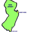
The Diligent CPA in NJ
Comments (327)| + Follow| Send Message

The problem is that they're drowning in debt. They way overpaid for all of their acquisitions. Now, going to be charged with fraud. That billions i n additional dollars wasted. I am afraid that shares go to zero.
5 Nov, 02:15 PMReply! Report AbuseLike3
vcpnttp
Comments (27)| + Follow| Send Message

VRX medicines will all be generic in ten years. So prices drop 90 percent. Also no r aNd d so no new products. Is cash flow enough to pay debt of $30 billion with cash on hand north of just one billion?
Will watch CDS writers on this one!
5 Nov, 02:16 PMReply! Report AbuseLike5
User 7174091
Comments (90)| + Follow| Send Message

Ackman's email to company was a sell. Sounded like he was supporting the scam as a shareholder friendly practice rather than what is ethical business.
5 Nov, 02:32 PMReply! Report AbuseLike7
paullyballz
Comments (153)| + Follow| Send Message

wonder what collateral damage is due here...if VRX goes to zero...who is their banker....?
5 Nov, 03:02 PMReply! Report AbuseLike1
paullyballz
Comments (153)| + Follow| Send Message

i imagine the only buying goin on here is covering......
5 Nov, 03:21 PMReply! Report AbuseLike1
Son of Bureaucrat
Comments (487)| + Follow| Send Message

"Ackman's email to company was a sell. Sounded like he was supporting the scam as a shareholder friendly practice rather than what is ethical business."

Ackmans's words of encouragement to Michael Pearson remind me of when George McGovern said he was backing his Vice Presidential candidate Senator Eagleton.
McGovern said he was a 1000% behind Eagleton. The next day Eagleton was removed from the democratic ticket.
Since I am dating myself the background story was the following. Somehow it came out that Senator Eagleton had undergone "electric shock therapy". Well, in 1972 this was equivalent to saying that the VP nominee was a "cannibal". Thus the 1000% support from George McGovern.
We will see how long Mr. Ackman supports VRX and its CEO.
5 Nov, 03:26 PMReply! Report AbuseLike3
centurion2046
Comments (11)| + Follow| Send Message

Why would anybody acquire Valeant for $150/share when the market clearly does not support that kind of premium? Unless a bidding war erupts, Valeant's assets will be on clearance.

The lack of timely response from Valeant indicates to me that, at best, they are extremely disorganized in house; and, at worst, there is something ugly which needs serious "message crafting" before being revealed to investors and the general public.

All this governmental overhang in an election year certainly doesn't help either. I see bi-partisan support for the upcoming witchhunt as well -- much like "save our children", who is going to play free market politics when it is described as price gouging of suffering patients?
5 Nov, 03:30 PMReply! Report AbuseLike1
watwat
Comments (3)| + Follow| Send Message

Boom - Head shot! http://bit.ly/1RL0N0L
5 Nov, 03:33 PMReply! Report AbuseLike4
paullyballz
Comments (153)| + Follow| Send Message

truly a tough day for Bill.......so for a manager to be so transparent and upfront about what he believes.....it's almost like the Fed...if everyone knows exactly what you're up to, it may seem "valiant" but in the end its very painful. bill made a kill on ggp and dared investors to prove him wrong......it would be very interesting to know what his exposure is like now.....I'm not sure if it's possible, but I wouldn't be surprised if he's net short by now....
5 Nov, 03:34 PMReply! Report AbuseLike3
IncomeYield
Comments (2725)| + Follow| Send Message

Did you say "Valium" ???
5 Nov, 05:25 PMReply! Report AbuseLike0
Darbyred
Comments (190)| + Follow| Send Message

Too many issues to resolve to be long: fraud by Philidor, employees using aliases, loss of business with PBMs, consolidated financial statements with Philidor and Valeant stating it is cutting its ties with Philidor, insurance company investigations, Congressional investigations, U.S. Attorneys investigating in 2 states, Valeant's raising prices by massive percentages on legacy drugs, cutting R&D, $30+ billion in debt on over paid mergers and acquisitions, likely larges drops in free cash flow, law suits by R&O, law suits by class action plaintiffs, and Valeant's public contentions it may not be moral, but Valeant's conduct was legal, et cetera. This is once in a ten years dream for shorts.
5 Nov, 03:52 PMReply! Report AbuseLike1
jstratt
Comments (3391)| + Follow| Send Message

I would like to see Ackman's actual trades on VRX.

My concern is he could be manipulating the value. Selling and shorting while holding a 4 hour press conference supporting the company. Then dumping shares at a profit as news comes to light and minimizing his original exposure.

Suggesting that he is taking opposite positions on different days out of a patriotic decency and fairness seems unlikely.
5 Nov, 04:36 PMReply! Report AbuseLike5
check-mate
Comments (67)| + Follow| Send Message

AGN would not be a buyer of a generic business as it sold off it's generic unit to teva
I was with you until you said AGN was similarly overvalued
5 Nov, 05:05 PMReply! Report AbuseLike3
Aritz
Comments (38)| + Follow| Send Message

I admire Charlie Munger, but I think there is to much negativity pointed towards Valeant now. I think if Valeant is the lehman of pharma in terms of behaviour, sin and folly, there is a bear stearns out there that is worse. When the tide goes out is too late to talk about justice, because Mr. Market can remain irrational longer than the company can remain solvent. There are so many haters out there that hate the model and might actually kill the company. Having said that, the guilt is in ourselves, not the stars.
5 Nov, 05:39 PMReply! Report AbuseLike2
JGC320
Comments (315)| + Follow| Send Message

On firing Mike Pearson, that is an admission that his model (of what a pharmceutical company should be) is a bad one full of tragic assumptions about the real world. A new CEO could be hired, but fundamentally it is a rejection of the Pearson model, and "New Valeant" would be a very different pharmaceutical company operating on a different premise.

Investors were always enamored with the Pearson Pharma Model: that is what they were really buying. And if there is no magical Pearson Pharma Model, then when you really look at their pharmaceutical portfolio, you will see there is nothing there much worth investing in.
5 Nov, 06:40 PMReply! Report AbuseLike8
Cotton2006
Comments (54)| + Follow| Send Message

Reasons for the damage as of late= GREED and profits at all costs by everyone involved with VRX. With all the ongoing AND future lawsuits, Govt investigations, downgrades, blatant lack of transparency, the list is truly endless. I would've expected the Bod to send a strong signal to the markets and investors by announcing an EXTERNAL independent audit. Internal audit is simply not enough- extreme circumstances call for extreme measures and it would've shown shareholders AND potential investors VRX was serious in regards to transparency.
As for Ackman and the other hedge funds- were they "screw- loose" when they decided to invest such a large portion of their fund into one particular stock? Did they just ignore the fact that questions about the business model surfaced awhile ago- long before the Citron article. Greed overtook commonsense. The minute I find out one of my investments is under Govt investigation I will generally dump it without hesitation.
Fix what's broken-
-dump the entire bod (new bod would have no responsibility/ attachment to past issues and could work towards resolving those issues in a transparent and timely manner), new auditor (including external audit), own up to all the issues, pay down debt drastically at the expense of earnings. Change the perception that they are viewed as a Hedge Fund and not a Pharma.
The above is a very tall order and would take some very talented people to turn it around- present bod is just not capable enough.
Haven't seen such a mess in a long time and it just seems to keep getting worse- who's at fault?
If it wasn't for the debt there probably would be suitors out there "thinking" about acquiring VRX but...
5 Nov, 07:27 PMReply! Report AbuseLike1
Casual User
Comments (16)| + Follow| Send Message

I see Valeant's bloated Goodwill and Intangibles in balance sheet as a solemn promise to price gouge US consumers to service Valeant's massive debt. If the price gouging is aggressively clawed back by the insurers (as it surely will, given Valeant's fraud/deception and the political environment), it is not at all obvious that Valeant's balance sheet has any positive equity left.
5 Nov, 07:51 PMReply! Report AbuseLike4
Darcangelo
Comments (404)| + Follow| Send Message

Everyone seems to forget that there is a real business here creating real profits. Revenue is real.
5 Nov, 08:15 PMReply! Report AbuseLike0
User 7174091
Comments (90)| + Follow| Send Message

A real business with $31b in debt. $200m or so a month in debt service.
5 Nov, 08:52 PMReply! Report AbuseLike1
Darcangelo
Comments (404)| + Follow| Send Message

There's a short squeeze coming.
5 Nov, 08:15 PMReply! Report AbuseLike1
biodxguy
Comments (70)| + Follow| Send Message

Good comments here. VRX is a tragic story of greed and hedge fund craziness. In the end you need real R&D investment - either through organic development or through license and acquisition. The model Pearson had was totally flawed in that he didn't invest enough. He cut too deep and then in order to prop up the business he had to push all the boundaries. VRX needed the AGN deal and when that went nowhere the foundation of the house of cards cracked. This was never a real business with the valuation it carried. It was just a bunch of hedge fund trickery and honestly I hope Pearson and crew get thrown out and have criminal charges against them. All the VRX bulls who pumped up the price with the hype machine - like Ackman - deserve to lose their money too. I can't wait to see this happen as it's well deserved to see this toxic business go the zero. Having said all of this - as in other posts I've made on this company - I feel bad for the employees. I'm sure there are a lot of good people with good intentions and work ethics who are going to be hammered by this situation and it really sucks for them big time. It disgusts me to think of the "sophisticated" shareholders that Ackman refers to, along with management, pocketing tons of money on the way up, and no doubt on the way down too. Prison is the only justice here for many of the execs. The "regular" guy/gal is going to get really impacted by this and even going forward will be held back by their toxic resumes that state Valeant. Sad turn for many people - but no sympathy for the marketeers and execs who defrauded everyone.
5 Nov, 09:12 PMReply! Report AbuseLike3
User 7174091
Comments (90)| + Follow| Send Message

Anyone that works for these types of managers/owners (PE etc.) knows their fate. It's like walking in the shadow of death. Your entry badge works today and you hope it works tomorrow. If not, hang it on the door and go home.

Be thankful if you don't have to train your outsourced replacement.
--

VALEANT PHARMACEUTICALS INTL VRX. S
July 27, 2015 by
ahab931
 |  |  |  |  |  | 2015 | 2016
Price: |  | 252.00 |  | EPS |  | 12 | 15
Shares Out. (in M): |  | 351 |  | P/E |  | 21 | 17
Market Cap (in M): |  | 88,452 |  | P/FCF |  | 50 | 30
Net Debt (in M): |  | 30,000 |  | EBIT |  | 3,500 | 4,700
TEV: |  | 118,000 |  | TEV/EBIT |  | 34 | 25
Borrow Cost: |  | General Collateral
Sign up for free guest access to view investment idea with a 45 days delay.
- Description / Catalyst
- Messages (2)

Description
Valeant is a spectacular platform story that rolls up specialty pharmaceuticals applying "The Outsider" philosophy with the aid of a tax-efficient coporate structure. Rollups like that has virtually unanalyzable accounting statements and forces you to decide whether you trust the management’s non-GAAP pro forma EPS numbers. Wall Street has chosen to operate on faith for this story.
“Trust but verify” is always a wise rule. Trust the non-GAAP EPS number but check whether its reported FCF from its cashflow statement eventually converge to it. In the spring of 2013, Valeant was guiding 2013 non-GAAP EPS of almost $6 when its reported FCF (GAAP cashflows from operations minus capex) was at about $2.3/share. No sweat. It should eventually converge once things normalize. The company is a classic rollup story and so there has always been heaps of one-time restructuring charges. Then Valeant announced the transformational acquisition of Bausch & Lomb and raised guidance of 2013 non-GAAP EPS to over $6 for the first time. This acquisition vindicated the company’s playbook. As long as they keep doing accretive acquisitions like that with cheap debt and tax-efficient structure, sky is the limit to what EPS can be. For sure reported GAAP FCF should be on a steady march toward that meager $6 sooner or later. Valeant claimed to have double-digit organic growth and that the string of tucked-in acquisition added to FCF. So by the time they gave up on the Allergan acquisition, they were already guiding a recurring non-GAAP EPS of over $10 for 2014 (in the 3Q14). The only problem was that Valeant was still struggling to report a GAAP FCF of $6/share then. The company’s trailing reported FCF continued to languish at $5 in the first half of 2015, showing no signs of converging with the $6 that they claimed they were already earning 2 years ago, never mind the $10 run-rate that they would have you believe. There was no sizeable acquisition since Bausch & Lomb closed in August 2013 to explain away the glaring gap. The Salix acquisition comes to the rescue. Because Salix is inherently a messy acquisition with channel inventory and accounting issues (even though it is less than you think), it serves to further suspend people’s skepticism over the Company’s GAAP numbers. The CFO Howard Schiller decided to leave just as the Salix deal closed in April 2015, surely for some legitimate personal reasons. The company is currently guiding over $12 pro forma EPS for 2015 and the Street expects $15 in 2016. The stock has thus rocketed from $80 to $250 during the last 2 years, propelled by a steadily rising non-GAAP EPS guidance.
But a careful review of the GAAP FCF trend would conclude that Valeant does not have much more than $6/share of earnings power before Salix. A casual review would lead you to the same conclusion all the same. This revelation would not have been possible if Valeant had not pursued Allergan and failed, leaving a window of almost 6 quarters of deal-free financial statements.
Many who are familiar with the power of roll-up stories know that faith-based stories like this can go on for as long as people are willing to believe in them because faith precipitates accretive acquisitions which can then fundamentally validate the faith in itself. But there are reasons for Valeant to be near the end of its acquisition spree, at least for a while. Back in 2013 Valeant was the only game in town. Nonetheless, in the intervening 2 years many inversions such as Actavis (now Allergan), Endo, Teva, Mallinckrodt, Mylan, etc have taken place. Deals below the size of Salix are very crowded now while Actavis and Teva are firmly in Valeant’s league for mega deals. The multiples at which M&A are done these days mean that any future acquisitions can only be accretive if a large amount of cheap debt is involved. But the Salix acquisition has exhausted Valeant’s borrowing capacity at least for another year.
If no major acquisition happens, by the end of 2Q16, we would get to see how far the Salix acquisition could lift the company’s trailing FCF/share to from its current level of $5. By then CEO Mike Pearson would probably have convinced everyone that the company earned $12 in 2015 and be guiding $15/share for 2016. If the company’s cashflow statement can report a trailing FCF of $10/share then maybe the stock deserves to trade at $250, or maybe even $300, i.e. 20x 2016 PF EPS. But in the unlikely event that the company struggles to report GAAP FCF of over $6, which they claimed they already earned in 2013, then the story is broken and we are looking at $100 stock if not lower. This scenario is unlikely only because the accounting mismatch is just too mind-blowingly ineffable and also because really smart people love this platform stock. Nonetheless, I like the risk reward in shorting this universally-loved (at least by sell side) stock.
I do not hold a position with the issuer such as employment, directorship, or consultancy.
I and/or others I advise do not hold a material investment in the issuer's securities.

Catalyst
After Salix, the company is tapped out in its debt capacity and so sizeable deals should take a breather, opening a window for investors to verify its lofty non-GAAP EPS guidances. The market meanwhile might continue to ignore the gap due to the Salix noise, but not for too many quarters.
The balance of risk is pretty favorable for a trade that I estimate to have a roughly 12-month horizon to play out.
Back to top
# | AUTHOR  Date  SUBJECT
18 | spike945  8/06/15  Re: Re: Re: Re: organic growth  reply
thank you for your reply. my question essentially was let's say hypothetically that VRX now has to pay a 20% tax rate (assuming that's kind of inline with other pharma names). where would the company trade at that point? perhaps cash eps is around 9 at that point, maybe give it a lower multiple also due to less accretive deals? right now it trades at 22x cash eps or so. maybe goes down to 20x or 180?
lots of smart money on the other side of the trade. it's got lots of HF on the other side very long from what i hear.
interesting idea, thanks.
· reply
14 | spike945  8/03/15  Re: Re: organic growth  reply
ahab - do you have a sense for how much value is in the tax "asset"? i.e. if they had to pay a normal 20% tax rate what would it do to the value of the company?
they repeatedly say the deals provide a good return excluding this tax benefit. just curious as to your thoughts.
· reply

VALEANT PHARMACEUTICALS INTL VRX
May 18, 2014 by
jon64
 |  |  |  |  |  | 2014 | 2015
Price: |  | 127.00 |  | EPS |  | $0.00 | $0.00
Shares Out. (in M): |  | 300 |  | P/E |  | 0.0x | 0.0x
Market Cap (in M): |  | 40,000 |  | P/FCF |  | 0.0x | 0.0x
Net Debt (in M): |  | 0 |  | EBIT |  | 0 | 0
TEV: |  | 0 |  | TEV/EBIT |  | 0.0x | 0.0x
Sign up for free guest access to view investment idea with a 45 days delay.
- Description / Catalyst
- Messages (7)

Description
Every so often the market offers a risk-reward that is both truly asymmetric and very simple. We believe that VRX equity is currently such an instance.
There is a heated and now very public debate amongst investors regarding what Valeant is ultimately worth – what’s true organic growth, what’s terminal value, what are the correct EPS adjustments, etc. While these are very important questions for a long term investor in VRX (or short seller of VRX) to ponder, the more immediate opportunity is a binary bet based on the outcome of Valeant’s bid for Allergan, which we believe offers a very compelling 7:1 risk-reward. The arithmetic is as follows:
- If VRX is unsuccessful in its attempt to acquire Allergan, and if VRX fails to close any incremental transactions or allocate any incremental capital through the end of 2015, consensus believes that Valeant will earn $10.55 in 2015 Cash EPS. We follow the company closely and believe that this no-deals consensus EPS estimate is reasonable. Conservatively assuming that Valeant trades at 11x forward earnings in this scenario, this implies 11x * $10.55 = $116 share price, or down 8% from the current ~$127 price. An 11x multiple may prove conservative, given the stock was trading at higher multiple pre-deal, but this reflects investor frustration with a failed attempt.
- If VRX is successful in its attempt to acquire Allergan, we believe that the deal, as currently constituted, will add $3 to VRX’s 2015 EPS on a fully-synergized basis, implying $10.55 + $3.00 = $13.55 in fully synergized 2015 EPS (actual EPS may be slightly lower since synergies may not be fully captured in 2015). Our analysis suggests that the revenue-weighted average historical EPS multiple for the combined VRX-AGN is 15x. As such, 15x * $13.55 = ~$203 share price, or up 60% from the current ~$127 price. The EPS number here may prove conservative, given that it doesn’t assume any incremental deals, whereas continuation of their history of doing a number of small deals could add $1+ to ’15 EPS. It’s worth noting that future smaller and medium size deals will likely be debt financed (this AGN deal delevers VRX on a pro forma basis, opening up ~10 billion of debt capacity), so their accretion relative to the size of the deal is higher than a deal like AGN where VRX needed an equity component.
Up 60% / down 8% is a 7:1 risk reward based on VRX’s ability to close the proposed AGN transaction, which we think is slighly more likely than not.
Disclosure:
We and our affiliates are long VRX and may buy additional shares or sell some or all of our securities, at any time. We have no obligation to inform anyone of any changes in our views of VRX. This is not a recommendation to buy or sell securities. Our research should not be taken for certainty. Please conduct your own research and reach your own conclusion.
I do not hold a position of employment, directorship, or consultancy with the issuer.
I and/or others I advise hold a material investment in the issuer's securities.

Catalyst
AGN deal, hopefullly.

# | AUTHOR  Date  SUBJECT
18 | tyler939  5/04/15  Does anyone have thoughts on Ackman's presentation?  reply
No position. Would love to hear thougths on his "platform" thesis (buy roll ups run by people you like when capital is cheap - not his words, but how I see it).
· reply
17 | avahaz  7/02/14  RE: : lot of criticism in the pres any thought  reply
joe, i believe what you are saying is that VRX (and any other drug company relying on patents) should be valued on DCF rather than P/E, correct? I don't think this idea will come as a big surprise to anyone who has ever looked at pharma...
· reply
14 | juice835  7/02/14  RE: : lot of criticism in the press... any thought  reply
I'm not sure i understand the question- if interest is included and the FD share count is used (relevant if using shares for acqusitions), how is the price paid not factored into the valuation? Seems like you're mixing issue of adding back restructuring charges which is a whole separate discussion to price paid for acqusitions. not saying the former isn't an issue that requires a lot of consideration.

separately, curious what is the most likely path to the AGN deal not getting done right now? seems like most roads lead to completion from here.
· reply
11 | Cries  6/19/14  RE: John Hempton  reply
I have no position here and am pretty neutral on the equity, although they are part of my coverage universe at work:

I read all of John's blog posts on this thing. I feel like he formed an investment opinion first, then tried to justify it after the fact.

Sure they have aggressive accounting and the valuation using any rational multiples-based approach is sky-high - but that doesnt mean the share price will collapse. After all, this is 2014, and we are likely in the "new normal" stage of the cycyle.

Its probably good exposure to sit on if you have a devoted short bucket - but I dont see a catalyst here
· reply
8 | conway968  5/20/14  RE: lot of criticism in the press... any thoughts?  reply
FCF seems pretty easy to manipulate in this context. Can't you just buy mediocre drugs with short patent protection, slash the marketing budget, push through big price increases, and lie to everyone about the sustainability of the resulting cash flows? Not saying that is happening in this particular case, but seems like a simple thing to do.
· reply
4 | juice835  5/19/14  RE: RE: RE: lot of criticism in the press...  reply
I'd be curious if anyone has any more substantive arguments against VRX than something to the effect of "the gaap #s are horribe." There may be some truth to this though it is also more or less true for all roll-ups and not all roll-ups are bad. Having reviewed the Grant's piece on VRX which supposedly laid out the Chanos thesis, there didn't seem to be any smoking guns. Perhaps organic growth isn't as great as advertised in certain quarters and perhaps there are some (very) small specific acquisition accounting and yes the stock is up a lot.

On the flip side, this company has generated cash (not so much in 2013 if that's all one focuses on), does have a highly advantageous tax structure, a lot of exposure in growing geographies, a mgmt team with a ton of skin in the game with an aggressive focus on costs, low level of drugs going off patent, etc.

· reply
1 | MJS27  5/19/14  lot of criticism in the press... any thoughts?  reply
Jim Chanos, Jim Grant, and now John Hempton have all recently called VRX a short due to aggressive accounting amongst other things.... I have never done any real work on the name, but i am curious how familiar you are with the short cases being thrown around and if you can provide any thoughts on them.
· reply

